Music Lesson Plan topic – Pitch

Lesson 6 of 6 Focus: Year 4
The focus of this whole Unit is Heritage and the power of traditional song. Traditional music can help people understand a culture better. It represents the history, traditions and thoughts of a community. We would like to collect songs from all over the Bristol from many cultures to create a bank of Songs of our City. Over the unit we would love schools to encourage individual children to ‘sing a special song’ to their class. Maybe one that is sung a lot at home, maybe a lullaby, maybe one they know from grandparents. The song can be in any language but the emphasis is a traditional song – one that has been passed down through generations. At the end of the Unit it would be amazing if you could choose one or two songs from your class and record an individual singing as an MP3 file and send them with the title of the song if known, words (and phonetic pronunciation if needed), as well as the meaning if not in English to kirsten.cunningham@bristolbeacon.org. These may be used in future Bristol Music lesson plans and if we get enough will be made into a song book. No recordings of individual children and no names will be used so there are no GDPR concerns.
Key Learning Objectives:
- To sing with confidence and control as an individual and in a group.
- To sing in parts.
- To understand the significance of folk songs and oral tradition and explain this with reference to known songs.
Inter-related music dimensions covered: Tempo, Duration, Structure (verse/chorus/round/call and response/partner song), Texture.
As you cover the different dimensions refer to them on the poster (see resource) and tick them off. You might like to laminate each of the different images and display on the board as you cover them.
Starter activity:
Tell the children that singers need to warm up their voice in the same way as sports people need to warm up. Singers do this by concentrating on various aspects such as breathing, diction and warming up the muscles surrounding the vocal chords. Listen to and learn the ‘Warmup and Stomp Canon’: Sing Up Warmups.

Main focus:
Ask the children which songs they have sung over the unit that have come from an oral tradition.
- John Kanaka (sea shanty).
- Hi lo Chickalo (playground game).
- L’il Liza (trad American).
- Four White Horses (trad Caribbean).

Discuss what makes traditional songs special. Traditional music can help people understand a culture better. It represents the history, traditions and thoughts of a community. Revisit and sing each song and for each song discuss who might sing it and why. Where might each song be sung? Which songs are happy? Which songs are sad? Why?

As the children listen to 30 seconds / 1 minute of the songs below can draw a face that they think best represents the mood of the song and write 10 words that captures the feeling of the music.
- Traditional Somali work song https://www.mamalisa.com/?t=es&p=5252.
- Traditional song from Cambodia about a starling https://www.mamalisa.com/?t=es&p=5000.
- Traditional Maori song from New Zealand about a whale https://www.mamalisa.com/?t=es&p=5634.
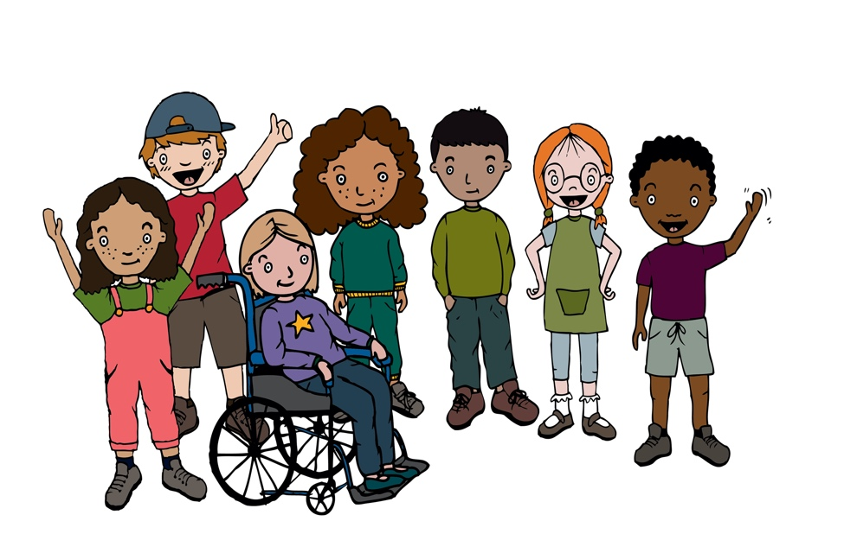
Plenary:
If children from the class have offered to sing a traditional song from their home, record this as part of the lesson and send in to Bristol Beacon.
Keywords / vocabulary: Unison, round, sea shanty, call and response, verse, chorus, folk song, traditional.
Self-assessment opportunities:
- I can sing with confidence and control as an individual and in a group.
- I can sing in parts.
- I understand the significance of folk songs and oral tradition and can explain this with reference. to known songs.
Resources: Recordings and lyrics from previous lessons.
Opportunities for sharing work e.g. by recording.

Music Assessment: Year 4 Lesson 6
You only need to note the names of children who are working towards or well above the criteria for the lesson. It will be assumed the majority of the class will achieve the objectives and you don’t need to record this. Use the space below for any specific notes on achievement or evaluation of class progress.

Names of any children who are working towards | ‘I can’ assessment criteria | Names of any children who are working at greater depth
- I can sing with confidence and control as an individual and in a group
- I can sing in parts
- I understand the significance of folk songs and oral tradition and can explain this with reference to known songs
Notes:

