Music Lesson Plan topic – Songs of the City

Lesson 5 of 6 Focus: Year 4
The focus of this whole Unit is Heritage and the power of traditional song. Traditional music can help people understand a culture better. It represents the history, traditions and thoughts of a community. We would like to collect songs from all over the Bristol from many cultures to create a bank of Songs of our City. Over the unit we would love schools to encourage individual children to ‘sing a special song’ to their class. Maybe one that is sung a lot at home, maybe a lullaby, maybe one they know from grandparents. The song can be in any language but the emphasis is a traditional song – one that has been passed down through generations. At the end of the Unit it would be amazing if you could choose one or two songs from your class and record an individual singing as an MP3 file and send them with the title of the song if known, words (and phonetic pronunciation if needed), as well as the meaning if not in English to kirsten.cunningham@bristolbeacon.org. These may be used in future Bristol Music lesson plans and if we get enough will be made into a song book. No recordings of individual children and no names will be used so there are no GDPR concerns.
Key Learning Objectives:
- To perform a sequence of movements to a song.
- To maintain a steady pulse.
- To clap the rhythm of the song.
- To trace the pitch of a melody.
Inter-related music dimensions covered: Duration, Tempo, Pitch, Dynamics.
As you cover the different dimensions refer to them on the poster (see resource) and tick them off.
You might like to laminate each of the different images and display on the board as you cover them.
Starter activity:
Warm up: ‘Plasticine person’ Sing Up. This warm up explores different vocal sounds exercises vocal muscles and is great for getting ready to sing.

Main focus:
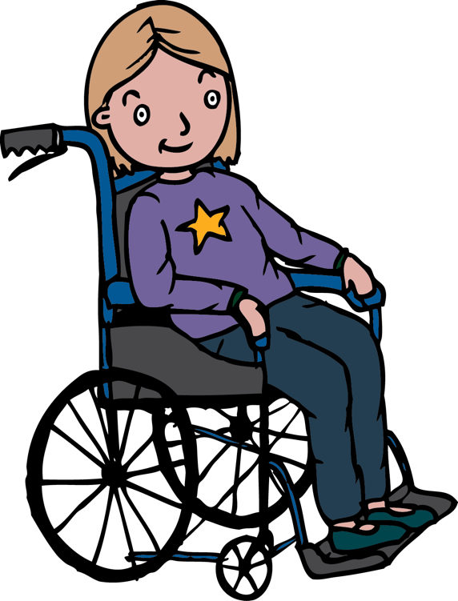
To learn the traditional Caribbean song, ‘Four White Horses’ - Sing Up.
Traditional songs like this might be sung by children playing in the playground. They are learnt by ear (oral traditional) and passed down verbally. They are often sung unaccompanied a capella, like sea shanties. They are rhythmic and repetitive and the words are often nonsense.

Four white horses on the river,
Hey, hey, hey, up tomorrow,
Up tomorrow is a rainy day.
Come on and join our shadow play,
Shadow play is a ripe banana.
Hey, hey, hey, up tomorrow,
Up tomorrow is a rainy day.
Come on and join our shadow play.

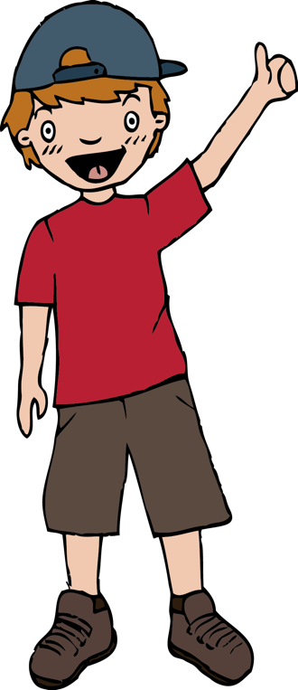
Learning the melody: Start by listening to the rehearsal track of Four white horses on Sing Up or from resource tracks. Use your hands to help trace the pitch of the echo line. Then use the same track to echo each line by singing again, this time singing as well as tracing the pitch. Divide the class in half: can half the class lead a line, and the other echo it? Whilst one group sings, the other non-singing group should pitch trace. Make a further link to the word ‘pitch’ can the children understand that the melody line moves up and down sometimes by a step and sometimes by a small leap. Can the children identify words that move by a leap (rai-ny / sha-dow). There is also lots of repetition and a strong sense of pulse.

Once the song is familiar to the children they should march on the spot whilst singing the song. The marching is the pulse (heartbeat) of the song. Now clap the rhythm of the words (every syllable) of line one. Notice how this is different to the pulse. Divide the class so that one half keeps the pulse by marching on the spot whilst the other claps the rhythm of the words. Once secure, aim for the children to say the words in their thinking voices and not out loud so that they clearly hear the musical lines.

Adding movement and rhythm:
Everyone faces a partner:
- Clapping rhythm: (4 beats)
Clap right hands, clap own hands, clap left hands, clap own hands. Rehearse this a few times without the song and make sure that everyone starts with a right-hand clap! Now try performing the pattern to the song, but don’t begin clapping during the introduction, wait until the singing starts.
- Clapping pattern 2 (6 beats):
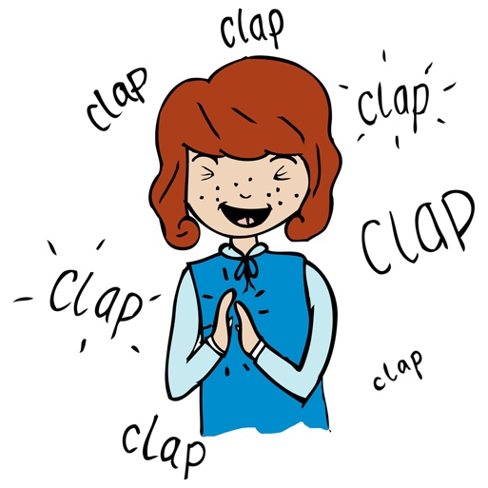
Clap right hands, clap own hands, clap left hands, clap own hands, clap both partner’s hands, clap own hands. As before, practise the new clapping pattern in pairs before trying it to the song. The music itself is arranged in four beats so when a six-beat clapping pattern is played against the music, some real concentration is required to keep everything together! Since the song has 48 beats, the six-beat pattern fits perfectly.
- Traditional clapping (more challenging)
Each pair now finds another pair and stands together in a mini-circle of four, with original partners facing. Children clap their knees, clap own hands, then alternately clap partners hands above or below the other pair as demonstrated here https://www.youtube.com/watch?v=dWQJeYHkA_c

Plenary:
Use four confident players to model this activity to the class and then take some time to rehearse the actions before adding the song.

Keywords / vocabulary:
Pitch, Tempo, Dynamic, Duration (pulse, rhythm), Caribbean, echo, melody, a capella, step. leap, oral tradition.
Self-assessment opportunities:
- I can trace the pitch of a melody.
- I can clap the rhythm of a song.
- I can maintain a steady pulse.
- I can perform a sequence of movements to a song.
Resources: Sing Up Four White Horses Piano and Vocal score and chords (pdf) from Sing Up or recording tracks and music in the resource pack.

Opportunities for sharing work e.g. by recording, notation: Make a video recording of the song with movements.

Music Assessment: Year 4 Lesson 5

You only need to note the names of children who are working towards or well above the criteria for the lesson. It will be assumed the majority of the class will achieve the objectives and you don’t need to record this. Use the space below for any specific notes on achievement or evaluation of class progress.

Names of any children who are working towards | ‘I can’ assessment criteria | Names of any children who are working at greater depth
- I can trace the pitch of a melody.
- I can clap the rhythm of a song.
- I can maintain a steady pulse.
- I can perform a sequence of movements to a song.

Notes:

