Music Lesson Plan topic – Pitch

Lesson 3 and 4 Focus: Year 4
The focus of this whole Unit is Heritage and the power of traditional song. Traditional music can help people understand a culture better. It represents the history, traditions and thoughts of a community. We would like to collect songs from all over the Bristol from many cultures to create a bank of Songs of our City. Over the unit we would love schools to encourage individual children to ‘sing a special song’ to their class. Maybe one that is sung a lot at home, maybe a lullaby, maybe one they know from grandparents. The song can be in any language but the emphasis is a traditional song – one that has been passed down through generations. At the end of the Unit it would be amazing if you could choose one or two songs from your class and record an individual singing as an MP3 file and send them with the title of the song if known, words (and phonetic pronunciation if needed), as well as the meaning if not in English to kirsten.cunningham@bristolbeacon.org. These may be used in future Bristol Music lesson plans and if we get enough will be made into a song book. No recordings of individual children and no names will be used so there are no GDPR concerns.
Key Learning Objective:
- To add tuned and untuned percussion parts to accompany the medley of traditional songs already learnt.
Inter-related music dimensions covered: Pitch, Rhythm, Texture, Timbre.
As you cover the different dimensions refer to them on the poster (see resource) and tick them off.
You might like to laminate each of the different images and display on the board as you cover them.
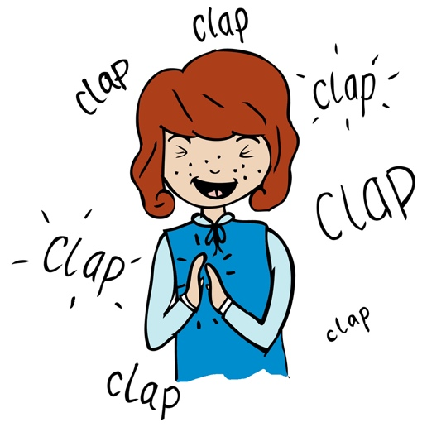
Starter activity:
Clap to the heartbeat and 1 1,2,1 Vocal warm ups (SingUp).

Main focus:
In this session, the focus is on adding instruments to accompany the Pentatonic Partner songs (‘John Kanaka’, ‘Liza Jane’, ‘Hi Lo Chickalo’, ‘Hill’n’Gully’)

There are various tuned and untuned percussion scores in the resource section that you can try with your class to accompany the songs. An ostinato is a melodic or rhythmic pattern repeated over and over again and all these parts are ostinatos. The parts work as an accompaniment to the song, but can also be layered by themselves with the class divided into groups and each group performing one ostinato.

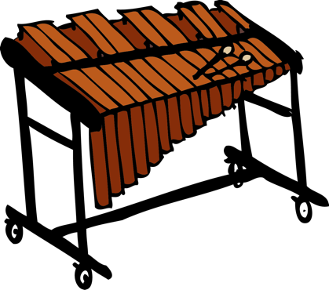
Develop the activity further by encouraging individuals to create an improvised (made up) melody of their own based on the rhythm of one or more of the songs. The key of the music is D major so any notes from the chord of D major (D,F sharp, A) will always work well and sound good. The children can improvise easily with just these notes. The children can play any of the notes in any order to the rhythm of one of the songs (D, F sharp, A) Discuss with the class which improvisations were the most effective and why? Using repeated pitches creates a catchier tune. Can they record their ostinato either as just letter names or with written rhythms and notes using knowledge gained from looking at the score of all the songs?

- Plenary:
- Singing the songs outside in the playground will encourage the children to sing independently. Appoint singing leaders to teach the song to children from other classes at playtime. Soon the whole school will be singing! Encourage small groups of children to rehearse all the songs together in the playground and to come back to share with the class!
- A traditional performance of John Kanaka https://www.youtube.com/watch?v=TWDuDosFZ_A.
- An example of other actions you could use https://www.youtube.com/watch?v=Ku3AZHamvhE.
- This recording shows friends improvising and singing the traditional American song L’il Liza Jane https://www.youtube.com/watch?v=9P_ZVQCA5lI.
- A traditional version of Hill ‘n’ Gully https://www.youtube.com/watch?v=OZBd8vIq3_8 Listen our for the call and response and the improvising instruments.
- Hi lo chicka lo clapping game https://www.youtube.com/watch?v=YCJzB1ne8s0.

Keywords / vocabulary: Ostinato, tuned percussion - glockenspiel, xylophone, chime bar, chord (C,E,G built up together), melody, harmony, untuned percussion, rhythm, names of notes, crotchet, minim, quaver, rest, improvise, accompaniment.
Self-assessment opportunities:
- I can follow an ostinato part.
- I can listen to others and keep in time.
- I can explain why traditional songs are special.
- I can notate my own ostinato part.
- I can identify different inter-related dimensions.
Resources: Scores and recordings of songs, untuned percussion, tuned percussion - glockenspiel, xylophones, chime bars, Sing Up, Ppt poster of inter related dimensions.

Opportunities for sharing work e.g. by recording, notation: Video and record performances by using an iPad.

Music Assessment: Year 4 Lesson 3 and 4

You only need to note the names of children who are working towards or well above the criteria for the lesson. It will be assumed the majority of the class will achieve the objectives and you don’t need to record this. Use the space below for any specific notes on achievement or evaluation of class progress.

Names of any children who are working towards | ‘I can’ assessment criteria | Names of any children who are working at greater depth
- I can follow an ostinato part
- I can listen to others and keep in time
- I can explain why traditional songs are special
- I can notate my own ostinato part
- I can identify different inter-related dimensions
Notes:

