Music Lesson Plan topic – Songs of the City

Lesson 1 and 2 Focus: Year 4
The focus of this whole Unit is Heritage and the power of traditional song. Traditional music can help people understand a culture better. It represents the history, traditions and thoughts of a community. We would like to collect songs from all over the Bristol from many cultures to create a bank of Songs of our City. Over the unit we would love schools to encourage individual children to ‘sing a special song’ to their class. Maybe one that is sung a lot at home, maybe a lullaby, maybe one they know from grandparents. The song can be in any language but the emphasis is a traditional song – one that has been passed down through generations. At the end of the Unit it would be amazing if you could choose one or two songs from your class and record an individual singing as an MP3 file and send them with the title of the song if known, words (and phonetic pronunciation if needed), as well as the meaning if not in English to kirsten.cunningham@bristolbeacon.org. These may be used in future Bristol Music lesson plans and if we get enough will be made into a song book. No recordings of individual children and no names will be used so there are no GDPR concerns.
Key Learning Objectives:
- To sing a song in unison using actions.
- To maintain a part when singing two or more songs.
- To explain what a traditional song is and to be able to say where a song originates from.
- To describe how several songs when sung together can create different textures.

Inter-related music dimensions covered: Texture, Duration-rhythm, Pulse, Structure.
As you cover the different dimensions refer to them on the poster (see resource) and tick them off.
You might like to laminate each of the different images and display on the board as you cover them.
Starter activity:
Tell the children that singers need to warm up their voice in the same way as sports people need to warm up. Singers do this by concentrating on various aspects such as breathing, diction and warming up the muscles surrounding the vocal cords. Listen to and learn the ‘Warmup and Stomp Canon’ - Sing Up Warmups.

Main focus:
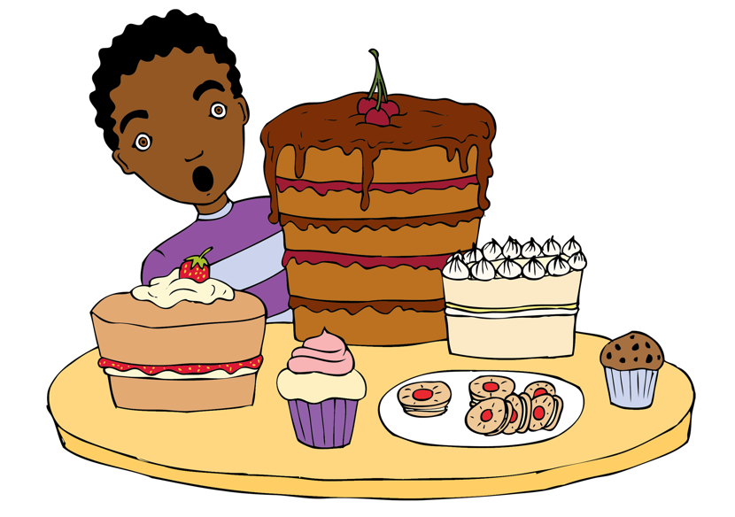
This collection of traditional songs introduces the idea to children that songs, when layered in various ways, can produce different textures. Traditional songs are rarely written down but are part of an oral tradition sharing cultures, history, emotions and stories. Over years of being handed down from generation to generation they change slightly with different words and melodies but maintain a message, meaning or story. The 4 Pentatonic Partner songs we will learn include ‘Liza Jane’ (Southern America), ‘John Kanaka’ (call and response sea shanty sung on ships sailing the Pacific ocean), ‘Hi Lo Chickalo’ (playground clapping game), ‘Hill ‘n’ Gully Rider’ (call and response song from the Caribbean).
These traditional songs that can be sung in places where people meet together like the playground, assembly, the classroom etc.

- Introduce and teach one song at a time using the backing track resources until secure and memorised by the children.
- Teach 2 bars at a time and use the ‘my turn’, ‘your turn’ method. The children listen to you (or the track) singing 2 bars at a time and they copy and repeat. Stop and correct any pitch or rhythm inaccuracies before continuing.
- Use your hand to ‘pitch pattern’ the notes to show the rise and fall of the pitch within each song.
- The children should be able to sing all 4 songs competently with the accompanying games, before singing 2 or more of them at the same time. This may not happen all in one lesson so you can split the songs up over two or three lessons before attempting to combine them.

Performing 2 or more songs together:
- You can combine any two of these songs. Experiment with combining different songs and discuss which combinations the children like best and why. Listen to the different textures created. Watch out for the entry of John Kanaka which occurs just before the first beat! (See the vocal score and resources). Each combination will create a different feel because of the varied textures and how the melodies weave together.
- One way to perform the songs together, is for one group to sing their song through once and as they repeat it, another group joins in with their song.
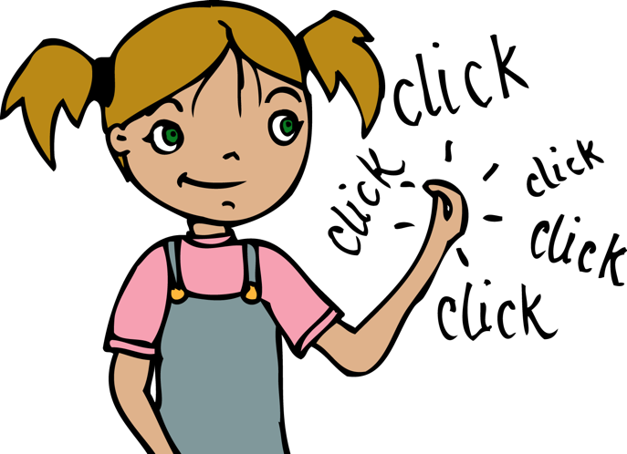
- Repeat the songs throughout the week by saying “Stop everything and Sing!” You might use these musical moments to sing the call and response song ‘Hill ‘n’ Gully Rider’. Either the children can sing the response to the backing track call or the teacher can sing the call, or you could divide the class in half with half singing the call and half the response. The same can be done with ‘John Kanaka’.
Adding body percussion and movement. Traditional songs like these have changed over the years through the oral tradition of passing things down and there is no right or wrong way of adding movements. Often these movements are not ever written down! The class might like to create their own ideas for movements in the playground and bring them back to show the class.
‘Liza Jane’-Stick Passing Game
Everyone sits in a circle with 2 claves each. This recording shows friends improvising and singing this traditional American song: https://www.youtube.com/watch?v=9P_ZVQCA5lI

‘I know a girl that you don’t know…’
- One clave in the RH is passed to the front of the person on the right (I know a / Way down)
- The clave that has been placed in front of you is picked up. (girl that / south in)
- Repeat the above. (you don’t know / Baltimore)
- “L’il Liza Jane”, the sticks are tapped to the rhythm of the words. Practise with the claves and speaking the words a little slower.

‘O Eliza….’
- Click the claves together above head twice. (Oh E)
- Tap floor twice with the claves (-liza)
- “L’il Liza Jane”, the sticks are tapped to the rhythm of the words
- Repeat above

‘John Kanaka’: (Sea Shanty)
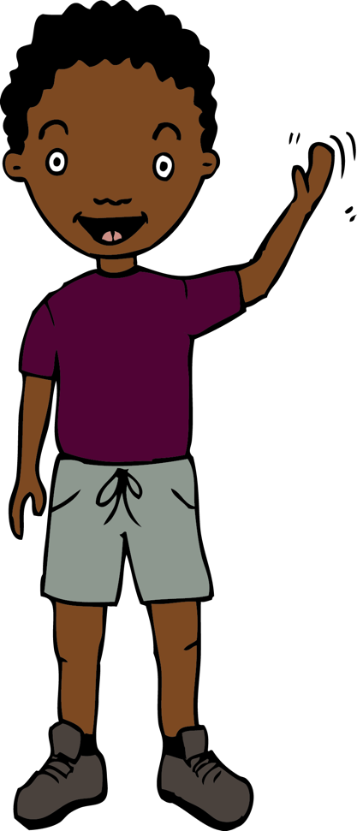
This is a halyard shanty sung by the sailors as they pulled on heavy ropes to haul the sails. An example of a traditional performance https://www.youtube.com/watch?v=TWDuDosFZ_A
Sing: ‘I heard, I heard the old man say’ (no actions)
- John: stamp right foot
- Kanakanaka: slap knees in rhythm
- tuli: clap hands twice
- a clap the two hands of your partner

- Sing: ‘Today, today’s a holiday’ (no actions)
- John stamp right foot
- Kanakanaka slap knees in rhythm
- Tuli clap hands twice
- a clap the two hands of your partner

- tuli clap hands twice (repeat)
- a clap the hands of your partner
- tuli clap hands twice (repeat)
- a clap the hands of your partner

- John : stamp right foot
- Kanakanaka slap knees in rhythm
- Tuli clap hands twice
- a clap the two hands of your partner

Example of other actions you could use https://www.youtube.com/watch?v=Ku3AZHamvhE

Body Percussion for John Kanaka: Ask the children to sing the word ‘John’ in their ‘thinking voices’ whilst still doing the body percussion action. With each new verse, put more words into the thinking voice until the whole song is being ‘sung’ in the thinking voice. The actions are still being performed, creating a wonderful percussive sound.
‘Hi Lo Chickalo’ Children stand opposite partner with RH back to back with partner (see resource).
You can also view these examples https://www.youtube.com/watch?v=YCJzB1ne8s0 to get ideas of how to create your own clapping ideas.

- Hi lo Children clap LH together ‘high’, children clap LH together ‘low’
- Chick – a – lo (x3) Children clap their own hand to Chick-a and clap LH to partner LH ‘low’ (x3)
- Hi lo Children clap LH together ‘high’, children clap LH together ‘low’
- Chick – a – lo (x2) Children clap their own hand to Chick-a and clap LH to partner LH ‘low’ (x2)
- Hi Children clap LH together ‘high’

For the lo hi verse reverse actions, clapping low first.

‘Hill ‘n’ Gully Rider’
Listen to this traditional version https://www.youtube.com/watch?v=OZBd8vIq3_8 Listen our for the call and response and the improvising instruments.
- Divide the class into three groups: one group chant the call, the second group march to the pulse, the final group will clap the response rhythm to ‘hill an’ gully’. Do this four times and then play ‘switch’, so each group moves around. Can the class do this without being reminded what they need to do next?
- ‘Hill ‘n’ Gully’ is a Jamaican call and response work song that used to be sung by workmen constructing new roads. It refers to the uneven land (hill and gully) through which the roads were built.
- Can a soloist or small group sing the ‘call’ with the rest singing the response?
Opportunities for greater depth:
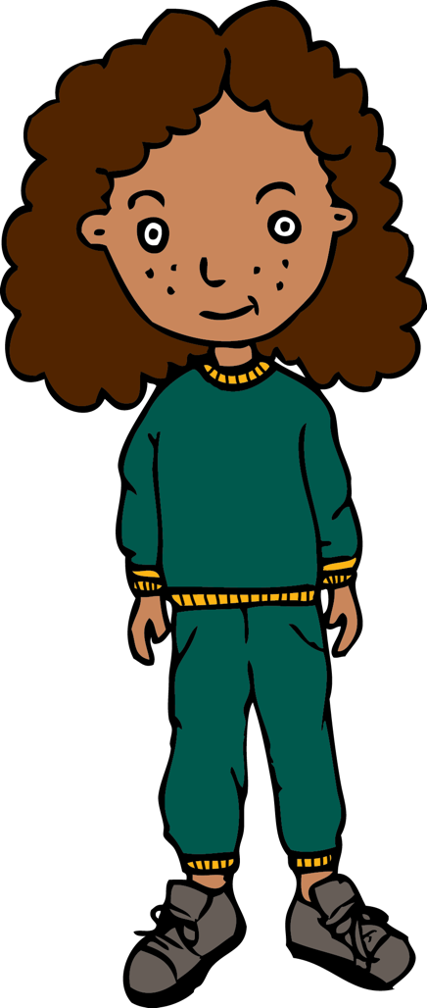
- Ask a child to lead or conduct a song.
- Use some of the word patterns as ostinati by repeating simple phrases over and over in a vocally percussive way for example L’il Liza Jane / tulia / chickalo chickalo / hill ‘n’ gully.
- Change the words to personalise the song to your class:
(insert another child’s name) or name of class, e.g. “I heard, I heard, Benjamin say, When will we be going out to play?” etc.
- You can replace words, e.g. “the old man” for a character from a book or story and this will allow you to explore vocal sounds, accents, language and to develop expression through dynamics as well e.g. “I heard, I heard the BFG / Gruffalo / fairy / witch / spaceman say” etc.
- The second phrase, ‘John Kanakanaka, tuli - a’ can be changed to new lyrics or phonic sounds to fit the same rhythm e.g. La, ta, ee, oo etc. Have fun combining these to make a new phrase.

Plenary:
Use the plenary as an opportunity to draw together musical learning in the lesson.
- What do the songs have in common? (all have a repeated phrase, all traditional songs)
- Which have repeated rhythms? (‘L’il Liza Jane’ and ‘Hill ‘n’ Gully’ have the same repeated rhythm).
- Which songs are work songs? (‘Hill ‘n’ Gully’ and ‘John Kanaka’ are work songs
- What is the musical word for building up the layers of sound by singing 2/3 or 4 sounds together? (texture)
Keywords / vocabulary: Texture, duration – rhythm, pulse, pitch - up/down, repeat, rest, structure, call and response, traditional, sea shanty, folk song, work song, playground song, ostinato, body percussion, warm up, unison.
Self-assessment opportunities:
- I can sing a song in unison whilst using actions.
- I can maintain a part when two or more songs are sung together.
- I know where the songs originate from.
- I can describe how several songs when sung together can create different textures.
- I can explain why traditional songs are special.
- I can identify different inter-related dimensions.
Resources:
Audio recording of all 4 Pentatonic Partner songs and one recording with the four songs sung together, plus sheet music and Power point with lyrics for the songs.
Rehearsal / Performance tracks for each song.
Claves, Sing Up, Ppt poster of inter related dimensions.
Opportunities for sharing work e.g. by recording, notation: Video or record the performance using an iPad, perform informally in the playground.

Music Assessment: Year 4 Lesson 1 and 2

You only need to note the names of children who are working towards or well above the criteria for the lesson. It will be assumed the majority of the class will achieve the objectives and you don’t need to record this. Use the space below for any specific notes on achievement or evaluation of class progress.

Names of any children who are working towards | ‘I can’ assessment criteria | Names of any children who are working at greater depth
- I can sing a song in unison whilst using actions
- I can maintain a part when two or more songs are sung together
- I know where the songs originate from
- I can describe how several songs when sung together can create different textures.
- I can explain why traditional songs are special
- I can identify different inter related dimensions

Notes:

