Music Lesson Plan topic – Pitch

Lesson 6 of 6 Focus: Year 2
The focus of this whole Unit is Heritage and the power of traditional song. Traditional music can help people understand a culture better. It represents the history, traditions and thoughts of a community. We would like to collect songs from all over the Bristol from many cultures to create a bank of Songs of our City. Over the unit we would love schools to encourage individual children to ‘sing a special song’ to their class. Maybe one that is sung a lot at home, maybe a lullaby, maybe one they know from grandparents. The song can be in any language but the emphasis is a traditional song – one that has been passed down through generations. At the end of the Unit it would be amazing if you could choose one or two songs from your class and record an individual singing as an MP3 file and send them with the title of the song if known, words (and phonetic pronunciation if needed), as well as the meaning if not in English to kirsten.cunningham@bristolbeacon.org. These may be used in future Bristol Music lesson plans and if we get enough will be made into a song book. No recordings of individual children and no names will be used so there are no GDPR concerns.
Key Learning Objective:
- To sing with increasing confidence and control as an individual and in a group.
- To identify a mood and sing with expression.
- To understand the significance of folk songs and oral tradition.
Inter-related music dimensions covered: Tempo, Duration, Structure (verse/chorus/round/call and response/nursery rhyme), Texture.
As you cover the different dimensions refer to them on the poster (see resource) and tick them off. You might like to laminate each of the different images and display on the board as you cover them.
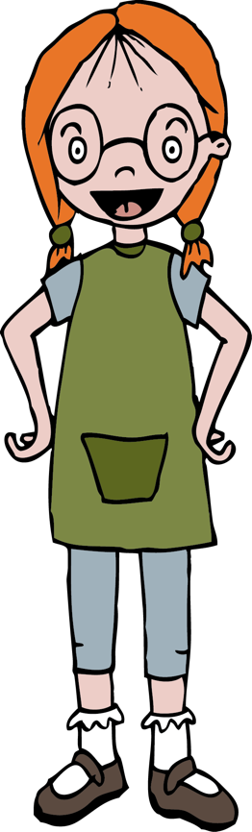
Starter activity:
Warm up voices ‘Boom chicka boom’ (See Sing Up)
Leader: Say "Boom Chicka Boom" Echo: Say "Boom Chicka Boom"
Leader: Say "Boom Chicka Boom" Echo: Say "Boom Chicka Boom"
Leader: Say "Boom Chicka Rocka Chicka Rocka Chicka Boom" Echo: Say "Boom Chicka Rocka Chicka Rocka Chicka Boom"
Leader: "Ah ha!" Echo: "Ah ha!"
Leader: "Ee hee!" Echo: "Eh hee!"
Leader: "One more time" Echo: "One more time"
At this point, the teacher should change a dimension of the music. For example the leader could change pitch (make the chant high-squeaky voice or low-deep voice), tempo (make the chant fast or slow), timbre (make the chant croaky, hold your nose, or smooth-posh voice) dynamics (whispered or shouted). The children should identify what change was made and relate this to one of the inter-related dimensions of music. Children can make up others. To end the song the words "One more time" could be replaced with "That's all".

Main focus:
Ask the children which songs they have sung over the unit that have come from an oral tradition.
- Jump Jim Joe.
- Rattlin’ bog.
- Leave her Johnny.
- Row Row the boat.
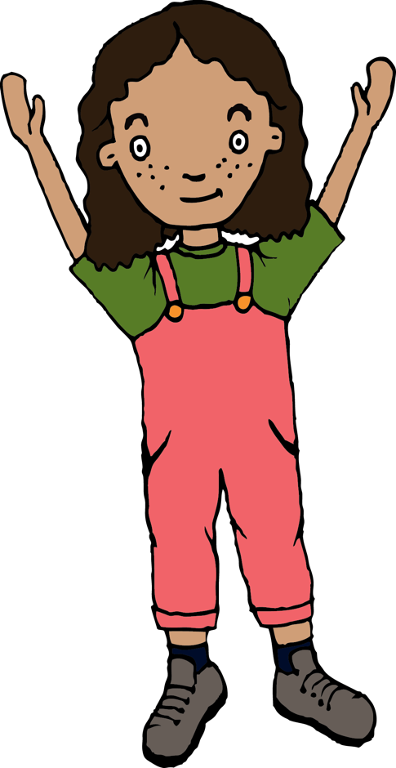
Discuss what make traditional songs special. Traditional music can help people understand a culture better. It represents the history, traditions and thoughts of a community. Revisit and sing each song and for each song discuss who might sing it and why. Where might each song be sing? Which songs are happy? Which songs are sad? Why?

As the children listen to 30 seconds / 1 minute of the songs below can draw a face that they think best represents the mood of the song and write 5 words that captures the feeling of the music.
- Wild Mountain Thyme sung by the folk singer Kate Rusby https://www.youtube.com/watch?v=zFgAJ4cDKQY Do the children think this is sad? What is thyme? What is heather? Where might this song be about? How do you think Kate learnt it?
- Hey Sokoly: Polish Folk song about someone special going away. https://www.youtube.com/watch?v=jhmEnOoubnU
- Sakura: a Japanese folk song welcoming the cherry blossom.https://www.youtube.com/watch?v=jqpFjsMtCb0

Plenary:
If children from the class have offered to sing a traditional song from their home, record this as part of the lesson and send in to Bristol Beacon.

Keywords / vocabulary: Unison, round, sea shanty, call and response, verse, chorus, folk song, traditional.
Self-assessment opportunities:
- To sing with increasing confidence and control as an individual and in a group.
- To identify a mood and sing with expression.
- To understand the significance of folk songs and oral tradition.
Resources: Recordings and lyrics from previous lessons.

Opportunities for sharing work e.g. by recording.

Music Assessment: Year 2 Lesson 6

You only need to note the names of children who are working towards or well above the criteria for the lesson. It will be assumed the majority of the class will achieve the objectives and you don’t need to record this. Use the space below for any specific notes on achievement or evaluation of class progress.

Names of any children who are working towards: | ‘I can’ assessment criteria | Names of any children who are working at greater depth:
- To sing with increasing confidence and control as an individual and in a group
- To identify a mood and sing with expression
- To understand the significance of folk songs and oral tradition I can recognise the inter-related dimensions within the music.

Notes:

