Music Lesson Plan topic – Pitch

Lesson 5 of 6 Focus: Year 2
The focus of this whole Unit is Heritage and the power of traditional song. Traditional music can help people understand a culture better. It represents the history, traditions and thoughts of a community. We would like to collect songs from all over the Bristol from many cultures to create a bank of Songs of our City. Over the unit we would love schools to encourage individual children to ‘sing a special song’ to their class. Maybe one that is sung a lot at home, maybe a lullaby, maybe one they know from grandparents. The song can be in any language but the emphasis is a traditional song – one that has been passed down through generations. At the end of the Unit it would be amazing if you could choose one or two songs from your class and record an individual singing as an MP3 file and send them with the title of the song if known, words (and phonetic pronunciation if needed), as well as the meaning if not in English to kirsten.cunningham@bristolbeacon.org. These may be used in future Bristol Music lesson plans and if we get enough will be made into a song book. No recordings of individual children and no names will be used so there are no GDPR concerns.
Key Learning Objectives:
- To sing with increasing confidence and control as an individual and in a group.
- To maintain a part in a round.
- To identify a mood and sing with expression.
- To identify the structure of two songs (round / call and response).
Inter-related music dimensions covered: Tempo, Duration, Structure (verse/chorus/round), Texture
As you cover the different dimensions refer to them on the poster (see resource) and tick them off. You might like to laminate each of the different images and display on the board as you cover them.
Starter activity:
Sing or listen to the ‘Sail the boat’ melody – Do the children recognise it? Who have they heard singing it before? This melody is from the well-known nursery rhyme Row, row the boat – again a traditional song that is passed down through generations by oral tradition. Ask the children in pairs to imagine they are hauling the ropes in time to the pulse. Discuss how it was important for sailors on boats to work together and to stay in time and that music helped them to do this. Sing the song as a round in 2, 3 or 4 parts. Build the song up in layers will create a thicker texture.
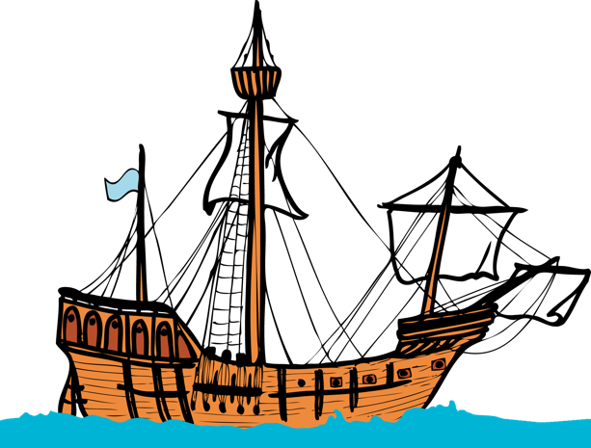
Use the words:
Sail, sail, sail our boat,
Sail it on the sea.
Climb up the rigging and haul up the sail.
A sailor’s life for me.

Main focus:
Bristol was for many years a significant port alongside London and Liverpool. Many boats would transport goods from England to other parts of the world and would bring back things like sugar, spices, tea, textiles, brandy and wine. As they travelled the sailors would sing sea shanties, which would help them with tasks on board such as winding the capstan, hauling ropes. They would form a tight knit community learning songs by ear (oral tradition).

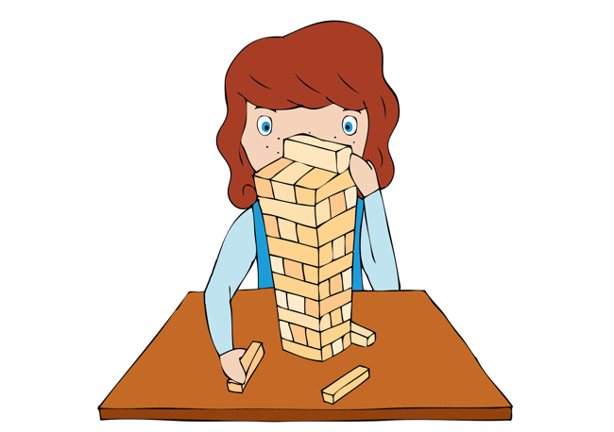
Listen to ‘Leave her Johnny’.
https://www.youtube.com/watch?v=4fVQwzv5Qfc
Is the song sad / happy? What might it be about? (The sailors are sad that they are leaving their ship and therefore all their friends, they even that the rats are leaving too!) What tempo is the music? (slow and steady to haul the ropes in time) Can the children hear the structure – call and response? https://www.youtube.com/watch?v=4fVQwzv5Qfc

This is a capstan shanty (the capstan was used to turn and bring up the anchor). It is a call and response structure – can the children hear the response? “Leave her Johnny, Leave her”.
Listen for the chorus, can the children identify where this occurs?

Look carefully at the language and discuss the meaning of the words in each verse. To begin with rather than singing all of the words, ask the children to just sing the response.

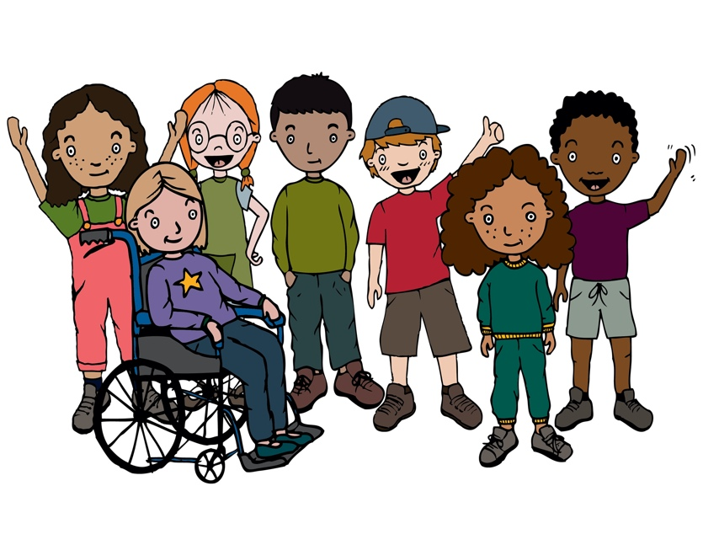
Having listened to the lyrics of the song, the children should use a storyboard with three boxes within which they can draw three frames that tell the sailors’ story.

Plenary:
The children should join in singing with the response and the chorus, as if they were the whole group of sailors. Which words are accented? “Leave” - this is emphasised be being on the strong beat whilst “Done” conveys the feeling of sadness.

Greater depth:
Are there any children, or a small group of children confident to sing the call whilst the class sings the response and chorus?

Keywords / vocabulary: Unison, round, sea shanty, call and response, tempo, duration (pulse), structure, texture, capstan, starboard, bosun (ships officer in charge of crew), mood, lyrics, expression.

Self-assessment opportunities:
- I can sing with increasing confidence and control as an individual and in a group.
- I can maintain a part in a round.
- I can identify a mood and sing with expression.
- I can identify the structure of two songs (round / call and response).
- I can recognise the inter-related dimensions within the music.
Resources: Recording, ppt of lyrics.
Opportunities for sharing work e.g. by recording, notation: video children hauling in time / singing as a round / taking part in the shanty.

Music Assessment: Year 2 Lesson 5
You only need to note the names of children who are working towards or well above the criteria for the lesson. It will be assumed the majority of the class will achieve the objectives and you don’t need to record this. Use the space below for any specific notes on achievement or evaluation of class progress.

Names of any children who are working towards | ‘I can’ assessment criteria | Names of any children who are working at greater depth
- I can sing with increasing confidence and control as an individual and in a group.
- I can maintain a part in a round.
- I can identify a mood and sing with expression.
- I can identify the structure of two songs (round / call and response).
- I can recognise the inter-related dimensions within the music.

Notes:

