Music Lesson Plan topic – Pitch

Lesson 3 and 4 Focus: Year 2
Key Learning Objectives:
- To sing a traditional Irish song and identify traditional Irish instruments.
- To convey the mood or meaning of a song.
- To sing with accuracy of pitch.
Inter-related music dimensions covered: Pitch, Tempo, Structure, Timbre
As you cover the different dimensions refer to them on the poster (see resource) and tick them off. You might like to laminate each of the different images and display on the board as you cover them.
Starter activity:
‘Bogapilla’ (Sing Up) use video to lead class first time, then class teacher can lead. Also ‘Rubber Chicken’ again Sing Up (watch the video with the children the first time)

Main focus:
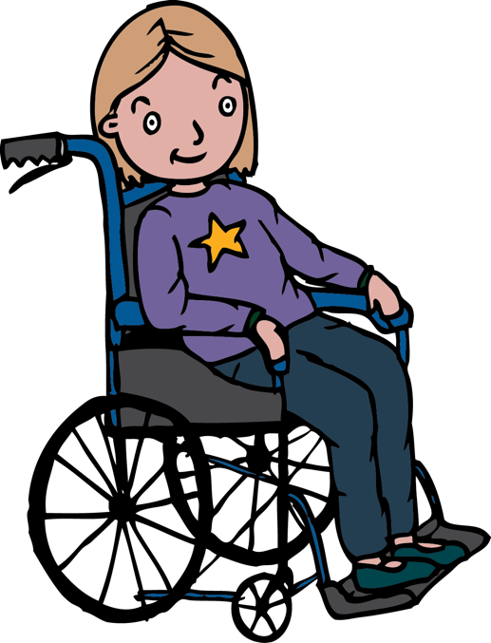
We know that there are many examples of Irish ancestry here in Bristol and still today there is evidence of Irish connections e.g. street names such as ‘Dublin Crescent’ and ‘Antrim Road’. Can you find these on Google Earth? Begin by listening to the Irish Rovers’ version of ‘The Rattlin’ Bog’. https://www.youtube.com/watch?v=aLHuu3Ygvns.

Listen to the traditional Irish instruments and the style in which the song has been sung. Can the children identify any of the instruments? e.g. accordian, guitar and banjo – all have different timbres. Ask the children to join in with the clapping on the recording by clapping and keeping the pulse. What do they notice about the tempo (speed) of the music? (it is fast) What is the song all about?
What is a ‘bog’? (A bog is a wetland of soft, spongy ground consisting mainly of partially decayed plant matter called peat).
Now look at the lyrics whilst listening to with the music. https://www.youtube.com/watch?v=M7oH5NdOjnI.

‘The Ratlin’ bog’ is a cumulative song. In each verse another word and phrase is added on, meaning you have to combine the sentences from the previous verse so the song becomes longer and longer. See the PowerPoint with all of the lyrics.

Teach the children the chorus. What is the difference between the first line/phrase and the second line/phrase? (Answer: second phrase drops down and finishes on a lower note).
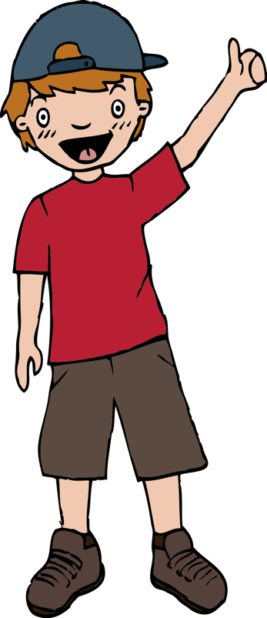
Repeat the chorus until the children are really familiar with it. You could divide the class into 2 long lines and one line could sing the first line and the other line the second. Or sing one line stood up / one crouched down, one facing one way one facing the other. This emphasises what a phrase is. You could use ‘phrase rainbows’ – using your hand to draw an arch in the sky for each phrase.

You can play with the tempo of the music. Begin slowly but gradually accelerate (accelerando). Can the children achieve the change of tempo? Sing along with the track that gradually accelerates.

Introduce the verses. One way of teaching the song is to draw a tree and to add more and more pictures as the song progresses. This is a kind of graphic score as you are using pictures to help internalise the structure of the song.

Plenary:
Watch this video of an American children’s choir singing the same song. You could either choose to use the same actions or make up your own: https://www.youtube.com/watch?v=T1fM2yKgI7o
What is different about the accompaniment? (It is only piano and not the folk instruments?) What is different about the singing? (It is in parts and there is a higher descant).

Keywords / vocabulary: Pitch, tempo, structure, timbre, duration, heritage, accompaniment acapella,
folk (traditional) instruments accordion, banjo, guitar, tambourine, cumulative, graphic score, chorus, verse, lyrics.
Self-assessment opportunities:
- I can sing and remember the structure of the song .
- I can identify traditional Irish instruments.
- I can convey the mood or meaning of a song.
- I can sing with accuracy of pitch.
- I can identify different inter-related dimensions.
Resources: Powerpoint of song words, pictures of instruments, Ppt poster of inter related dimensions, pictures of prompts for song tree.

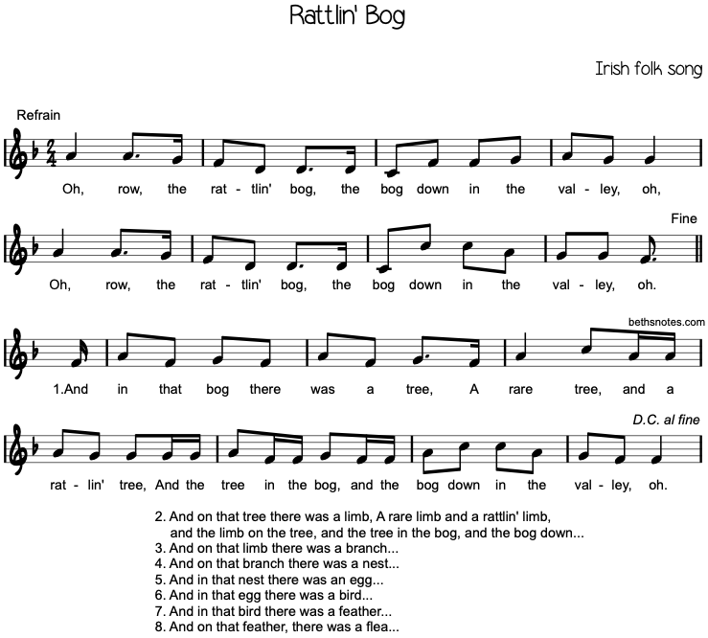

Music Assessment: Year 2 Lesson 3 and 4
You only need to note the names of children who are working towards or well above the criteria for the lesson. It will be assumed the majority of the class will achieve the objectives and you don’t need to record this. Use the space below for any specific notes on achievement or evaluation of class progress.

Names of any children who are working towards | ‘I can’ assessment criteria | Names of any children who are working at greater depth
- I can sing and remember the structure of the song

- I can identify traditional Irish instruments

- I can convey the mood or meaning of a song

- I can sing with accuracy of pitch

- I can identify different inter-related dimensions

Notes:

