Music Lesson Plan topic – Calypso

Lesson 6 of 6 Focus: Reception
Early Learning Goal:
- To create a performance we can share.
Inter-related music dimensions covered: Duration, texture, dynamics.

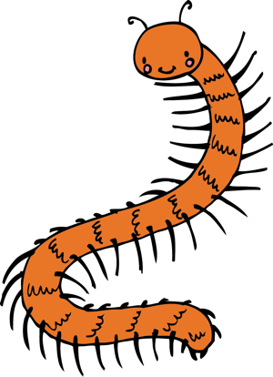
Starter activity:
Put on the creepy crawly masks made by the class and find a mirror / reflection to look in. Everybody have a go at moving like their insect to the ‘Creepy Crawly Calypso’. Use words like scuttle, creep, march, flap, wriggle, prance etc.

Main focus:

- Wearing their own mask rehearse and perform the song ‘Mini-beast calypso’– clapping on the word calypso. The word calypso is syncopated. This is a special rhythm often found in calypso music. Encourage the dynamic volume to be loud - because carnival is a loud celebration and often people wear masks during carnival.

- Perform the texture piece in three lines from Lesson 5 using the rhythm backing track https://www.youtube.com/watch?v=_0CaO_9FMtk and ‘Creepy Crawly score’.
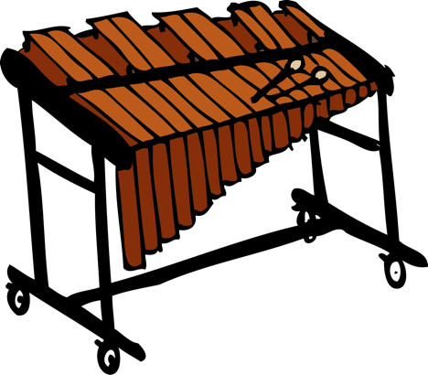
- Give out the instruments as in Lesson 4 and perform the ‘Instrument Calypso’, where children play their instruments to the rhythm of each line in the verse that names their instrument. Everyone sing wearing their masks. If possible create a Carnival parade in a line, like a centipede – marching around the hall or the school/playground singing and playing as if at a Carnival celebration. Encourage the children to join in with confidence and a smile!

Plenary:
Record this on an iPad and watch it back. If your school invites parents in occasionally at the end of a term - this would be a great thing to show them. Watch the ‘Creepy Crawly Calypso’ one last time: (5) Creepy Crawly Calypso | Barefoot Books Singalong - YouTube.
Ask the children how it makes them feel.
Watch the film of St Paul’s Carnival: https://www.bbc.co.uk/news/av/uk-england-bristol-44756869/st-pauls-carnival-celebrates-caribbean-culture-in-bristol.
Ask the children how they think people who are watching or joining in with the carnival in St Paul’s feel.
Self-assessment opportunities:
- I can create a performance and share with an audience.
Resources: Classroom percussion: drums, maracas, claves, tambourines, woodblocks plus beaters, shaky eggs, bells. Powerpoint and pictures of ants, beetles and butterflies, masks, backing tracks.
Opportunities for sharing work e.g. by recording, notation: Recording of performance.

Music Assessment: Reception Lesson 6
You only need to note the names of children who are working towards or well above the criteria for the lesson. It will be assumed the majority of the class will achieve the objectives and you don’t need to record this. Use the space below for any specific notes on achievement or evaluation of class progress.

Names of any children who are working towards | ‘I can’ assessment criteria | Names of any children who are working at greater depth
 | - I can create a performance and share with an audience
Notes:

