Music Lesson Plan topic – Calypso

Lesson 4 of 6 Focus: Reception
Early Learning Goals:
- To identify different un-tuned percussion instruments by their sounds.
- To be able to name a selection of un-tuned percussion instruments and be able to play them in an appropriate way.
Inter-related music dimensions covered: Timbre.
Starter activity:
Watch the ‘Creepy Crawly Calypso’ (5) Creepy Crawly Calypso | Barefoot Books Singalong - YouTube.
Can the children remember the different instruments used in each of the verses? Can the children follow an adult or leader who is doing actions to the pulse? Can they remember what a pulse is? (the steady beat of the music).

Main focus:
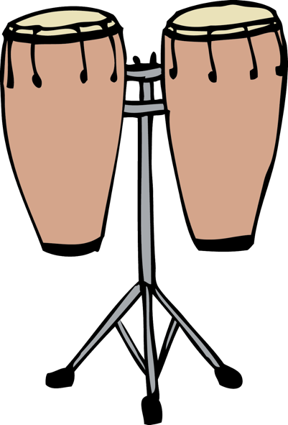
The children should sit in a circle on the floor. Place a collection of 7 instruments in the centre of the circle (you will need one maracas, one set of claves, tambourine, woodblock plus beater, shaky egg, bells).
Play the first verse of ‘Instrument Calypso’ and choose one child to collect the instrument they hear in that verse. As the children listen to the song, one child is asked in each verse to go and collect the instrument from that verse.
At the end of the song seven instruments should have been chosen. Ask each of the seven children to play their instrument one at a time. Can the class identify how each instrument has its own special sound (timbre)? Ask all the children except those with instruments to close their eyes. The teacher selects one child with an instrument to play. Can the class guess which one it was from the sound made? What clues could they use? Was the sound wooden / bell like / short / long / loud / soft?
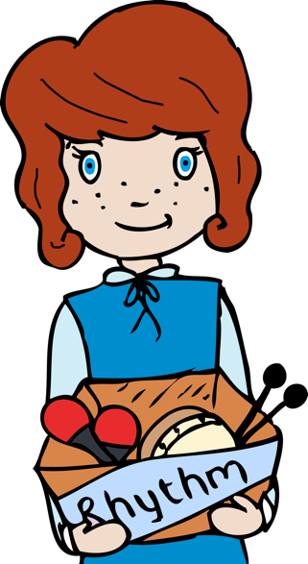

Now give each child in the class one of the above instruments. Using the original instrument collectors as leaders listen to the song again but this time each group play the pulse just in their verse. Can the class do this even when they are not sat next to a child holding the same instrument as them?

Plenary:
Ask the children to all shut their eyes. Teacher: play the rhythm of the first line of any verse on one instrument. The children who have this same instrument should echo the line. Using a blindfold have a group of instruments available to pairs of children to explore sounds with one playing and one listening during the week.
Keywords / vocabulary: Calypso, carnival, timbre, tone colour, duration, rhythm, drums, maracas, claves, tambourines, woodblocks plus beaters, shaky eggs, bells.
Self-assessment opportunities:
- I can identify different non tuned percussion instruments by their sound.
- I can name a selection of un-tuned percussion instruments and be able to play them in an appropriate way.
Resources: Selection of classroom percussion drums, maracas, claves, tambourines, woodblocks plus beaters, shaky eggs, bells.
Opportunities for sharing work e.g. by recording, notation: N/A

Music Assessment: Reception Lesson 4

You only need to note the names of children who are working towards or well above the criteria for the lesson. It will be assumed the majority of the class will achieve the objectives and you don’t need to record this. Use the space below for any specific notes on achievement or evaluation of class progress.

Names of any children who are working towards | ‘I can’ assessment criteria | Names of any children who are working at greater depth
- I can identify different non tuned percussion instruments by their sound.

- I can name a selection of un-tuned percussion instruments and be able to play them in an appropriate way.
Notes:

