Music Lesson Plan topic – Calypso
Lesson 2 of 6 Focus: Reception
Early Learning Goals:
- To feel rhythm and respond with movement.
- To sing as part of a group.
Inter-related music dimensions covered: Duration (listening and following rhythms).
Starter activity:
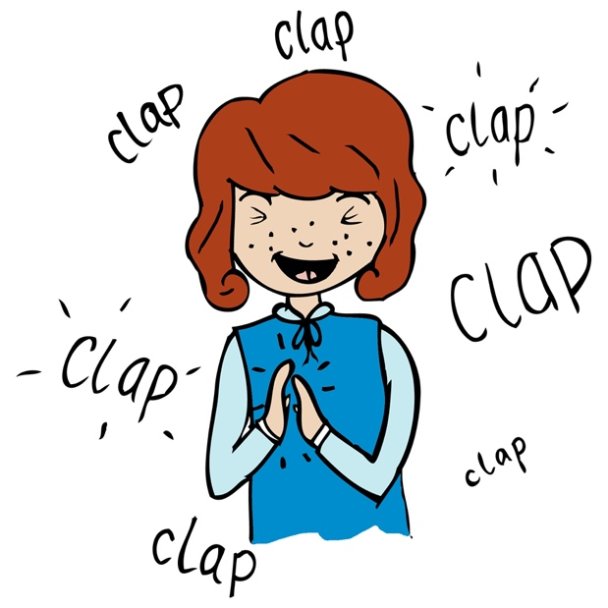
Watch the YouTube clip of Creepy Crawly Calypso.
(5) Creepy Crawly Calypso | Barefoot Books Singalong - YouTube.
Ask the children if they can remember what sort of music this is? (Calypso).
Listen to ‘Calypso With Me’. Can the children remember moving their shoulders to the repeated words Calypso? Look at the pictures of the Creepy Crawlies, can the children remember what they are? Then sing the song with dancing shoulders. Can the children now suggest some actions to represent each creepy crawlies? Sing the song again, this time with the actions.

Main focus:
Learn ‘Calypso with me’ song using the rehearsal tracks (where every verse is repeated). This version explores different movements.
Verse 1 - stand on the spot moving shoulders.
Verse 2 – follow the movement of the teacher step and tap from side to side.
Verse 3 – move shoulders as before on the word Calypso.
Verse 4 – clap hands to the pulse.
Verse 5 - tap feet to the pulse.
Verse 6 - children dance freely.

Ask the children to think about their singing voices. Can they miss out the actions and just sing the song with the recording? Can they all join in as part of the group?
Now instead of singing, can the children spot where the word calypso is repeated and can they clap instead to show the rhythm of the word? Play the recording so that the can children join in by clapping the rhythm of the word ‘calypso’ every time it occurs. This activity could be available so children could play the music and choose to develop their own movement ideas over the week.

Plenary:
Can the children spot on the map where Calypso music originates from? (the West Indies/Caribbean). In our country we can share in and celebrate the music from all over the world. Show the clip from last week. Can children remember where it was filmed? https://www.bbc.co.uk/news/av/uk-england-bristol-44756869/st-pauls-carnival-celebrates-caribbean-culture-in-bristol. Ask if any of the children have been to the St Paul’s Carnival? Look at some of the pictures from the Carnival at the bottom of this page Carnival 2019 — St Paul's Carnival. Click on each photo and scroll through. Look at the amazing smiles, costumes and colours.
Keywords / vocabulary: Calypso, carnival, rhythm, syncopated swinging rhythms, Trinidad and Tobago.
Self-assessment opportunities:
- I can feel rhythm and respond with movement.
- I can sing as part of a group.

Resources: Songs and backing tracks, Creepy crawly images, Clips from internet, Power point with map.
Opportunities for sharing work e.g. by recording, notation: Take a clip to share on Tapestry or similar with parents and carer.

Music Assessment: Reception Lesson 2

You only need to note the names of children who are working towards or well above the criteria for the lesson. It will be assumed the majority of the class will achieve the objectives and you don’t need to record this. Use the space below for any specific notes on achievement or evaluation of class progress.

Names of any children who are working towards | ‘I can’ assessment criteria | Names of any children who are working at greater depth
- I can feel rhythm and respond with movement

- I can sing as part of a group

Notes:

