Music Lesson Plan topic – Calypso

Lesson 5 of 6 Focus: Reception
Early Learning Goals:
- To understand that 'texture' is the layering of sounds.
- To follow pictorial notation.
Inter-related music dimensions covered: Texture, Structure.
Starter activity:
This lesson will work best in the hall.
Watch the ‘Creepy Crawly Calypso’ (5) Creepy Crawly Calypso | Barefoot Books Singalong - YouTube.
As it is playing the children should follow the teacher who should use different body percussion actions to the pulse. The children should copy the actions moving in time with the pulse. The teacher should change the action after every 8 beats. At the end, ask the children if they were keeping the pulse or playing the rhythm of the words. They were keeping the pulse (the regular beat). Clap the rhythm of the word ‘calypso’ (ca-lyp-so short long short) to show the difference between rhythm and the pulse.

Main focus:
Ask the children to stand in a space and march, saying 1,2,3,4 as they do so. You might like to march to this rhythm backing https://www.youtube.com/watch?v=_0CaO_9FMtk.

Add in 'ants' on beat. 1. Ask children to clap as they say 'ants'. Keep saying “Ants 2,3,4”.
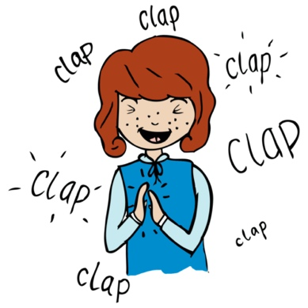
Next, teach ‘beetles beating drums’. Ask children to listen and repeat “beetles beating drums” (quick, quick quick, quick slow). Next, clap and say the phrase at the same time.
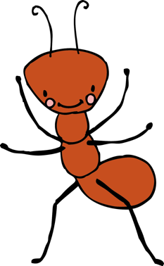
Split the class in two, in two long lines - half ants and half beetles. Ants, should chant “Ants 2,3,4” clapping on beat 1 and march on the spot whilst the beetles, chant “beetles beating drums” and slap this rhythm on their thighs. Use the backing to keep a basic pulse. Select one child to be a conductor whose job it is to indicate when each line should start and stop. Sometimes both lines will be playing together thus altering the texture. Discuss how a child is going to signal start / stop.

Now the texture has 2 layers. To add a third layer to the texture ask the class to whisper “butterflies”. It might help to tip toe their fingers on their hand in time. Divide the class in three. Line one stands and they are the ants. Line two kneel up in front and become beetles. Ask line three to sit on the floor at the very front as butterflies. Using a standing whiteboard and a picture of each beetle, butterfly and ant a child can place the pictures in layers on the whiteboard (or take them off) to indicate which rows should be playing at any time. The song will sometimes have 3 layers sometime one and sometimes two. Sometimes the texture will be thin and sometimes thicker. It will sound different if for example the ants and butterflies are chanting as opposed to the ants and beetles.

Plenary:
Perform the score on the Power Point resource. The children will follow the pictures chanting as if they are reading a piece of music. To begin with only the ants chant ,then the beetles join in etc. Children can use small laminated pictures of the animals to create their own score and then try performing it.
Keywords / vocabulary: Texture, rhythm, conductor, score.
Self-assessment opportunities:
- I can understand that 'texture' is the layering of sounds.
- I can follow pictures to tell me when to join in.
- I can understand that 'texture' is the layering of sounds.
- I can follow pictures to tell me when to join in.
Resources: YouTube backing track, Power point, laminated picture of an ant, beetle and butterfly printed from the Power point.

Opportunities for sharing work e.g. by recording, notation: Take a photo of the children in lines to remind them what texture is.

Music Assessment: Reception Lesson 5

You only need to note the names of children who are working towards or well above the criteria for the lesson. It will be assumed the majority of the class will achieve the objectives and you don’t need to record this. Use the space below for any specific notes on achievement or evaluation of class progress.

Names of any children who are working towards | ‘I can’ assessment criteria | Names of any children who are working at greater depth
- I can understand that 'texture' is the layering of sounds

- I can follow pictures to tell me when to join in

Notes:

