Music Lesson Plan topic – Chronology through Shakespeare

Lesson 6 of 6 Focus: Year 5 and 6
Key Learning Objectives:
- To make predictions about how a song will sound based on the lyrics.
- To add in percussion or sound effects appropriate to the mood of a song.
- To sing and perform a song with accurate intonation.

Inter-related music dimensions covered: Timbre, dynamics.
Starter activity:
Explain that today we’re going to be looking at Shakespeare’s most notorious play – ‘Macbeth’ –show children summary video: https://www.youtube.com/watch?v=RCsQ21ySfvA.
Why do you think the composer of the music for this piece decided to use the electronic/hip hop style to tell this story?

Main focus:
Introduce children to Horfield School/Claire Alsop’s piece ‘Macbeth’. Explain that someone who lives and works locally wrote this piece of music together with children from Year 4 and 5. Show children the Shakespeare text first – these are Shakespeare’s actual words from the Witches’ spell in the play. What do you think the music for this will sound like? Will it be a happy (major) or sad/spooky (minor) tune? Discuss the children’s ideas.

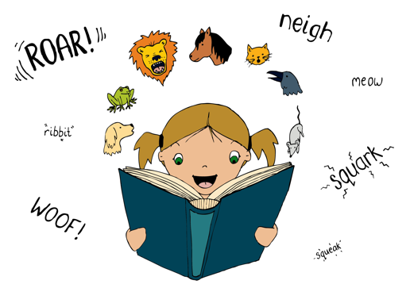
Listen to the song.

Teach the children the songs using my turn/your turn style paying particular attention to the dynamics and the rhythm of the lyrics. Encourage children to make sure their delivery, articulation and pronunciation of the lyric is clear and they focus of good intonation (tuning) as this adds to the spooky feel of the piece. How can they vary their dynamic to improve the effectiveness?

Once the children are secure in singing the song depending on what resources you have in your class add in percussion or spooky sound effects to the song – children can notate this either straight onto the sheet music if they feel comfortable with that or by annotating their lyrics adding in particular symbols or cues when they need to play or use a sound effect. The children could design instruments to make wind sounds for the beginning and end of the piece.

The children could then perform the song to another class or record their performance.

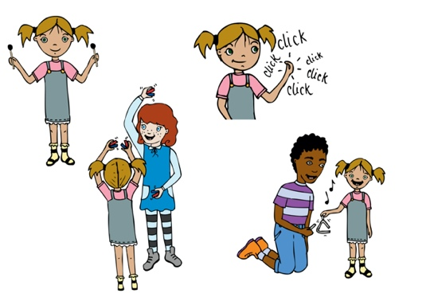
Plenary:
This piece was composed very recently, why do you think that composers and musicians are still inspired by Shakespeare’s stories today and have been for hundreds of years? Which of the stories and pieces of music you have looked at during this unit do you like best? Why? If you could compose a piece of music based on a story what story would you choose? What kind of style would you use? The children could record their ideas on the sheet resource.

Quiz for the end of the unit – Note – this could be a stand-alone lesson and does not need to be done as part of this lesson.
Using the Year 5/6 Music Quiz Powerpoint and Answer sheet – give the children the opportunity to show what they have learnt about the chronology of music during this unit. Children don’t have to do this individually the children could work in teams named after some of Shakespeare’s characters.

Opportunities for mastery: Using another Shakespeare play as inspiration compose lyrics that both include Shakespeare’s language and also add a contemporary/Bristol dimension. Use the suite of songs in the resources as a prompt / talking point.
General Chronology/Shakespeare resources for the end of the unit
- An entertaining song for the children to watch about Shakespeare from Horrible Histories : https://www.youtube.com/watch?v=65Cy4-rfd24 - lots of opportunities to discuss the different plays and what period the song itself could come from.
- A video to end a Chronology of Music unit with, Pentatonix - Evolution of Music - https://www.youtube.com/watch?v=lExW80sXsHs - Could be used just for fun or children could try counting how many pieces of music they hear, how the music changes as time goes on etc.
Keywords / vocabulary: Note – you may need to explain the meaning of some of the words in the song to the children (e.g. sulphur/fumes etc)
Major, minor, tempo, lyrics, dynamics, intonation, articulation, phrasing.

Self-assessment opportunities:
- I can make a prediction of how a piece of music will sound based on the lyrics.
- I can suggest and create sound effects that will enhance the spooky feel of a song.
- I can perform a song using accurate intonation, diction and a sense of performance.

Resources:
Video resource of the song
Lyrics sheet
Instruments/objects for sound effects
My musical story sheet (optional)
Quiz and answer sheets

Opportunities for sharing work e.g. by recording, notation:
- Annotations on sheet music/lyric sheets for percussion and sound effects for the song.
- Performance of the song could be recorded.

Year 5/6 Chronology Lesson 6
You only need to note the names of children who are working towards or well above the criteria for the lesson. It will be assumed the majority of the class will achieve the objectives and you don’t need to record this. Use the space below for any specific notes on achievement or evaluation of class progress.

Names of any children who do not meet the learning objectives for this lesson | ‘I can’ assessment criteria | Names of any children who exceed the learning objectives for this lesson.
- I can make a prediction of how a piece of music will sound based on the lyrics.

- I can suggest and create sound effects that will enhance the spooky feel of a song

- I can perform a song using accurate intonation, diction and a sense of performance

Notes:

