Music Lesson Plan topic – Chronology through Shakespeare

Lesson 5 of 6 Focus: Year 5 and 6
Key Learning Objectives:
- To identify a number of features of 20th century/modern music.
- To compare features of music from two different historical periods.

Inter-related music dimensions covered: Timbre, dynamics.
Starter activity:
Introduce the children to modern/20th century music with this Classic FM video: https://www.youtube.com/watch?v=YUDQurQ42VI.
Modern music is all about “a break from the past” and a “musical melting pot”. Unlike earlier eras in music history where composers largely conformed to a style of music in the 20th Century there were many genres and new ideas. Features include dissonance (notes or chords that might seem to clash), music that appeared to have no rules or newly created rules, chance music (aleatoric) which was dependent on just that, electronic music, minimalist music (repetition of a small idea or cell), a return to old ways.

Main focus:
Remind the children of the story of Romeo and Juliet originally written as a play by Shakespeare.
Summary here: https://www.youtube.com/watch?v=X3N73mju_Pw. Explain that this very popular story that has been told in many different ways by different people over the years. One version of this was ‘West Side Story’ composed by the American composer Leonard Bernstein (1918-1990). It took the original Shakespeare story and moved it to 1950s New York.
The song ‘Mambo’ is from the same part of the story as Prokoviev’s ‘Dance of the Knights’ in lesson 3. Listen to both pieces of music without showing the children the videos:
‘Mambo’: https://www.youtube.com/watch?v=kokbJvSEMUY
‘Dance of the Knights’: https://www.youtube.com/watch?v=MDHc40aT_AY
How are these two pieces similar and how are they different? Discuss the tempo, dynamics, instruments used and mood of the two pieces. Record the children’s thoughts on the two pieces on a flip chart or sugar paper. After the discussion show the children the two videos of the dances. Which one would they like to go to? Why? Would a party like that look like this today? What would it look like?
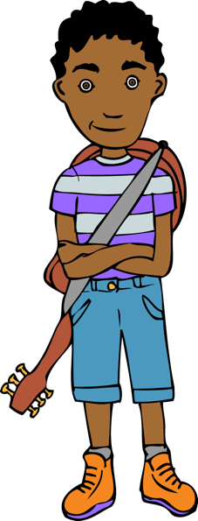
Explain to the children that they are putting together the playlist for the Capulet’s ball that would be held in the present day. Discuss what kind of music you would hear at this kind of event and what people would be doing and the mood that you would want to create. Children to then choose 4 songs for the party playlist and complete the Capulet Ball 2017/18 worksheet (resource). This could be completed individually or in pairs or small groups depending on your class.
Note: to help children who would struggle to make their own choices of song and to cut down on the possibility of inappropriate choices you could create your own spotify/youtube/itunes playlist that the children choose their favourites from. Children can then compare their choices and reasons with each other or as class.

Plenary:
Reflect back on all of the music we have listened to and discussed today, what were the main differences between them all? Was there an overarching theme throughout? Could you tell that they were all chosen for the same event in a story?

Opportunities for mastery:
Listen to other 20th century composers who were inspired by Shakespeare e.g. Vaughan Williams Full Fathom Five from The Tempest https://www.youtube.com/watch?v=r4RJoD-RMhY .
What instrumentation is used? (voices only). How has the composer used musical effects in the music? (Voices are used like bells to depict the tolling bell, voices are quiet and this is mysterious, word painting the word ‘strange’ uses dissonance in a ‘strange’, on the word ‘change’ the music ‘changes’ before settling on one chord).
Keywords / vocabulary:
Timbre, tempo, dynamics, mood, rhythm.
Self-assessment opportunities:
- I can discuss some of the key features of 20th century/modern music.
- I can use musical language to compare two pieces of music from different historical periods.
- I can suggest and discuss my own musical choices for a particular occasion.
Resources:
IWB or similar to show videos.
Opportunities for sharing work e.g. by recording, notation:
The children’s discussions will be recorded on the discussion notes from the lesson and their worksheets
If you decide to do any of the mastery activities there are opportunities to record dancing and for the children to create artwork based on the music they have been listening to

Year 5/6 Chronology Lesson 5
You only need to note the names of children who are working towards or well above the criteria for the lesson. It will be assumed the majority of the class will achieve the objectives and you don’t need to record this. Use the space below for any specific notes on achievement or evaluation of class progress.

Names of any children who do not meet the learning objectives for this lesson | ‘I can’ assessment criteria | Names of any children who exceed the learning objectives for this lesson.
- I can discuss some of the key features of 20th century/modern music
- I can use musical language to compare two pieces of music from different historical periods
- I can suggest and discuss my own musical choices for a particular occasion
Notes:

