Music Lesson Plan topic –Chronology through Shakespeare

Lesson 4 of 6 Focus: Years 5&6
Key Learning Objectives:
- To listen to incidental music written for Shakespeare’s play ‘The Tempest’ and identify Nationalistic features.
- To identify how a composer uses instruments to create an effect or paint a picture in the music.

Inter-related music dimensions covered: Pitch, timbre, dynamics, texture.

Starter activity:
Play the sound only from the following video : https://www.youtube.com/watch?v=IwxbrikcwUE.
This is the overture to ‘The Tempest’ by Sibelius (don’t reveal the title). Invite the children to close their eyes and encourage them to listen quietly. What does the music make the children think of?
Pause it after the first 2 minutes. Explain that incidental music is written to be performed at the theatre before or during a play. This is the opening music to a play; what do they think this play might be about? Tell the children the piece is by Sibelius who wrote it in 1925-26 as incidental music to Shakespeare’s play ‘The Tempest.’ Sibelius was from Finland and wrote in a Nationalist style. Musical nationalism is the use of musical ideas that are identified with a specific country, region, or ethnicity, such as folk tunes and melodies, rhythms, and harmonies inspired by them. Sibelius loved nature and the Finnish landscape featured strongly in much of his music.
Continue playing the music and at the end ask the children to describe what the instruments were doing to create the impression of a storm at sea, e.g. they are imitating waves with rising and falling pitch; crescendos, diminuendos; changes in texture (number of instruments playing) from thick to thin. Read together the information on Shakespeare’s play, The Tempest.

Main focus:
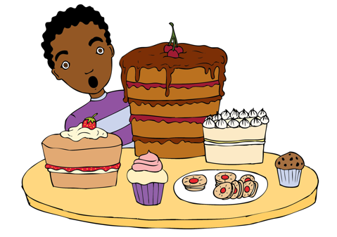
Sit the children in a circle. Explain that they are going to simulate a storm using only body percussion. Start with rubbing hands and encourage the children to copy you, one at a time around the circle. When the hand rubbing reaches you again, change to clicking your fingers (children to copy one at a time around the circle), change to hand clapping, then patting your lap, ending with a stamp of your feet (thunder). Talk the children about the effects created; experiment with changing the dynamics from soft to loud and the number of people performing (texture). Record the performance and listen back to it. Discuss what went well and what could be improved upon. Encourage the children to use musical vocabulary. Video resource.

Plenary:
Watch a video of a choir performing a ‘storm’, created with body percussion: https://www.youtube.com/watch?v=zCsFOUlM65A. How does this compare to the version the children recorded?
If time, you could watch a further short video by Evelyn Glennie, percussionist, on creating incidental music for Shakespeare’s The Tempest:
http://www.bbc.co.uk/programmes/p045z7pw?utm_content=buffercaa2a&utm_medium=social&utm_source=twitter.com&utm_campaign=buffer.
Opportunities for mastery: Listen to Four Sea Interludes by the English composer Benjamin Britten twenty years after the Sibelius. These are not directly inspired by Shakespeare but do represent the sea in four contrasting moods. Can children listen the beginning of each of the four movements and list possible moods. See resource.
Keywords / vocabulary: Nationalism orchestra, overture, incidental music, pitch, dynamics, crescendo, diminuendo, texture, body percussion.
Self-assessment opportunities:
- I can demonstrate changes in texture and dynamics using body percussion.
- I can identify Nationalistic features in music.
- I can explain how a composer uses instruments to create an effect or paint a picture in the music.
Resources: Interactive whiteboard, Youtube, information sheet on The Tempest.
Opportunities for sharing work e.g. by recording, notation: Record a performance of the body percussion ‘storm’.

Music Assessment: Years 5&6 Chronology Lesson 4
You only need to note the names of children who are working towards or well above the criteria for the lesson. It will be assumed the majority of the class will achieve the objectives and you don’t need to record this. Use the space below for any specific notes on achievement or evaluation of class progress.

Names of any children who do not meet the learning objectives for this lesson | ‘I can’ assessment criteria | Names of any children who exceed the learning objectives for this lesson.
- I can demonstrate changes in texture and dynamics using body percussion

- I can identify Nationalistic features in music

- I can explain how a composer uses instruments to create an effect or paint a picture in the music

Notes:

