Music Lesson Plan topic – Chronology through Shakespeare

Lesson 3 of 6 Focus: Year 5 and 6
Key Learning Objectives:
- To identify the key features of the Romantic music.
- To compare music from the same era and identify similarities.
- To explain how music can create a mood in terms of instruments, dynamics and texture.

Inter-related music dimensions covered: Timbre, dynamics, pitch, duration.
Starter activity:
Introduce the Romantic Period of music to the children by playing ‘Dance of the Knights’ by the Russian composer Sergei Prokofiev (1891-1953) - https://www.youtube.com/watch?v=Z_hOR50u7ek.
What do the children notice about it? What can they hear? How does it make them feel? What does it make the children think of? Collect ideas and vocabulary on a flip chart/sugar paper. Go through the main features of music from this period and how this piece exemplifies them: big orchestra, wide range of dynamics, strong feelings, big mood changes, often based on stories…this will link you into the next part of the lesson!

Main focus:
This piece of music is from the ballet based on the play Romeo and Juliet - Show the children a quick version of Romeo and Juliet. https://www.youtube.com/watch?v=X3N73mju_Pw.

Explain the context of the piece – it is the music played when the Capulet family are ‘showing off’ at their ball – it could almost be called their walk on music or entrance music. What message does this send out about them as a family? What do they want people to think about them? How would this make their enemies feel? Collect children’s ideas and discuss.

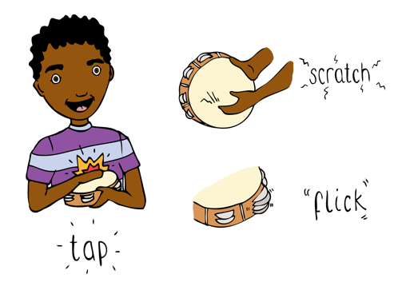
The Capulet family’s enemies are the Montagues, if they were having a big party what kind of music would they use for their entrance? Collect adjectives etc as a class and then in small mixed groups the children should brainstorm ideas for how the piece might sound. They will need to think about what instruments (timbres) would be used for the melody, how the dynamics of the piece would work and the main melody would be like. The children could use pitched percussion/keyboards/piano/ipad apps to compose a simple melody and either record it using note names or draw/create a graphic score to show how it will look in terms of pitch.

Children should then share their ideas/melody with another group – what similarities and differences are there between their different ideas? Why might that be?

Plenary:
Play the children some other examples of music from the Romantic period:
Saint-Saens – Danse Macabre - https://www.youtube.com/watch?v=ytpqcJ1IfoA
Tchaikovsky: Swan Lake Waltz - https://www.youtube.com/watch?v=DparHmVommQ
Debussy: Prélude à l'après-midi d'un faune - https://www.youtube.com/watch?v=1xK0F5KkfT4 (this is Impressionistic inspired by the canon of art in the same name).
Do these pieces have the main features of the Romantic period we discussed earlier? Could these pieces of music fit in with any other parts of the story of Romeo and Juliet? How/ Why?

Opportunities for mastery: Children to mood map the whole of the story of Romeo and Juliet – suggesting and finding music that they discover or know that could be played at different parts of the story.

Keywords / vocabulary: Orchestra, strings, woodwind, brass, percussion, dynamic (forte - loud, piano, soft), mood, Romantic music.
Self-assessment opportunities:
- I can explain the main features of Romantic music.
- I can discuss how music creates a mood describing the instruments, dynamics and melody.
- I can select music that will match adjectives I have collected.

Resources:
Youtube videos.
Sugar paper and post it notes for notes.
Instruments/apps to compose on.
Paper for children to record compositions on.

Opportunities for sharing work e.g. by recording, notation:
- children will record their compositions either with pitch diagrams, or note names
- Children could also record themselves recording the “Montagues” piece.

Year 5/6 Chronology Lesson 3
You only need to note the names of children who are working towards or well above the criteria for the lesson. It will be assumed the majority of the class will achieve the objectives and you don’t need to record this. Use the space below for any specific notes on achievement or evaluation of class progress.

Names of any children who do not meet the learning objectives for this lesson | ‘I can’ assessment criteria | Names of any children who exceed the learning objectives for this lesson.
- I can explain the main features of Romantic music

- I can discuss how music creates a mood describing the instruments, dynamics and melody

- I can select music that will match adjectives I have collected

Notes:

