Music Lesson Plan topic – Chronology through Shakespeare

Lesson 1 of 6 Focus: Year 5&6
Key Learning Objectives:
- To identify some instruments from the Renaissance period.
- To learn to sing a song from the Renaissance period.
- To identify some features of a Madrigal.
Inter-related music dimensions covered: Timbre, texture, pitch, rhythm, structure.

Starter activity:
Listen to an example of a Renaissance madrigal, ‘Sing we and Chant it’ by the English composer Thomas Morley. (1558-1602). Morley lived in London at the same time as William Shakespeare. https://www.youtube.com/watch?v=ciIvhB-zTfc.
Ask the children to raise their hand when they hear the chorus. What were the words? (fa la la!) Madrigals were songs first written in Italy and the first madrigals in England came from Italy and were translated into English. Madrigals were performed at court and in the home. The music was printed in three directions so that performers could sit round a table and all see their music (see Madrigal score resource). This madrigal is a ballet, it has 2 or more verses and always a fa la la chorus. Can the children recognise the difference between the texture of the verse and the chorus? The verse was homophonic (all parts move together) and the chorus was polyphonic (musical lines weave in and out of each other). Can children spot this in the music from the youtube clip.

Main focus:
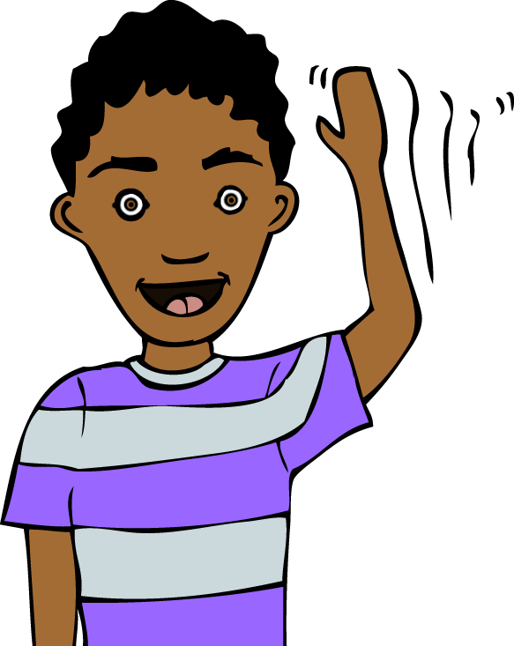
Play the performance track of the song Greensleeves (Singup website). This English song dates from the 16th century, and it has been thought that it was composed by Henry VIII, who was an excellent musician. However today there is some doubt that he was the composer. Play the track again and display the lyrics. The children should now listen out for two parts singing together, melody and harmony. Ask them to raise their hands when the second part enters (at the beginning of verse 3).
Learn to sing the melody using the echo track and then sing along with the performance track.
Add some percussion to Greensleeves using drums and/or tambour/tambourines. Try playing on the pulse/beat first and then pick out some of the rhythm patterns from the song, e.g. the rhythm of ‘courteously’.

Plenary:
Listen to an example of a Renaissance instrumental consort https://www.youtube.com/watch?v=vxPB76pmWss.
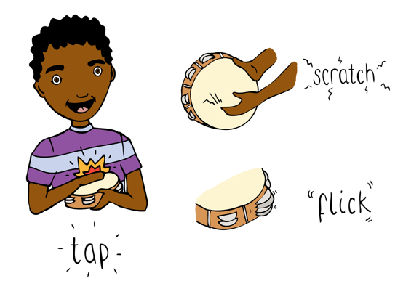
Can children name any of the instruments as being similar to any that they would see today? How do the sounds created by these instruments differ from the timbre (sound) of instruments they hear today? Many instruments were developed to be played outdoors so their wound would carry. Which instrumental family do these instruments belong to (strings, woodwind, brass, percussion). Use the Renaissance instrument chart to find the instruments on the clip. (Curtal, Shawm, Long tabor, Renaissance guitar)
Opportunities for mastery:
- In Greensleeves teach the harmony part to the class and then choose a small group of pupils to sing the part in verse 3 and the final chorus.
- More advanced instrumental players could learn to play the main melody or part 2 as this is easier.
Elizabeth I was a keen dancer and she employed many musicians to compose and perform music for her and her court. Watch a video on how the Tudors danced: http://www.bbc.co.uk/education/clips/zt4kjxs
If time, divide the class into small groups and arrange them into circles to try the dance for themselves.
Keywords / vocabulary: Renaissance period, madrigal – ballet, homophonic, polyphonic.

Self-assessment opportunities:
- I can maintain a musical line as part of a vocal ensemble.
- I can identify some features of Renaissance music.

Resources: Access to interactive whiteboard with sound, Singup website, Youtube, unpitched percussion instruments: hand drum and/or tambour/tambourine, ppt of instrumental families/madrigal music, printouts of instrumental parts if required.

Opportunities for sharing work e.g. by recording, notation: The song could be recorded or performed in an assembly.

Music Assessment: Years 5/6 Chronology Lesson 1
You only need to note the names of children who are working towards or well above the criteria for the lesson. It will be assumed the majority of the class will achieve the objectives and you don’t need to record this. Use the space below for any specific notes on achievement or evaluation of class progress.

Names of any children who do not meet the learning objectives for this lesson | ‘I can’ assessment criteria | Names of any children who exceed the learning objectives for this lesson.
- I can maintain a musical line as part of a vocal ensemble

- I can identify some features of Renaissance music.

Notes:

