Music lesson plan - Samba

Lesson 6 of 6 Focus: Year 5/6
Learning Objectives:
- To maintain a musical line within a Samba structure, recognising and responding appropriately to calls.
- To refine and improve a performance.
Inter-related music dimensions covered: Duration (rhythm / pulse), dynamics, structure, texture, timbre, tempo, notation.
Starter activity:
Inspired by Steve Reich’s Clapping Music set the online metronome [www.metronomeonline.com] to 120.
Ask children to count to 3 over and over again, clapping only on beat one. Once confident do the same but count to 4, and only clap on one. Divide the class in two (one group clap on 1 of 3 and the other 1 of 4), set the metronome and begin with everyone starting together. Class stop when they all clap on one for a second time. Can anyone calculate after how many beats both groups clap together again. (3x4=12 beats). How does this exercise relate to the Steve Reich music heard last lesson? (Both patterns start and finish together [see the powerpoint] look at the first and last bar) Can you do this with 7 and 9 (groups will come together on beat 63!).

Main focus:
Revise all the calls and responses from last week; the introduction, Section A and B. Practise each call and response and the signals to each section.

The Samba performance follows this structure:
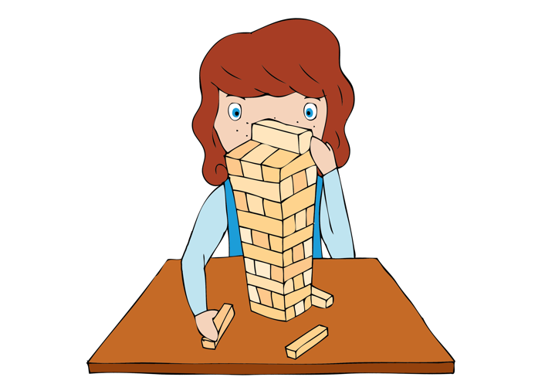
- Introduction call and response (here we go / playing our piece) Do this three times
- Call for Section A (1, 2, 3, 4)
- Section A – the four Samba rhythms played all together – decide how many times to repeat this rhythm – 8 times would work well
- Call for section B (played over the above rhythms) the football rhythm call
- Section B (everyone plays in unison the football rhythm response)
- Finish with the football unison response played four times gradually getting louder! (crescendo)

Perform as a class. You may use the Samba backing track. As part of your performance you may choose to vary the dynamics. You could repeat Section A or B using the call to signal which section is played to create your own structure. Wow!
Record the performance and appraise based on the I can self-assessment statements.

Plenary:
Watch [www.youtube.com/watch?v=IDvIo_MLRIZ4].
Set homework /playground challenge to create a similar piece!
Keywords / vocabulary: Duration (rhythm / pulse), tempo, beat, tempo, dynamics, crescendo (gradually getting louder), structure, texture, timbre, ensemble, solo, call, response.
Extension opportunities: Children can now create their own call and response adding further section or sections to your class Samba.

Self-assessment opportunities:
- I can recognise a call and respond appropriately with the correct rhythm.
- I can move from one section of a piece to another whilst maintaining the pulse.
- I can maintain a part and keep in time when playing as part of an ensemble.
- I can create a sensitive and exciting performance through the use of dynamic contrast.

Resources: Percussion / Samba Instruments, Samba rhythms and backing track, Youtube, metronome online, Reich resource powerpoint.
Opportunities for sharing work e.g. by recording, notation: There should be a wide range of materials, recordings and photographs to display and share at the end of this project. This piece would make a wonderful assembly performance.

Music Assessment: Year 5 and 6 Samba Lesson 6

You only need to note the names of children who are working towards or well above the criteria for the lesson. It will be assumed the majority of the class will achieve the objectives and you don’t need to record this. Use the space below for any specific notes on achievement or evaluation of class progress.

Names of any children who do not meet the learning objectives for this lesson | ‘I can’ assessment criteria | Names of any children who exceed the learning objectives for this lesson.
- I can recognise a call and respond appropriately with the correct rhythm

- I can move from one section of a piece to another whilst maintaining the pulse

- I can maintain a part and keep in time when playing as part of an ensemble

- I can create a sensitive and exciting performance through the use of dynamic contrast.
Notes:

