Music lesson plan Topic - Samba

Lesson 5 of 6 Focus: Year 5/6
Learning Objectives:
- To maintain a rhythmic line within a Samba structure.
- To respond correctly to a given call.

Inter-related music dimensions covered: Duration (rhythm / pulse), structure, tempo, texture.

Starter activity:
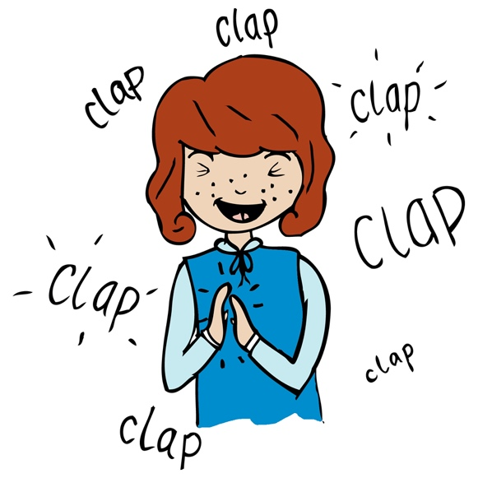
Inspired by Steve Reich’s Clapping Music: 5/7 clapping music. Set the online metronome to 120
[www.metronomeonline.com].
Ask children to count to 5 over and over again, in time with the pulse, clapping only on beat one. Once confident do the same but count to 7, and only clap on one. Divide the class into two groups, one group to clap on beat one of five and the other to clap on beat one of seven. Set the metronome and begin with everyone starting together (each half will clap at different times). Class stop when they all clap together again. Can anyone calculate after how many beats both groups clap together again? (5x7=35 beats). How does this exercise relate to the Steve Reich music heard last lesson? (Both patterns start and finish together – see the powerpoint look at the first and last bar).

Main focus:
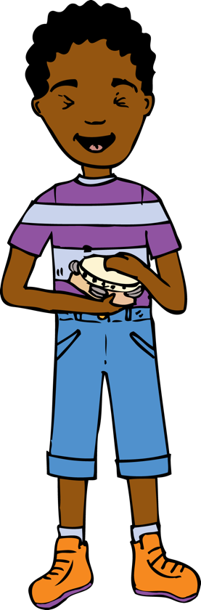
- The aim of the lesson is to create a Samba performance. Children will need instruments as lessons 2/3. Revise Samba rhythms with the call on a whistle to start (four quarter notes / crotchets), this is now known as Section A. Revise starting everyone together and rehearse! If needs be start each sections one by one always starting with the Surdo rhythm which is the same rhythm as the call.
- A Samba always starts with an introductory call and response. Again the call is on a whistle and the response is played by everyone (in unison) playing the same rhythm. Use the words given to help learn the rhythms. The call (‘here we go’) is answered by everyone with the rhythm/words (‘play-ing our piece’). Children need to learn both, clapping the call (‘here we go’), then slapping their thighs for the response (‘play-ing our piece’). Do this three times and then the whole class . This is written out on Year 6 rhythm card 5, and there is a recording in the resource bank.
- Speak/clap 1, 2, 3, 4 (quarter notes/crotchet), which is the call leading into section A.
- Now repeat steps 2 and 3 with instruments instead of chanting/body percussion. The teacher or an able pupil needs to blow the call on a whistle.
- Now learn the Section B call and response. You will recognise this as a football chant. You could use these words to help. The call which children clap is ‘hear this Sam-ba beat’ and the response ‘everyone knows it well’ . This is written out on Year 6 Rhythm Cards 6 and 7.

Plenary:
Watch and discuss this video about an Olympic archer and a Brazilian Samba musician swapping roles : www.youtube.com/watch?v=DasluA52g04 What sort of things do you think Sport and Music have in common? (practise, skill, technique, hold, posture, concentration/focus, resilience)? Playing a musical instrument requires stamina and commitment especially when playing fast, loud music like Samba, just like in sport.
Keywords / vocabulary: Call, response, structure, Samba, solo, ensemble, duration (rhythm/pulse), tempo, texture.

Extension opportunities: N/A
Self-assessment opportunities:
- I can recognise a call and respond appropriately with the correct rhythm.
- I can move from one section of a piece to another and in time.
- I can maintain a part when playing as part of an ensemble.

Resources: Rhythm cards, video clips, percussion instruments, metronome online, powerpoint of Steve Reich’s Clapping Music.

Opportunities for sharing work: N/A

Music Assessment: Year 5 and 6 Samba Lesson 5

You only need to note the names of children who are working towards or well above the criteria for the lesson. It will be assumed the majority of the class will achieve the objectives and you don’t need to record this. Use the space below for any specific notes on achievement or evaluation of class progress.

Names of any children who do not meet the learning objectives for this lesson | ‘I can’ assessment criteria | Names of any children who exceed the learning objectives for this lesson.
- I can recognise a call and respond appropriately with the correct rhythm

- I can move from one section of a piece to another and in time

- I can maintain a part when playing as part of an ensemble
Notes:

