Music lesson plan Topic - Samba

Lesson 4 of 6 Focus: Year 5/6
Learning Objective:
- To recognise and perform complex rhythms and maintain a rhythmic part in canon / in a round (where one parts begins before another).

Inter-related music dimensions covered: Duration, (rhythm / pulse), tempo, structure.

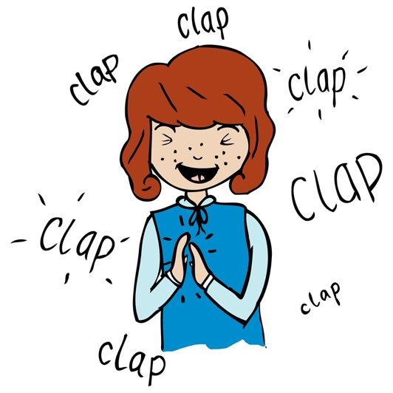
Starter activity:
Practise call and response rhythms, teacher to whisper the call and children to echo the response rhythms: ‘fish and chips’ (call) ‘mushy peas tomato ketchup’ (response), then whisper and clap ‘fish and chips’ line slap knees for tomato ketchup line. When secure divide into two groups. Group 1 (fish and chips) start and group 2 enter 4 beats later so that both rhythms are played simultaneously. See resource video clip. If you feel confident you can teach this after looking at the clip yourself. Otherwise teach alongside the clip with the clip ‘leading’ the class.

Main focus:
Watch this performance of ‘Baiao de Ninar’ [www.youtube.com/watch?v=TljEv_3HDwM]. How does it differ from our performance last week? What can we take away from watching this? How can we improve our performance as a result? Did children spot how the lesson starter rhythms were taken from the end of this clip. Try singing through ‘Baiao de Ninar’ using this clip and add the body percussion at the end. Watch the conductor for the last bar - she signals down before the last line and children perform the ‘mushy peas tomato ketchup’ rhythm.

Activity 2:
Listening – ‘Clapping Music’ by Steve Reich [www.youtube.com/watch?v=hH1j06bMHDQ]
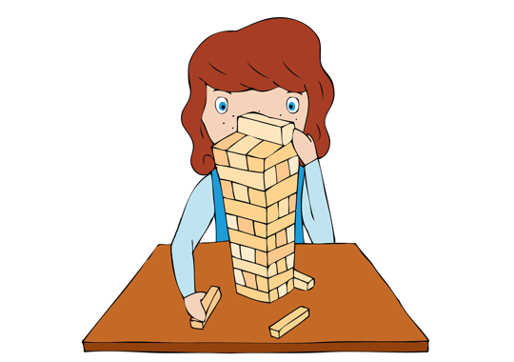
Which element of music does this focus your attention on? Pitch, rhythm, melody or tempo? (rhythm) Is this music? (it is organised sound). Have a look at the score (powerpoint) - look closely at the notes and rests. Can the children spot/identify any patterns. Part 1 is repeated over and over again. Part two shifts by one eighth note (quaver) in every bar.

Plenary:
Explore in more detail two of the traditional Samba instruments the repinique and the tamborim. Use the follow clips: www.youtube.com/watch?v=7UnGrB3Ezo0 / www.youtube.com/watch?v=89C_KnkcFR4.

Keywords / vocabulary:
Duration, (rhythm / pulse), tempo, structure, repinique, tamborim, canon / round, echo, call and response.
Extension opportunities: N/A

Self-assessment opportunities:
- I can echo a rhythm.
- I can perform complex rhythms.
- I can maintain a complex rhythmic line in canon / round.

Resources: Video teacher resource, powerpoint of Steve Reich’s music, YouTube.
Opportunities for sharing work: N/A

Music Assessment: Year 5 and 6 Samba Lesson 4

You only need to note the names of children who are working towards or well above the criteria for the lesson. It will be assumed the majority of the class will achieve the objectives and you don’t need to record this. Use the space below for any specific notes on achievement or evaluation of class progress.

Names of any children who do not meet the learning objectives for this lesson | ‘I can’ assessment criteria | Names of any children who exceed the learning objectives for this lesson.
- I can read and perform four basic samba rhythms in ensemble and in response to a call

- I can maintain a line in a round / canon

- I can identify samba instruments

Notes:

