Music lesson plan - Samba

Lesson 3 of 6 Focus: Year 5/6
Learning Objectives:
- Children are able to read and perform four basic samba rhythms in ensemble.
- Children are able to maintain a line in a round / canon.
- Children can recognise and identify samba instruments.

Inter-related music dimensions covered: Duration (pulse / rhythm), tempo, dynamics, texture.

Starter activity:
Review Street Samba [www.youtube.com/watch?v=jQLvGghaDbE].
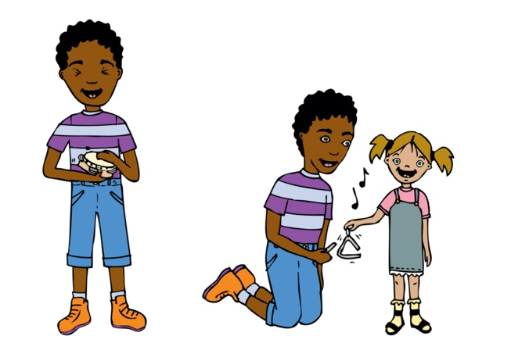
Samba Batacuda is a solely percussion form of Samba. Look at the powerpoint to view the instruments and their roles more closely. Copy slide 5 of the information powerpoint for each child. As they watch clip ask them to tick as they see / hear the instruments. As children listen ask them to put hands up when they hear the beginning of a new section for example at 01:49 a chant begins. Samba music is well known for being exciting and loud. Other than the dynamics, what is it about the music that makes it exciting? - everybody is involved, dynamic sound engages you, repetition allows everyone to join in a whole body experience - there is lots of dancing. The combination and contrast of all the rhythms building a variety of textures keeps the listener’s interest.

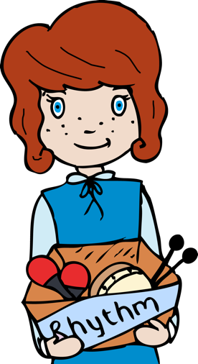
Main activities:
In the 4 groups from last week revise the basic Samba rhythms from the last lesson on untuned percussion instruments. With a whistle, teacher blows four beats. When the children hear this, group one begins with their rhythm. When this is secure blow four more beats to add the second group and so on until all four groups are playing. Find a tempo that works - not too fast but with some energy. To aid this there is a Samba backing track and a further recording of the rhythm of the samba rhythm cards which can be played. Now teacher use the whistle to blow 4 beats to signal that children should enter with their rhythms. This will become Section A of a future Samba performance! Once well-rehearsed try blowing the whistle at different dynamic levels with children responding at the same dynamic. Record this on an ipad or similar.

Plenary:
Play an excerpt of this link without watching the video [www.youtube.com/watch?v=mw-VAKVCSfA] There is an unusual sound after a short introduction played by an instrument. What does it remind you of (a dog, monkey). It’s called a cuica. Now watch and listen. Follow this up with a short explanation of how the strange sound is made. [www.youtube.com/watch?v=NVOtE1qSymU]

Sing through ‘Baiao de Ninar’ with the SingUp rehearsal tracks. Listen to the track sung as a round/canon. A round / canon is where the music starts and then a second part enters later but with exactly the same music. Try singing the first part with this track using the recording to provide the second part. Once secure try singing with the second part.

Keywords / vocabulary: Samba, cuica, surdo, caixa de gueoor, repinique, chocolo, tamborim, agogo, reco-reco, apito, duration (pulse / rhythm), tempo, dynamics, repetition, call and response, solo, ensemble.

Extension opportunities: Select four children who are confident with the rhythms rehearsed. Can they play as an ensemble, playing the four rhythms together. They need to work out how to start and stop as a group. A fifth child can lead the performance with the whistle.

Self-assessment opportunities:
- I can read and perform four basic samba rhythms in ensemble and in response to a call.
- I can maintain a line in a round/canon.
- I can identify samba instruments.

Resources: YouTube links (above), Samba powerpoint, SingUp, Samba backing track and rhythm cards.

Opportunities for sharing work: e.g. by recording, notation (see above).

Music Assessment: Year 5 and 6 Samba Lesson 3
You only need to note the names of children who are working towards or well above the criteria for the lesson. It will be assumed the majority of the class will achieve the objectives and you don’t need to record this. Use the space below for any specific notes on achievement or evaluation of class progress.

Names of any children who do not meet the learning objectives for this lesson | ‘I can’ assessment criteria | Names of any children who exceed the learning objectives for this lesson.
- I can read and perform four basic samba rhythms in ensemble and in response to a call

- I can maintain a line in a round / canon

- I can identify samba instruments

Notes:

