Music lesson plan - Samba

Lesson 2 of 6 Focus: Year 5/6
Learning Objective:
- To echo, read and perform four basic samba rhythms in unison.

Inter-related music dimensions covered: Duration (pulse / rhythm), tempo, timbre, texture.

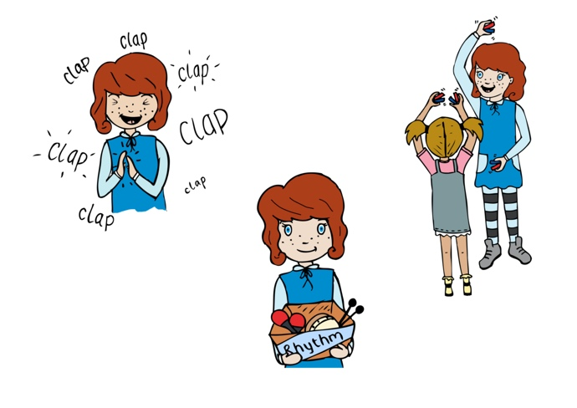
Starter activity:
Select rhythm flashcards 6, 8, 9, 10. Read and clap each card four times using a backing track to help maintain a constant pulse. When the children are confident divide the class first into two and then four groups giving each group a rhythm which they need to repeat over and over again. Display these rhythms on the board as a ‘rhythm clock’ i.e. one at 12 o’clock one at 3, 6 and 9. On a given signal e.g. blow a whistle four times (four quarter notes / crotchet) each group moves to the next rhythm in a clockwise direction.

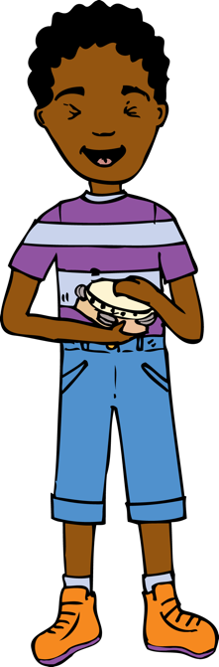
Main focus:
Use the recording of the basic samba rhythms. As a class children echo each rhythm in turn. Put the four samba rhythm cards on the board and ask the children to match each with the one that they hear. Split into four groups, and using the four basic samba rhythms learnt last week, give each group one of these rhythms. Children should practise repeating each rhythm as a group. Each table needs a set of percussion instruments e.g. one table might all have skin (drums, tambourines) one table all have shakers, another wood (eg claves, guiros) another metal (eg agogo bells, triangle) so that each table has instruments with a similar timbre. Groups practise the same repeated rhythm using the instruments. Children should consider how they are going to maintain their line as an ensemble, keeping a steady pulse. They will need to look at each other, maybe one child counts four in). You could use an online metronome to help keep children in time. [www.metronomeonline.com]
Use 80 beats a minute. When you use this children will need to play quietly in order that they can hear the click. Listen to each group in turn and assess. Rotate groups so that children rehearse as many of the four rhythms as possible.

Plenary:
Listen back to the first verse of ‘Baiao de Ninar’ from last week. Revise and rehearse for 2 minutes.

Keywords / vocabulary: Duration (pulse/rhythm), tempo, timbre, samba, signal.

Extension opportunities: Using Garageband (iPad version), record a number of the rhythms using the virtual drums and listen back to them. How do they sound? Try getting people to clap them back to you. If time, try layering them one on top of the other to create different textures.

Self-assessment opportunities:
- I can echo, read and perform four basic samba rhythms in unison.
- I can repeat and maintain a rhythm to a given pulse.
- I can sing in time and in tune with others.

Resources: Samba rhythm cards, backing tracks, instruments.

Opportunities for sharing work: e.g. by recording.

Music Assessment: Year 5 and 6 Samba Lesson 2
You only need to note the names of children who are working towards or well above the criteria for the lesson. It will be assumed the majority of the class will achieve the objectives and you don’t need to record this. Use the space below for any specific notes on achievement or evaluation of class progress.

Names of any children who do not meet the learning objectives for this lesson | ‘I can’ assessment criteria | Names of any children who exceed the learning objectives for this lesson.
- I can echo, read and perform four basic samba rhythms in unison

- I can repeat and maintain a rhythm to a given pulse.

- I can sing in time and in tune with others

Notes:

