Get on Board Music lesson plan - Samba

Bristol Plays Music offers a selection of one off awe inspiring ‘Samba music’ workshops. 10-30 week courses can also be booked. For more information visit: www.bristolplaysmusic.org

Lesson 1 of 6 Focus: Year 5/6
Learning Objectives:
- To identify features of Brazilian Carnival / Samba music.
- To recognise, read and perform four basic samba rhythms.

Inter-related music dimensions covered: Dynamics, tempo, duration (pulse / rhythm), pitch, timbre, texture, structure.
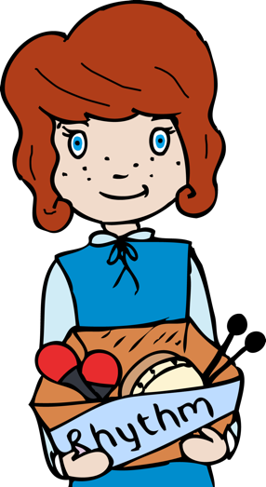
Starter activity:
The sounds of carnival [www.youtube.com/watch?v=jQLvGghaDbE] – listening to street samba.
How many different sounds can you hear - list them? (drums, shakers, whistle, metallic sounds e.g. agogo bells).
Samba is a lively, rhythmical dance of Brazilian origin. The music is played with different instruments – bass drums (a surdo drum, used for keeping a steady beat), snare drums caixa de guerro, a whistle (called an apito [a-peet-oh], used for beginning and ending sections of music), other types of untuned percussion chocolo – shaker, reco-reco - scraper, tamborim -small drum, and different varieties of bells, agogo two pitched cow bell.
The apito blasts one rhythm, and all other instruments respond using another rhythm, this is a call and response section; and a Samba piece can have instrumental solos, where one instrument is playing an exciting rhythm. The apito caller signals the end of one section and the beginning of the next by blasting a short call. Pieces always have clear beginnings and ends.
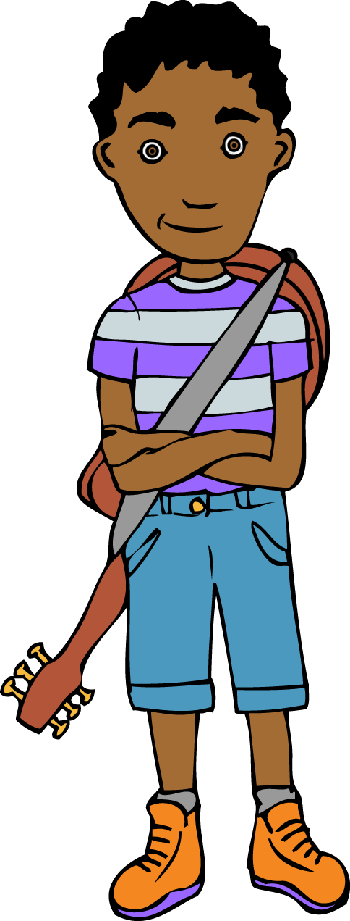
How would you describe the music in terms of the dimensions of music?
Pitch - all unpitched. The drums range from large to small, the largest drums make the lowest sound.
Duration - pulse/rhythm, lots of repeated rhythms (ostinato) Polyrhythm (many rhythms)
Dynamics - it is very loud
Tempo - fast
Timbre - a variety of instruments
Texture - instruments coming in and out and sometimes playing all together as an ensemble
Structure - lots of repetition and call and response
Watch [https://www.youtube.com/watch?v=iCNXHb9kwOk] notice particularly the emphasis on display and costume.

Main focus:
- Learn the mnemonic for spelling rhythm correctly. Rhythm Has Your Two Hips Moving. Refer to samba powerpoint.
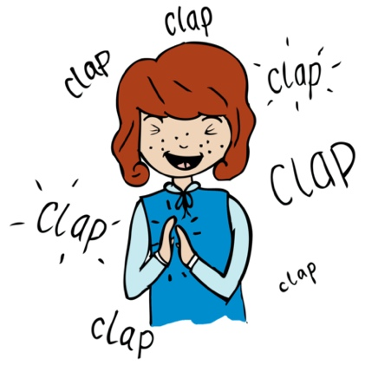
- Teach the class four of the basic samba rhythms through clapping and saying the words rhythmically to a moderate pulse. Refer to cards and recording of Year 6 rhythm cards 1-4.
- Once they can clap all four rhythms in time with the beat reliably, show the card rhythms up on the board – mixed up, without the words. Can they work out which is which? Remember to ask them to clap the rhythm they think it is, rather than just say.
- Repeat rhythms over and over until the children are confident performing all the rhythms. Try clapping the first half of a rhythm and seeing if the children can clap the second half.

Plenary:
Listen to the melody of the Brazilian song ‘Baiao de ninar’ - load up into SingUp, use the lyrics / Whiteboard UNISON option to follow the words. Check pronunciation, sound out harder words, then work on it slowly - use the echo track if necessary.

Keywords / vocabulary:
Dynamics, tempo, duration (pulse/rhythm), pitch, timbre, texture, structure, ostinato, polyrhythm, surdo (bass drum), caixa de guerro (snare drum), apito (a whistle), chocolo (shaker), reco-reco (scraper), tamborim (small drum), agogo (two pitched cow-bell).

Self-assessment opportunities:
- I can identify some features of a Brazilian carnival/samba.
- I can read and perform four basic samba rhythms.

Resources: Powerpoint with information on Carnival and Samba and rhythm cards / recording.

Opportunities for sharing work: N/A

Music Assessment: Year 5 and 6 Samba Lesson 1
You only need to note the names of children who are working towards or well above the criteria for the lesson. It will be assumed the majority of the class will achieve the objectives and you don’t need to record this. Use the space below for any specific notes on achievement or evaluation of class progress.

Names of any children who do not meet the learning objectives for this lesson | ‘I can’ assessment criteria | Names of any children who exceed the learning objectives for this lesson.
- I can identify some features of a Brazilian carnival/samba

- I can read and perform four basic samba rhythms

Notes:

