Music Lesson Plan topic - Water

Lesson 6 of 6 Focus: Year 5/6
Key Learning Objective:
- To perform and celebrate compositions.
Other Learning Objective:
- To evaluate aspects of final work in relation to musical learning over the term.
Inter related music dimensions covered: Duration (rhythm), tempo, structure, pitch, dynamics.
Warm up /Starter activity:
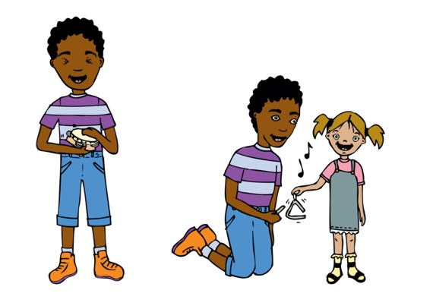
Listen to part of Ravel’s ‘Jeux d’Eau’. This piece was first performed in 1902 for solo piano. Ravel says this about his work: ‘This piece, inspired by the noise of water and by the musical sounds which make one hear the spraying water, the cascades, and the brooks.’ www.youtube.com/watch?v=UJK6yZJ8b5Y
Ask: “How does the composer give an impression of water?”
Main activity:
Divide class into groups for a brief rehearsal of their ternary form compositions, using graphic scores for the waves and word cards / rhythm cards for the engine ostinati. Groups perform to the rest of the class. RECORD.

Listen to the final performances identifying strengths using the criteria below.
Can students identify:
-changes of tempo
- where ostinato is used
- good starting and stopping
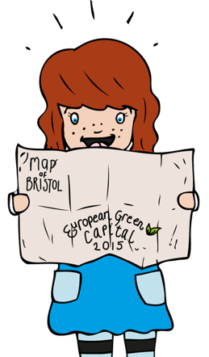
- use of dynamics
- where ternary form is used
- how good the sense of ensemble is
- did the score(s) help the performers to follow the performance
- can students describe a performance using a full musical vocabulary e.g. tempo, dynamics, pitch, ostinato.

Plenary:
Perform ‘Yeave Ho’ sea shanty and RECORD.

Keywords / vocabulary: Rhythm, pulse, structure, texture, dynamics, ostimato, ternary form.

Extension opportunities: The children could perform the ternary form composition and sea shanty as a ‘sea journey’ piece in an assembly or concert.

Self assessment opportunities:
- I can maintain an independent part in a group performance, keeping in time with the group.
- I can evaluate group compositions using appropriate musical vocabulary.
Resources: Percussion instruments, recording equipment, scores, Bristol Folk Song Pack.

Opportunities for sharing work: Record work as evidence and for assessment.

Music Assessment: Year 5/6 Water Lesson 6

You only need to note the names of children who are working towards or well above the criteria for the lesson. It will be assumed the majority of the class will achieve the objectives and you don’t need to record this. Use the space below for any specific notes on achievement or evaluation of class progress.

Names of any children who do not meet the learning objectives for this lesson | ‘I can’ assessment criteria | Names of any children who exceed the learning objectives for this lesson.
I can maintain an independent part in a group performance, keeping in time with the group.

I can evaluate group compositions using appropriate musical vocabulary.

Notes:

