Music Lesson Plan topic - Water

Lesson 5 of 6 Focus: Year 5/6
Key Learning Objective:
- To create a composition in ternary form.

Inter related music dimensions covered: Duration (rhythm), tempo, structure (ternary form A,B,A), texture.
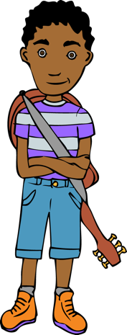
Warm up /Starter activity:
Listen to ‘Connect It’ by Anna Meredith, Ten Pieces, DVD clip from 39-44 minutes or you can find it on line: www.bbc.co.uk/programmes/p02b5cqg.
Listen out for the ostinato rhythms (short repeated rhythmic patterns).

Perform rhythms learnt last lesson and play ‘spot the rhythm’ matching the words to the rhythmic phrase.

Main activity:
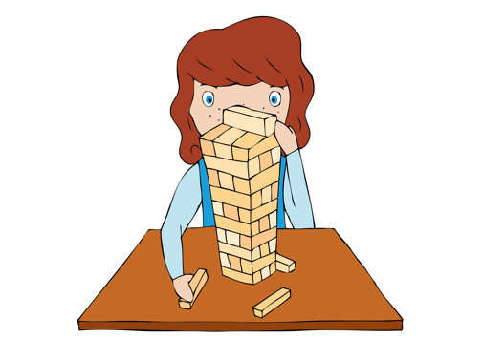
Divide class into groups to work further on their engine pieces. Discuss ways in which they could combine their rhythms and those of other groups to form a longer piece and or layer rhythms so that two or three repeated rhythms are performed simultaneously. Ask: Could they experiment with changes of tempo as if the engine is starting up/slowing down? Transfer some of the rhythms onto percussion instruments. Can the rhythms be written down as staff notation? Create rhythm cards to notate each rhythmic cell. Develop the compositions so that they have an ABA structure (called Ternary form in music). This is a structure that has a clear beginning, a middle and an end. Start with the ‘Wave’ composition then performing the engine composition, finally returning to the ‘wave’ music.

Plenary: Revise and rehearse ‘Yeave Ho’.

Keywords / vocabulary: Duration, rhythm, pulse, ostinato, structure, ternary form, tempo, texture.

Extension opportunities: Develop one of the pieces by adding movement as in Anna Meredith’s piece Connect It. Do this in groups or as a whole class.
Self-assessment opportunities:
- I can combine rhythms in different ways.
- I can recognise some simple rhythms aurally and from staff notation.
- I can structure a composition in ternary form.

Resources: Whiteboards/pens or paper & pencils, recording equipment, rhythm flashcards, classroom percussion, Bristol Folk Pack Resource.
Opportunities for sharing work: Record work in progress for comparison with final composition.

Music Assessment: Year 5/6 Water Lesson 5

You only need to note the names of children who are working towards or well above the criteria for the lesson. It will be assumed the majority of the class will achieve the objectives and you don’t need to record this. Use the space below for any specific notes on achievement or evaluation of class progress.
Names of any children who do not meet the learning objectives for this lesson | ‘I can’ assessment criteria | Names of any children who exceed the learning objectives for this lesson.
I can combine rhythms in different ways.

I can recognise some simple rhythms aurally and from staff notation.

I can structure a composition in ternary form

Notes:

