Music Lesson Plan topic - Water

Lesson 4 of 6 Focus: Year 5/6

Learning Objective:
- To compose a rhythmic ostinato inspired by engine sounds.
Inter related music dimensions covered: Duration (rhythm), tempo, structure, dynamics.
Starter activity:
Watch the clip of Titanic’s engine audio: www.youtube.com/watch?v=4FVD8FQhaKQ.
Ask what happens to the tempo (speed)? Identify a repeated rhythm that occurs over and over again. Can children tap one of these rhythms out. These rhythms are like an ostinato (a continually repeated short musical phrase or rhythm).

Main activity:
Collect words or phrases based on the engine sounds of a big steam ship such as the SS Great Britain. Up, down, up down; round, click shhhhh; backwards, forwards, backwards, forwards: Turn these into body percussion rhythms. Children perform as an ostinato (a short repeated rhythmic cell).
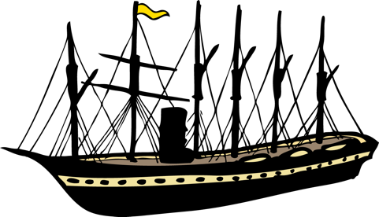
Listen to each group’s ideas. Ask: “what works well? What needs to be improved next time? Are the rhythms consistent, repetitive, have a steady pulse?”

Plenary:
Revise ‘Yeave Ho’ and rehearse the next verse in preparation for performance.

Keywords / vocabulary: Dynamics, duration (rhythm), pulse.

Extension opportunities: Perform the rhythms at different tempi (speeds) as if the engine is starting / running at full speed / stopping. Consider the attack / decay – start and stop of the ostinato. How can you ensure everyone starts / stops together?

Self-assessment opportunities:
- I can compose music as part of a group from different starting ideas.
- I can use my voice/body to create descriptive music.
- I can perform an ostinato and use rhythm to create an effect.

Resources: Whiteboards/big pieces of paper and pens. Bristol Folk Song Pak for Yeave Ho.

Opportunities for sharing work: Groups perform to each other and provide feedback.

Music Assessment: Year 5/6 Water Lesson 4

You only need to note the names of children who are working towards or well above the criteria for the lesson. It will be assumed the majority of the class will achieve the objectives and you don’t need to record this. Use the space below for any specific notes on achievement or evaluation of class progress.
Names of any children who do not meet the learning objectives for this lesson | ‘I can’ assessment criteria | Names of any children who exceed the learning objectives for this lesson.
I can compose music as part of a group from different starting ideas.

I can use my voice/body to create descriptive music.

I can perform an ostinato and use rhythm to create an effect.
Notes:

