Music Lesson Plan topic - Water

Lesson 3 of 6 Focus: Year 5/6

Key Learning Objective:
- To explore and recognise a variety of dynamics.
Inter related music dimensions covered: Dynamics, pitch, structure.
Warm up /Starter activity:
Listen to the sound clip of waves: www.soundjay.com/nature/sounds/ocean-waves-1.mp3.
Discuss the shape and dynamics created by a wave. Link to science: sound waves and previous listening; ‘My Bonnie lies over the ocean’ and ‘Fingal’s cave’.
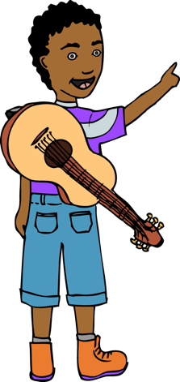
Main activity:
Revise the rules of using instruments and hand out percussion. As a whole class recreate a wave effect with percussion, voices and body percussion. Think about building a sound as a wave builds. Look at the clip that describes how to create a graphic score www.youtube.com/watch?v=gkA7dW2zlzA#t=60.
How could you represent ideas of wave sounds as a graphic score. Children use whiteboards to collect ideas. Can you use different instruments to represent waves building? Or start with one instrument and increase the number of instruments to depict growing strength of a wave? Create a class graphic score to depict a class wave composition. Record the class wave composition.

Plenary:
Listen back to the recording. Did it follow the graphic score?
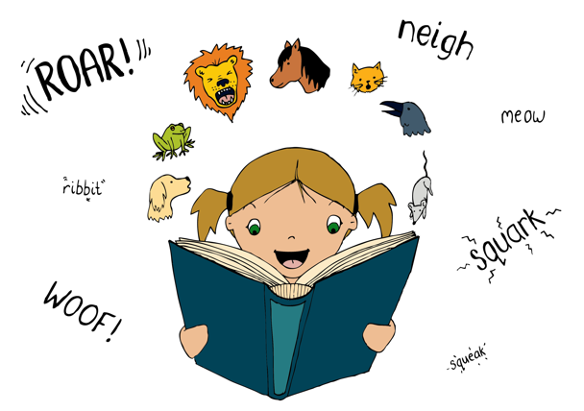
Listen to Rimsky Korsakov ‘s from ‘Scherherazade’: www.youtube.com/watch?v=_5REOSSRalc from 4’40”. According to the 1,001 Nights, this tale finds the seafaring adventurer Sinbad meeting many strange folk, birds, fish and other rarities after landing on an island that turns out to be the back of a giant fish. After the gruff opening gives way to the irresistible melody that depicts the storyteller ‘Scherherazade’, it softens into the tune, over string instruments that conjure the undulations and changing moods of the ocean. Ask: “how does the composer recreate the effect of waves in this piece?” – The dynamics of the music (loud/quiet) and the building up of the texture creates an effect of surging waves.

Keywords / vocabulary: Words relating to dynamics: crescendo (gradually getting louder) /diminuendo (gradually getting quieter), forte (loud), piano (quiet), pitch, graphic score.

Extension opportunities: Children compose their own snapshots of a graphic score using the sea as a theme (e.g. beachscape, storm, tropical island, harbour) using classroom percussion and their voices.

Self-assessment opportunities:
- I can use instruments or my voice creatively to make an interesting performance.
- I can compose music as part of a group from different starting ideas.
- I can represent my ideas as a graphic score.
- I can use dynamics to create an effect.
Resources: Classroom percussion, links as above.

Opportunities for sharing work: Record for discussion, as above.

Music Assessment: Year 5/6 Water Lesson 3

You only need to note the names of children who are working towards or well above the criteria for the lesson. It will be assumed the majority of the class will achieve the objectives and you don’t need to record this. Use the space below for any specific notes on achievement or evaluation of class progress.
Names of any children who do not meet the learning objectives for this lesson | ‘I can’ assessment criteria | Names of any children who exceed the learning objectives for this lesson.
I can use instruments or my voice creatively to make an interesting performance.

I can compose music as part of a group from different starting ideas.

I can represent my ideas as a graphic score

I can use dynamics to create an effect.
Notes:

