Music Lesson Plan topic - Water

Lesson 2 of 6 Focus: Year 5/6

Key Learning Objective:
- To add and maintain a second part to the sea shanty in harmony.
Other Learning Objective:
- To explore call and response structure further.
Inter related music dimensions covered: Pitch, tempo, structure.
Warm up/Starter activity:
Focussed listening: Mendelssohn ‘The Hebrides (Fingal’s Cave)’ Overture: www.youtube.com/watch?v=a3MiETaBSnc.
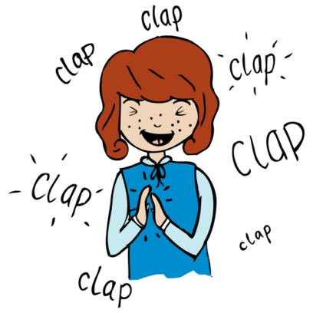
Fingal’s Cave is on the island of Staffa, in West Scotland. It is over sixty meters deep and in stormy tides the cacophonous sounds of the waves inside it rumble out for miles. The intense and rolling melodies within the music perfectly capture this sense of both drama and awe; calmer passages, meanwhile, convey stiller waters and more tranquil surroundings. But it’s never long before the return of that stormy scene. Discuss the shape of the melody (falling phrases – just like a wave). What images do the children imagine when they are listening. Can they hear the echo in the music, just like the echo in the actual cave that is said to have inspired the original composition. Read more at www.classicfm.com/composers/mendelssohn/music/hebrides-overture/#1rvTFAFC1iKAxWbb.99

Warm up voices:
Sing ‘My Bonnie Lies Over the Ocean’. Stand up/sit down on words beginning with ‘B’; extension: clap on words containing ‘O’, and then try both together! Notice the leap up from My – Bonnie. (This is an interval of a major 6th ).

Main activity:
Revise ‘Yeave Ho’ sea shanty; listen to the harmony of part 1 (track 2). Teach the harmony of part 1 to the class using track 2. Split the class into two groups to try the ‘yeave ho, yeave ho’ response in two parts. Invite individuals or a small group to sing the main melody, adding in the ‘yeave ho’ response by the rest of the class. RECORD

Plenary:
Listen back to the recording. Can children recognise unison and harmony singing? Evaluate the performance in terms of ensemble – did everyone sing together, dynamic – were they too quiet / loud, lyrics – could you clearly hear the words in the playback. What could be improved next time?
Keywords / vocabulary: Rhythm, shanty, call and response, harmony, unison.

Extension opportunities: Sing or listen to further shanties such as ‘A Long Time Ago’ or ‘A Roving’. Other sea shanties can be found on Sing Up, e.g. ‘One More Day’ or ‘Fire Down Below’.
Resources: Bristol Folk Song Pack (see lesson 1).
Opportunities for sharing work: The sea shanty could be performed in an assembly or concert at a later stage of the term.

Music Assessment: Year 5/6 Water Lesson 2

You only need to note the names of children who are working towards or well above the criteria for the lesson. It will be assumed the majority of the class will achieve the objectives and you don’t need to record this. Use the space below for any specific notes on achievement or evaluation of class progress.
Names of any children who do not meet the learning objectives for this lesson | ‘I can’ assessment criteria | Names of any children who exceed the learning objectives for this lesson.
I can identify unison and harmony singing

I can maintain an individual melodic line in harmony

I can compare the shape of two different melodies

I can keep in time in an ensemble performance.

I can listen to, discuss and explain some features of a range of music.
Notes:

