Music Lesson Plan topic - Water

Lesson 1 of 6 Focus: Year 5/6
Key Learning Objective:
- To recognise the call and response structure of a sea shanty.
Inter related music dimensions covered: Structure, tempo, dynamics duration (rhythm), pitch.
Warm up /Starter activity:
As an introduction to the project watch the video clip of ‘Take her to Sea, Mr Murdoch’ from The Titanic. www.youtube.com/watch?v=1uUaL7X_F2o
Discuss how the music enhances your understanding of the film (feeling of excitement & suspense; sound effects of engines, propellers, water & wind).
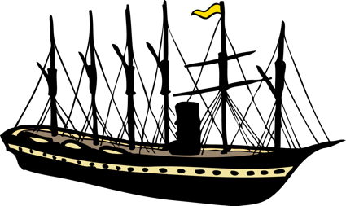
Warm up voices:
Sing ‘My Bonnie Lies Over the Ocean’ (download from SingUp).
Stand up/sit down on words beginning with ‘B’. Notice how the melody ‘jumps’ up on My Bonnie each time. The shape of the melody is a bit like a wave.

Main activity:
Listen to ‘Yeave Ho’ sea shanty (track 1) and discuss ref. p5 Bristol folk song pack. A shanty is a work song that was sung by sailors on large merchant sailing ships to keep them in time when hauling on the ropes or pulling oars etc. The songs had different rhythms and were improvised (adapted and made up) to be longer or shorter as needed. They were call and response songs performed by a soloist who sang a line and the rest of the crew responded in chorus. The soloist was called the shanty man. In time steam ships replaced manpower.

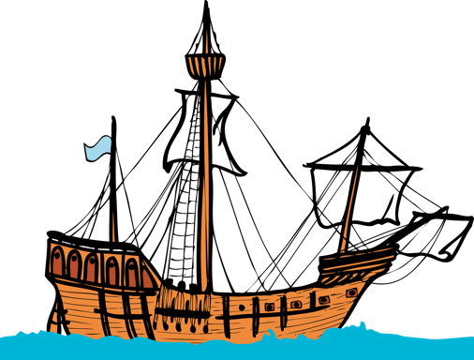
Teach the main melody of ‘Yeave Ho’ using track 2, taking care of the rhythm on ‘spin you a sailor’s yarn all about the deep blue sea’. Split into two groups, the first group to sing the song and the second group to join in on the response, ‘yeave ho, yeave ho’. Swap over groups. Listen for where the voices split to sing in parts (harmony) at the end of each phrase. Harmony is when two or more notes are heard simultaneously, usually sounding ‘pleasant’ to the ear. This shanty was collected by Cecil Sharp, famous for travelling around Britain and recording folk songs. He wrote it down in Somerset in July 1914 when it was sung to him by a Miss Dobbyan. Can children identify when song is sung in harmony / unison by putting hands up when they hear harmony?

Plenary:
Listen to the sea shanty ‘Santy Anno’. Ask children to identify the response (‘away Santy Anno’ and ‘along the plains of Mexico’.
www.youtube.com/watch?v=nPIcwFKrTus&index=2&list=PLGoN3TGcSawmeG608Q8xaalsTs7MdtPKz
Keywords / vocabulary: Shanty, call and response, harmony, unison.
Extension opportunities: Add actions to the sea shanty during the response; invite the children to imagine that they are hauling on ropes or pulling on oars. Invite a soloist to sing a line of the melody whilst the rest of the class respond with ‘yeave ho’.
Self-assessment opportunities:
- I can describe the structure of a sea shanty (call and response).
- I can understand that pitch can be shaped to form a melody.
Resources: Bristol Folk Song Pack, available from Bristol Plays Music as a resource pack or: media.efdss.org.uk/resourcebank/docs/RB108SeaSongsShantiesPack-CarolynRobson.pdf
Opportunities for sharing work: Record initial performance of the song so you that it can be reviewed in a few weeks when improvements can be identified.

Music Assessment: Year 5/6 Water Lesson 1

You only need to note the names of children who are working towards or well above the criteria for the lesson. It will be assumed the majority of the class will achieve the objectives and you don’t need to record this. Use the space below for any specific notes on achievement or evaluation of class progress.
Names of any children who do not meet the learning objectives for this lesson | ‘I can’ assessment criteria | Names of any children who exceed the learning objectives for this lesson.
I can describe the structure of a sea shanty (call and response)

I can understand that pitch can be shaped to form a melody.

Notes:

