Music Lesson Plan topic – Rhythm

Lesson 1 of 6 Focus: Year R/1/2
Key Learning Objectives:
- To feel and internalise the pulse/beat
- To identify the strong beat and demonstrate with an action/clapping.
Inter-related music dimensions covered: Duration (pulse/rhythm), tempo.

Starter activity:
Children stand up and get their voices, bodies, and brains warmed up.
- Warm up and Stomp Canon - Tell the children they will be warming up their voices, brains and bodies with an interactive chant. [www.singup.org]
- ‘Kye Kye Kule’ - A call and response song with actions. [www.singup.org]
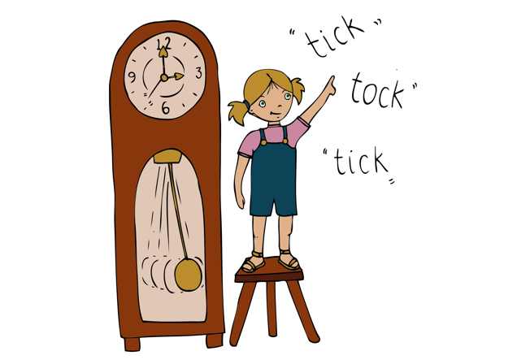
Main focus:
Introduce the concept of a pulse/beat. The beat or the pulse in music is like your heartbeat. Sometimes when you have been running around in the playground, you can feel your heartbeat go faster, and sometimes when you’ve been sitting down or sleeping, it’s a lot slower, but it’s always REGULAR. If children put their finger on their neck or their wrist they will find their heartbeat. That’s just the same as the pulse or the beat in music. Ask the children in Talk Partners to think of other things that might have a regular “beat” or “pulse”. (grandfather clock, tap dripping, drum in a parade). [The pulse is a regular beat that you feel but do not hear]

Listen to a piece of music called the ‘Zebra Crossing’ www.youtube.com/watch?v=ayKzmySojM8 played by a group called the ‘Soweto String Quartet’ from Africa. After the initial slow section of music at the beginning, the challenge is to feel the pulse/beat and silently move shoulders back and forth. Progress to tapping the pulse/beat on thighs. Whenever you repeat this activity try different body percussion sounds.
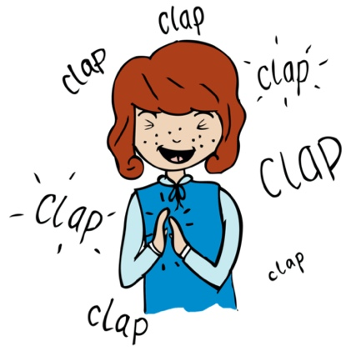
When revisiting this activity try Talk Partners, clapping their own hands together and then clapping each other’s’ hands to the beat. (1 – own hands together, 2 – partner’s hands, 3 – own hands, 4 – partner’s)
Listen again and this time children whisper counting to four, clapping on beat one and tapping thighs on beats 2,3,4.

Extension: Get the children to stand up, and step on the 1st beat of each bar as they move around the circle. Extend this to stepping on the first beat and clapping on beats 2,3,4.
Plenary:
Focus Song: ‘This Train’- [www.singup.org]
Play the song to the children. Have them listen out for the hidden train sounds (bell, steam). Can they listen out for any other instruments? See if children can feel the pulse/beat by demonstrating with an action /body percussion to show where the beat is.
Keywords / vocabulary: Duration - pulse/ beat.
Self-assessment opportunities:
- I can explain what the pulse/beat is.
- I can tap/clap/sway the beat in time with the music.
- I can identify the strong beat.
Resources: Large space, Drum/tambour, pictures or objects with a regular beat, claves.
Opportunities for sharing work e.g. by recording, notation: Record with ipad or video camera the children swaying/tapping to the pulse in the last song.

Music Assessment: Year R/Y1/Y2 Rhythm Lesson 1
You only need to note the names of children who are working towards or well above the criteria for the lesson. It will be assumed the majority of the class will achieve the objectives and you don’t need to record this. Use the space below for any specific notes on achievement or evaluation of class progress.

Names of any children who do not meet the learning objectives for this lesson | ‘I can’ assessment criteria | Names of any children who exceed the learning objectives for this lesson.
- I can explain what the pulse/beat is

- I can tap/clap/sway the beat in time with the music
- I can identify the strong beat

Notes:

