Music Lesson Plan topic – Pitch / Chronology

Lesson 6 of 6 Focus: Year 5/6
Key Learning Objectives:
- To learn to play an instrumental accompaniment and maintain a line in an ensemble.
- To maintain a vocal line in a three part song.
- To recognise an octave.

Inter-related music dimensions covered: Pitch.
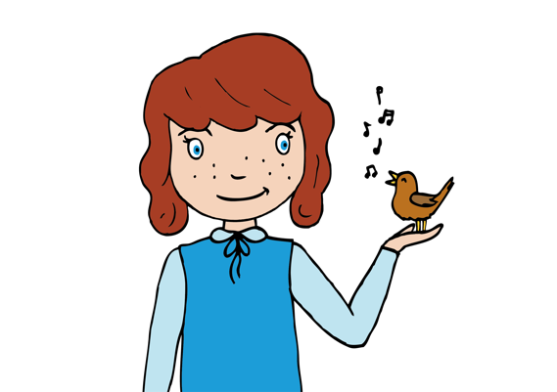
Starter activity:
Listen again to part 3 of ‘Rock a my soul.’ This has the largest leaps on the words ‘so high, so low’. This is another example of word painting. Notice that the melody goes up on high down on low. Children sing or play a pair of notes to each other – partner to identify if they moved from one note to another using steps or leaps. NB Teacher could play step or leap to the class and listener (class) note if it is a step or a leap on a white board.

Main focus:
Revise parts 1 and 3 of ‘Rock-a-my Soul’ and learn part 2. Divide the class into three groups and sing the song, bringing one part in at a time until they are all singing together (use audio resource).

Explain to the children that they are going to play a simple accompaniment. Listen to the accompaniment and follow the notation. Ask: “what is the difference between the two notes named C in this piece?” (They are an octave or eight notes apart). Look at a glockenspiel to demonstrate the relative sizes of the two bars. Which one is high in pitch and which one is low in pitch (longer is low, shorter is high)? Show the children the printed music for part 3 and look at how the higher notes are placed ‘further up’ the stave ladder and the lower notes are ‘lower down.
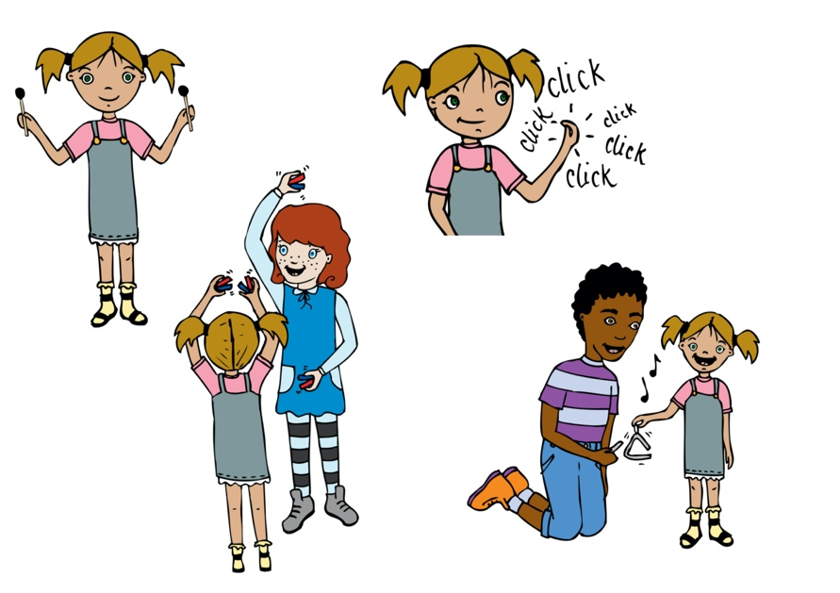
Using the backing track sing the accompaniment to the note names. Ask an individual or group play the notes on a glockenspiel or other tuned percussion or a keyboard.

Once the class are secure singing the vocal part then divide into three vocal parts and rehearse and perform with the accompaniment as an ensemble.

Plenary:
Listen to another version of ‘Rock-a-my Soul’: https://www.youtube.com/watch?v=iprgWSOayoE.
‘Rock a my soul’ is from an oral tradition where the songs are passed down generations by sung performances rather than writing music down. This means there are often many variations of the same song. This is in contrast to the Handel listened to in Lesson 5 which will always be performed the same way as the musicians rely on written notation.
Opportunities for mastery: Children who have instrumental lessons play the accompaniment part on their own instruments. Guitarists could use the tabs to play a chordal accompaniment.
Keywords / vocabulary: Pitch (high, low) interval (step, leap, octave), notation, word painting, ensemble, accompaniment.

Self-assessment opportunities:
- I can learn to play an instrumental accompaniment and maintain a line in an ensemble.
- I can maintain a vocal line in a three part song.
- I can recognise an octave.
Resources: Youtube, Rock a my Soul song lyrics & printed music, chime bars or xylophones, whiteboards.
Opportunities for sharing work e.g. by recording, notation: the song could be recorded or sung in an assembly.

Music Assessment: Year 5/6 Pitch Lesson 6
You only need to note the names of children who are working towards or well above the criteria for the lesson. It will be assumed the majority of the class will achieve the objectives and you don’t need to record this. Use the space below for any specific notes on achievement or evaluation of class progress.

Names of any children who do not meet the learning objectives for this lesson | ‘I can’ assessment criteria | Names of any children who exceed the learning objectives for this lesson.
- I can learn to play an instrumental accompaniment and maintain a line in an ensemble

- I can maintain a vocal line in a three part song

- I can recognise an octave

Notes:

