Music Lesson Plan topic – Pitch

Lesson 3 of 6 Focus: Year 5/6
Key Learning Objective:
- To identify, sing and perform intervals/leaps in a melody.

Inter-related music dimensions covered: Pitch.

Starter activity:
Choose an activity from the Pitch and Vocal starter bank. (The Numbers/Intervals song is a good way to warm up voices and prepare for the skills developed in this lesson. https://www.singup.org/nc/singup-songbank/songs-and-warm-ups/song-detail/type/warmup/view/21-numbersintervals-warm-up/ )

Main focus:
Listen to ‘Young Rider’ (audio resource). What does this song make you think of? (horse). The repeated piano vamp gives an idea of the repeated movement of the horse.
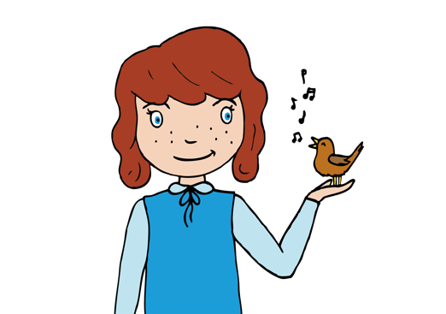
Begin to learn the song – what do our voices have to do in terms of pitch? Are they moving up gradually in steps or are they leaping around? (the song is characterised by the interval/leap down of a fourth G to D – the first two notes). Take care that the leaps (intervals) are correctly pitched. Give the children their own copies of the lyrics, and in pairs ask them to draw the shape of the melody to the words Young Rider, apple cheeked one, O whither riding? On your steed so proud and prancing, O, whither rider. What do they notice about the shapes they have drawn? How have they represented high and low. (The children should have noticed that the second phrase repeats the same shape as the first).

Plenary:
Give the children the music to ‘Young Rider’ and ask them to identify the leaps that are shown in the notation? Can they spot any steps? Are there any intervals in the song that are bigger than the characteristic fourth at the beginning of the song? (Yes – on the word Du-scha moya (this is a minor 6th the sound it makes creates a Slovakian feel). See vocal line music.

Opportunities for mastery: Create an untuned percussion ostinato to accompany the song. Try to create the effect of horses hooves.

Keywords / vocabulary: Pitch (high/low), interval (leap, step), notation, round, unison.
Self-assessment opportunities:
- I can pitch a range of interval/leaps correctly.
- I can recognise the differences between steps and leaps in a melody.
- I can demonstrate the shape of a melodic line.

Resources:
Audio file – ‘Young Rider’
Lyrics for Young Rider
Notation for ‘Young Rider’
Pitch starters and Vocal Warm Up
Backing tracks
Opportunities for sharing work e.g. by recording, notation:
Annotation on lyrics
Annotation on written music
Recording the children singing in a round

Music Assessment: Year 5 and Year 6 Pitch
You only need to note the names of children who are working towards or well above the criteria for the lesson. It will be assumed the majority of the class will achieve the objectives and you don’t need to record this. Use the space below for any specific notes on achievement or evaluation of class progress.

Names of any children who do not meet the learning objectives for this lesson | ‘I can’ assessment criteria | Names of any children who exceed the learning objectives for this lesson.
- I can pitch a range of
interval/leaps correctly

- I can recognise the differences between steps and leaps in a melody

- I can demonstrate the shape of a melodic line

Notes:

