Music Lesson Plan topic – Pitch

Lesson 2 of 6 Focus: Year 5/6
Key Learning Objective:
- To maintain a musical line in a part song – melody/ostinato.

Inter-related music dimensions covered: Pitch, duration (rhythm), dynamics.
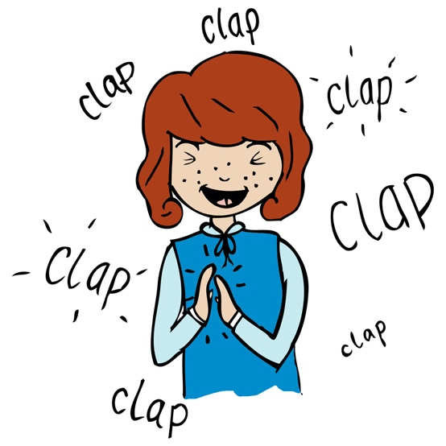
Starter activity:
Choose an activity from the Vocal and Pitch starter bank.

Play the performance track of ‘Wimoweh’. Ask the children to march in time with the pulse for 8 bars. When the melody enters, ask the children to continue marching but to also clap the rhythm of the melody (In the jungle etc up to lion sleeps tonight). Why is this difficult (because the melody is syncopated, which means that it often appears to reach the next beat earlier than expected). To reinforce this divide the class in two. Half the class will march the pulse / beat and the other half will clap the rhythm of the words / melody (and swap).

Main focus:
Listen to the xylophone part on the recording. Can the children hear that it is syncopated. Clap the rhythm whilst listening. Then clap the rhythm whilst singing the letter names of the notes. G, G, G, C, C, C, G, G, G, D, D, D. Can the children write the order of the pitches using H for high, M for middle, L for low. (Answer: M, H, M, L). Using class tuned percussion / keyboard ask a small group of children to play this ostinato.
Revise singing Voice 3. Revise Voice 2 and then sing both parts 3 and 2 together. Add the xylophone part.
Using the backing track Learn Voice 1. This is a simple four bar pattern on two notes that is repeated over and over again. Ask children to listen to the rehearsal track for Voice 1 and use their hands to trace the shape of the two note pitch. Rehearse, perform and record. Discuss balance, does one part need to more prominent at any time? If so, how can this be achieved? (dynamics).

Plenary:
Listen to ‘Amazing Grace’ sung by Ladysmith Black Mambazo http://www.mambazo.com/.
What is similar/different to ‘Wimoweh’. Similar – sung in harmony, one part sings melody others have harmony, sung in more than one part. Differences: there are vocal effects, there is no instrumental accompaniment (it is a capella – sung unaccompanied).
Opportunities for mastery: Using the choral score, add the additional ostinato part on G / F sharp and include a solo for Verse 3.

Keywords / vocabulary: Pitch (high/low), interval (step/ leap), melody, harmony, melodic ostinato, rhythm, a capella, syncopation.

Self-assessment opportunities:
- I can clap a syncopated rhythm.
- I can maintain a melodic ostinato that moves by step and leap.
- I can demonstrate the shape of a melodic line.
- I can maintain a melodic line when singing in harmony.
Resources:
Video/audio file of Wimoweh.
Youtube
Opportunities for sharing work e.g. by recording, notation:
- record children’s performance.
- video / photograph the children jumping up and down the notes of the Voice 3.

Music Assessment: Year 5 and 6 Pitch/Chronology Lesson 2
You only need to note the names of children who are working towards or well above the criteria for the lesson. It will be assumed the majority of the class will achieve the objectives and you don’t need to record this. Use the space below for any specific notes on achievement or evaluation of class progress.

Names of any children who do not meet the learning objectives for this lesson | ‘I can’ assessment criteria | Names of any children who exceed the learning objectives for this lesson.
- I can clap a syncopated rhythm

- I can maintain a melodic ostinato that moves by step and leap

- I can demonstrate the shape of a melodic line

- I can maintain a melodic line when singing in harmony

Notes:

