Music Lesson Plan topic – Pitch

Lesson 1 of 6 Focus: Year 5/6
Key Learning Objective:
- To understand that music moves between high and low pitches.
- To identify melodic shape
- To maintain a musical line in a 2 part song – melody/ostinato

Inter-related music dimensions covered: Pitch, duration (rhythm), dynamics.

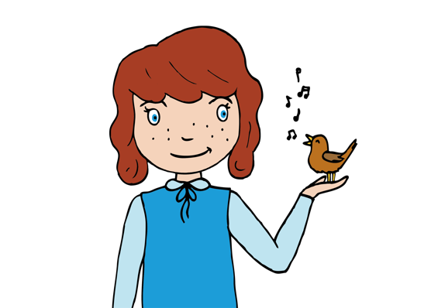
Starter activity:
Choose an activity from the Pitch and Vocal starter bank
Question the children’s understanding of pitch so far. Do they understand what pitch is? (pitch - high / low sounds)? Can you name something that produces a high sound? (kettle, squeaky door, mouse, whistle, piccolo) Can you name something that produces a low sound? (low rumble of thunder, lorry starting, low pedal of an organ). Sing or play a range of notes, can the children work out where they are pitched? Children listen to the teacher play 3 different pitches on a tuned percussion instrument / keyboard and then they write which order the notes were played (H for high, M for middle and L for low). Play two C’s one low and one 8 notes higher. Can the children hear which it higher /lower? The interval between these two notes is an octave.

Main focus:
Play the children ‘Wimoweh.’ How many parts are there? What are the different parts doing? (4 vocal parts, a xylophone a piano and a ‘cello.)

Teach the children Voice 3 (melodic ostinato) of ‘Wimoweh.’. An ostinato is a short repeated phrase. Set out 2 lines of rope or tape on the floor – everyone to stand in between the two lines and sing the first Wimoweh, jump forwards onto the top line, then back into the space and then backwards further onto the bottom line for the last note of the four bar phrase. How were we moving for this part of the song in steps or in leaps? (steps). Encourage the children to sing the note names as they jump e.g. BBBBBBBB, CCCCCCCC, BBBBBBBB, AAAAAAAA etc.


Listen again to the first line of Voice 2 (In the jungle the mighty jungle). Can the children draw the shape of the melody with their hands in the air? Does it move mostly by step or leap? (step). Is the Voice 3 melody pitched higher or lower than Voice 2? (higher). Use the rehearsal track to learn the first verse melody (Voice 2).

Use the performance track to sing Voice 3 to the actual lyrics (‘Wimoweh.’). Then use the track to enable children to sing Voice 3 against Voice 2 and then to sing Voice 2 against Voice 3. Once confident with each line try putting both parts together. Group the class into two parts with confident children leading each part. The children should maintain their line confidently. The children are now singing in harmony (two or more notes sung at the same time).

Plenary:
Listen to the Ladysmith Black Mambazo version of ‘Wimoweh.’ (youtube: https://www.youtube.com/watch?v=sJF87m4_k88)
How does this compare and contrast to our version? (more parts, different rhythms, same melodic shape as the ostinato, same words, extra vocal effects, no part one melody, all male voices).

Opportunities for mastery:
Encourage children who have instrumental lessons to work out the melody or ostinato of our version on their instruments.
Research other settings of Wimoweh and compare and contrast these with those used in this lesson.
Keywords / vocabulary: Pitch (high/low), octave, interval (steps/ leaps), melody, harmony, melodic ostinato, rhythm.
Self-assessment opportunities:
- I can sing a simple part that moves in steps
- I can recognise and sing a melodic ostinato that moves by step
- I can demonstrate the shape of a melodic line
- I can maintain a melodic line when singing in harmony
Resources:
Rope/tape
Video/audio file of Wimoweh
Youtube
4 chime bars (low, middle, high, octave)
Keyboard or tuned percussion
Opportunities for sharing work e.g. by recording, notation:
- Record children’s performance.
- Draw the shape of the melody.
- Video / photograph the children jumping up and down to the notes of the Voice 3.

Music Assessment: Year 5 and 6 Pitch/Chronology Lesson 1
You only need to note the names of children who are working towards or well above the criteria for the lesson. It will be assumed the majority of the class will achieve the objectives and you don’t need to record this. Use the space below for any specific notes on achievement or evaluation of class progress.

Names of any children who do not meet the learning objectives for this lesson | ‘I can’ assessment criteria | Names of any children who exceed the learning objectives for this lesson.
- I can sing a simple part that moves in steps

- I can recognise and sing a melodic ostinato that moves by step

- I can demonstrate the shape of a melodic line

- I can maintain a melodic line when singing in harmony
Notes:

