Music Lesson Plan - Train Journey/Rhythm

Lesson 2 of 6 Focus: Year 5/6
Key Learning Objective:
- To learn and maintain a complex rhythmic ostinato.

Inter related music dimensions covered: Duration - pulse/beat, rhythm.

Starter activity:
Choose one of the activities from the Rhythm Starter Bank.

Main focus:
Re-listen to ‘Bolero’ [www.youtube.com/watch?v=KdScZjx1c2w] revise what an ostinato is (a repeated rhythmic pattern). Which instrument is playing the ostinato? (snare drum). Clap the ostinato and look at the rhythm cards (Year 5 cards 4, 5, 6) noticing the triplets. Ravel is a French composer and ‘Bolero’ is a Spanish dance. Ravel finished this 15 minute composition in 1928 and the ostinato continues for the whole 15 minutes. Try to tap the ostinato along with the recording.

Sing ‘The Greatest Railway’ using the teaching resources to support learning.
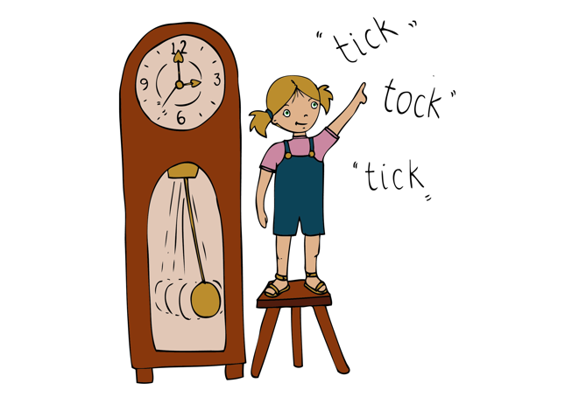
Whisper in a rhythmic manner ‘clickety clack rails on the track, keep on moving clickety clack’ (Year 5 rhythm cards numbers 1 and 2). Ask the whole class to whisper the latter over the recording of ‘The Greatest Railway.’ Then divide the class into 2, one half singing to the recording and the other chanting and clapping the rhythmic ostinato. Swap over. Now, rather than clapping the rhythmic ostinato use rhythm sticks. Encourage class to internalise the ostinato - using their thinking voice instead of chanting the words.


Plenary:
Look at the and rehearse note values as one bar rhythms one after another to create a sense of momentum. (echo, say, clap) 4 crotchets, 8 quavers, 16 semiquavers. This creates a sense of movement. Then you could increase the challenge by using the following rhythms; quick semi x4, semi quick x4, triplet, crotchet, triplet, crotchet x2 [see video resource].

Keywords / vocabulary: Duration pulse / rhythm, ostinato, structure - verse / chorus.

Self-assessment opportunities:
- I can read and play a complex rhythmic ostinato.
- I can read and play quaver, semi quaver and triplet rhythms.

Resources: Youtube clip, claves, recording of The Greatest Railway / MP3 file / Powerpoint of lyrics, SingUp, Rhythmic starter bank.

Opportunities for sharing work e.g. by recording, notation: N/A.

Music Assessment: Year 5/6 Rhythm Lesson 2
You only need to note the names of children who are working towards or well above the criteria for the lesson. It will be assumed the majority of the class will achieve the objectives and you don’t need to record this. Use the space below for any specific notes on achievement or evaluation of class progress.

Names of any children who do not meet the learning objectives for this lesson | ‘I can’ assessment criteria | Names of any children who exceed the learning objectives for this lesson.
- I can read and play a complex rhythmic ostinato

- I can read and play quaver, semi quaver and triplet rhythms

Notes:

