Music Lesson Plan topic - Air

Lesson 3 of 6 Focus: Year 5/6
Key Learning Objective:
- To identify, follow and conduct tempo changes.
Other Learning objectives:
- To understand how composers use tempo to create effects.
Inter related music dimensions covered: Tempo, pitch, rhythm, duration
Key music skills covered: listening, performing, singing.
Warm up /Starter activity:
TEMPO / Listening and Discussion:
Bristol is famous for its mastery of the air. What do you think the difference in speed is between the Bristol Box Kite www.youtube.com/watch?v=Ib7UT0NMlUc and Concorde www.youtube.com/watch?v=LyxiqgNOECc (skip to 4:09). How can we use music to show this difference?
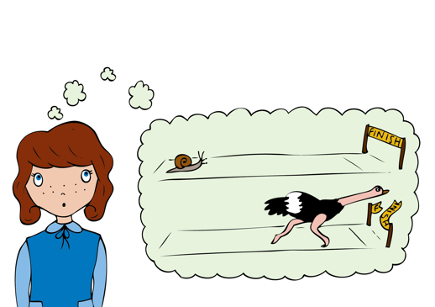
Main activities:
Listening: www.youtube.com/watch?v=5QsRDpsItq0.
Tap 2 fingers on palm of other hand along with the beat of this piece. What do you notice? How many different speeds are there (slow / slower: fast / faster / fast / faster / slow / slower)? Ask the children to put their hands in the air when they hear the speed change. What is the musical word for speed? (TEMPO) What do we call it when the music slows down? (rallentando) or speeds up (accelerando). You could stop the music after 4 changes in tempo.
Learn the second verse of ‘Those Magnificent Men in their Flying Machines’. Load up into SingUp, use the Lyrics/Whiteboard option and rehearse the second verse. Check pronunciation, sound out harder words. Check accuracy of pitch in the falling and rising sections (for example, “frightfully keen”).The class should listen to the recording again whilst tapping the pulse and singing quietly along to the verse 1. Then as a class try ‘conducting’ the last section with 2 beats in a bar: ‘They’re all frightfully keen, those magnificent man, those magnificent men, those magnificent men in their flying machines’. To conduct in 2 move right hand down (on the first beat) and up (on the second beat) as if painting a wall. Split into groups with one conductor per group. The conductor may alter the speed of the performance and the group should try and follow the beat as it gets faster/slower. This works best if the tempo change is maintained for a while before making the change.

Plenary:
Watch the Evolution of Music by Pentatonix for a range of tempos in one entertaining 4.30” video. www.youtube.com/watch?v=lExW80sXsHs How many different tempos (tempi) can you hear? (31?)

Keywords / vocabulary: Tempo, speed, gradually speeding up/accelerando, gradually slowing down.
Extension opportunities: Invite an able pupil to conduct a class performance of the song with two beats in a bar as in activity 2.
Self assessment opportunities: (I can..)
- I understand how tempo can change the mood of the music.
- I can feel the pulse / beat of a piece of music and identify when the tempo changes.
- I can follow a conductor as they change the tempo.
Resources: YouTube links (above), SingUp.
Opportunities for sharing work e.g. by recording.

Music Assessment: Year 5/6 Air Lesson 3

You only need to note the names of children who are working towards or well above the criteria for the lesson. It will be assumed the majority of the class will achieve the objectives and you don’t need to record this. Use the space below for any specific notes on achievement or evaluation of class progress.

Names of any children who do not meet the learning objectives for this lesson | ‘I can’ assessment criteria | Names of any children who exceed the learning objectives for this lesson.
I understand how tempo can change the mood of the music

I can feel the pulse / beat of a piece of music and identify when the tempo changes

I can follow a conductor as they change the tempo
Notes:

