Music Lesson Plan topic - Air

Lesson 2 of 6 Focus: Year 5/6

Learning Objective:
- To organise pitch to create the effect of flight.

Inter related music dimensions covered: Pitch, dynamics.

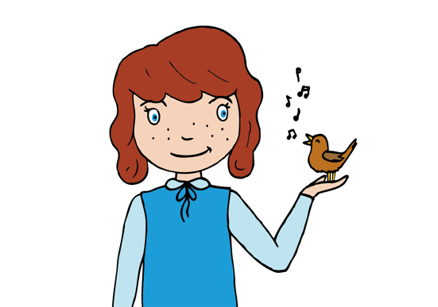
Warm up / Starter activity:
Listening – ‘Flight of the Bumblebee’ by Rimsky Korsakov written in 1899-1900, originally for orchestra. www.youtube.com/watch?v=6QV1RGMLUKE
Which creature is this? Pupils suggest keywords to describe the movement of the music. What happens to the pitch of the music and the shapes it creates; at the beginning the pitch goes down (descends) then it goes up and down in very close steps – (a chromatic scale). The small patterns appear to hover.
RECORD for evidence

Main activities:
ACTIVITY ONE: PITCH
Show the melodic line from ‘Flight of the Bumblebee’ on the screen – emphasise the wandering/meandering nature of the melody, and point out that the pitches all move by step. (If confident you or an able pupil can show this on a keyboard or glockenspiel). Children use a range of tuned and untuned percussion instruments (and others, if available) to create sounds that might represent the movement of the flying creatures.
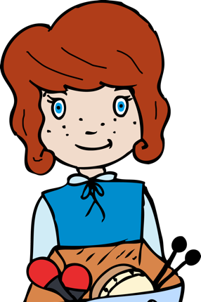
The children can then use paper / whiteboards to design their own snap shot of a flying melody for a creature (hawk, sparrow, bat, owl, housefly) as a graphic score. Encourage careful work here - suggest thinking carefully about the flight behaviour and see if they can show that effectively in a graphic score that demonstrates contrasting pitch. A graphic score is when symbols are used instead of traditional staff notation to represent pitch, duration and dynamics. The symbols act as an aide memoire to the performer who is then able to recreate the same piece of music again and again when he/she performs it. See examples of scores in resources. PHOTOGRAPH SCORES for evidence

ACTIVITY TWO (up to 10 minutes) CHOOSE ONE DEPENDING ON TECH FACILITIES:

Either: (iPad version) Use the app ‘Singing Fingers’, and draw the lines in one at a time and listen back to them. How do they sound? Can you identify the animal/machine without looking at the page/board? RECORD SAMPLES/SAVE LINES TO CAMERA ROLL

Or: (Instruments) Teacher models a performance of one of the graphic scores, then students (or one from each group), recreate, rehearse and perform their own graphic score on classroom instruments. Use any tuned percussion or melodic instruments. RECORD
Plenary: (5 minutes)
Listen back to the recording you made of the first verse of ‘Those Magnificent Men in their Flying Machines’ from last week. Remind class of the targets set after last rehearsal. Revise and rehearse for 2 minutes. Evaluate performance to see if the objectives have been achieved. RECORD

Keywords / vocabulary: Pitch, scale/chromatic movement, flight/flying, buzzing, soaring, bumbling, dynamics.
Extension opportunities: To consider how dynamics could be introduced into students compositions to add expression to their flight compositions. Some pupils may be confident to notate their pieces for the instruments they play.

Self-assessment opportunities: (I can..)
- I can identify how pitch can be used and use a music vocabulary to describe what I hear.
- I can use tuned percussion / melodic instruments / my voice with increasing expression and confidence.
- I can use symbols to notate a piece of music on a score which is designed to reflect changes in pitch.

Resources: Melodic line of the ‘Flight of the Bumblebee’, sample graphic scores, Singup for the song.

Opportunities for sharing work e.g. by recording, notation: N/A

Music Assessment: Year 5/6 Air Lesson 2

You only need to note the names of children who are working towards or well above the criteria for the lesson. It will be assumed the majority of the class will achieve the objectives and you don’t need to record this. Use the space below for any specific notes on achievement or evaluation of class progress.
Names of any children who do not meet the learning objectives for this lesson | ‘I can’ assessment criteria | Names of any children who exceed the learning objectives for this lesson.
I can identify how pitch can be used and use a music vocabulary to describe what I hear.

I can use tuned percussion / melodic instruments / my voice with increasing expression and confidence.

I can use symbols to notate a piece of music on a score which is designed to reflect changes in pitch.
Notes:

