Music Lesson Plan topic – Music Chronology

Lesson 5 of 6 Focus: Year 3/4
Key Learning Objectives:
- To respond to a piece of music with creative writing.
- To recognise changes in dynamics within a piece of music.
- To identify how a composer can orchestrate a simple theme in a variety of ways to create varying effects.
Inter-related music dimensions covered: Dynamics, timbre (tone colour), texture, pitch.
This lesson focuses on listening and creatively responding to ‘Firebird’ (Finale) by the Russian 20th Century composer Igor Stravinsky (1882-1971)

Listening focus:
1) Introduce this piece of music by watching the introduction by Claudia Winkleman on the BBC Ten Pieces Video:
http://www.bbc.co.uk/programmes/articles/4JMLr6V55sQKzMPgv401my0/the-firebird-suite-1911-finale-by-igor-stravinsky
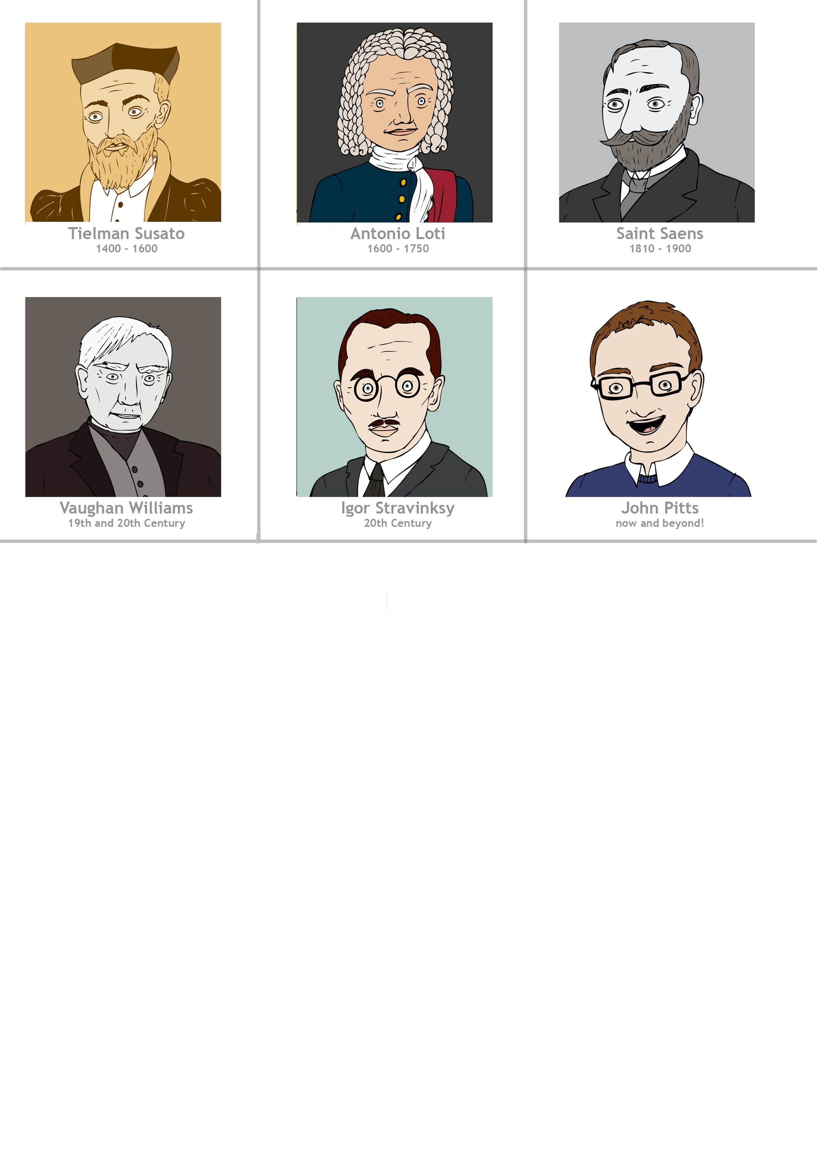
- Watch and listen to the full orchestral version of the piece, this time considering:
- This piece features a noticeable, yet gradual change in dynamics. Can the children hear that the piece gradually gets louder? (This is called a crescendo)
- Which instrument begins the piece? (French horn)
- What other instruments help to create this soft (piano) section? (harp, strings, flutes, clarinets)
- Can the children hear the timpani and trumpets? How does the music change here? The note values change to ones of equal value and then the effect is one of broadening out as the orchestra takes up the melody majestically with the pace twice as slow. This leads to triumphant chords played by the brass, celebrating that the princesses have been freed by the Firebird’s magic.
You can find a link to the full story here http://downloads.bbc.co.uk/tv/tenpieces/stravinsky_lesson_plan.pdf

The Firebird is a ballet based on a Russian fairy tale, influenced by Russian folklore using folk songs. It uses a large orchestra 2 flutes (2nd = piccolo), 2 oboes (2nd = English horn), 2 clarinets, 2 bassoons, 4 horns, 2 trumpets, 3 trombones, tuba, timpani, percussion, harp, piano, and strings to create a dazzling evocative atmosphere. The beautiful bird has dazzling feathers which seem to be made of flames and Stravinsky uses the colours in the orchestra to help the listener conjure up this image.

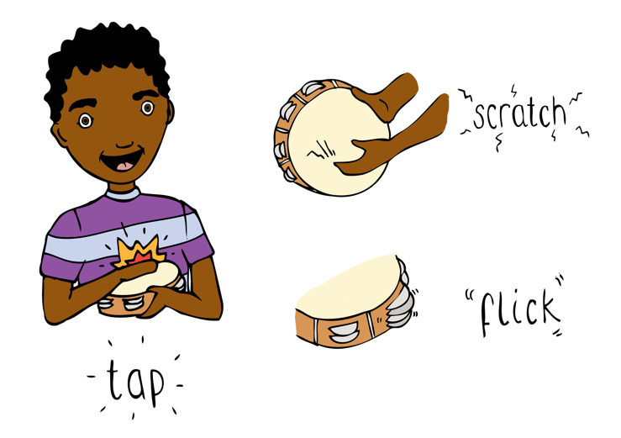
Main activity:
- Using the music and the ‘Firebird Images Powerpoint’, ask the children to think of adjectives to describe the firebird (vibrant, flaming, majestic, dynamic, graceful, powerful). Teacher to record ideas.

- Ask the children to think of adverbial phrases to describe the firebird’s movements rising from the flames. How might the firebird be moving at the beginning of the piece? (gently stirring, delicately rising) or the middle and end of the piece? (majestically soaring, powerfully spiralling…) Teacher to record these ideas to form a word bank.

- Working individually or in small groups, the children should use this word bank and their own ideas to create a Firebird inspired list poem. Listen to ‘The Firebird’ as they create their poems.

Example:
Flaming,
Gently stirring,
Colourful,
Quietly rising,
Powerful,
Majestically soaring.

Plenary:
Watch https://www.youtube.com/watch?v=qdCOitPMX_c inspired by the story. This is the opening of the story. Use the link to discuss how you could extend this animation. The children might create a story board or continue the film using the same media.

Opportunities for mastery (extended creative opportunity): An additional creative response could be to create some Firebird flaming feathers. Use pipettes or thin paintbrushes to place droplets of watered down red, yellow or orange paint onto the edges of your poem. Blow the droplets into flames across the words of your poem using a straw!

Keywords / vocabulary: Folklore, folksong, timbre (tone colour), orchestra, dynamics (forte/loud, piano/soft, crescendo/gradually getting louder).

Self-assessment opportunities:
- I can respond to a piece of music with creative writing.
- I can recognise changes in dynamics within a piece of music.
- I can identify how a composer can orchestrate a simple theme in a variety of ways to create varying effects.

Resources:
Firebird (Finale) by Igor Stravinsky.
BBC Ten Pieces videos (Introduction to Firebird and full orchestral performance).
Firebird images Powerpoint.
Watered down paint, brushes/pipettes (extended creative opportunity).
Opportunities for sharing work e.g. by recording, notation: Create a musical poetry performance to share with another class. Play the piece and read your poems at the same time to encourage your audience to feel the excitement of the rising firebird!

Music Assessment: Year 3/4 Music Chronology Lesson 5
You only need to note the names of children who are working towards or well above the criteria for the lesson. It will be assumed the majority of the class will achieve the objectives and you don’t need to record this. Use the space below for any specific notes on achievement or evaluation of class progress.

Names of any children who do not meet the learning objectives for this lesson | ‘I can’ assessment criteria | Names of any children who exceed the learning objectives for this lesson.
- I can respond to a piece of music with creative writing.

- I can recognise changes in dynamics within a piece of music.

- I can identify how a composer can orchestrate a simple theme in a variety of ways to create varying effects.

Notes:

