Music Lesson Plan topic – Music Chronology

Lesson 4 of 6 Focus: Year 3/4
Key Learning Objectives:
- To respond creatively to a piece of music.
- To suggest words to describe the mood of a piece of music, considering how the composer may have wanted the listener to feel.
- To identify instruments and to consider how their timbre suggests tone colours.

Inter-related music dimensions covered: Dynamics, tempo, timbre.
This lesson focuses on listening and creatively responding to ‘The Lark Ascending’, written by the English composer Vaughan Williams (1872-1958) and inspired by a poem written by George Meredith (poem https://allpoetry.com/The-Lark-Ascending )

Listening focus: https://www.youtube.com/watch?v=Vx5fTqWYx68
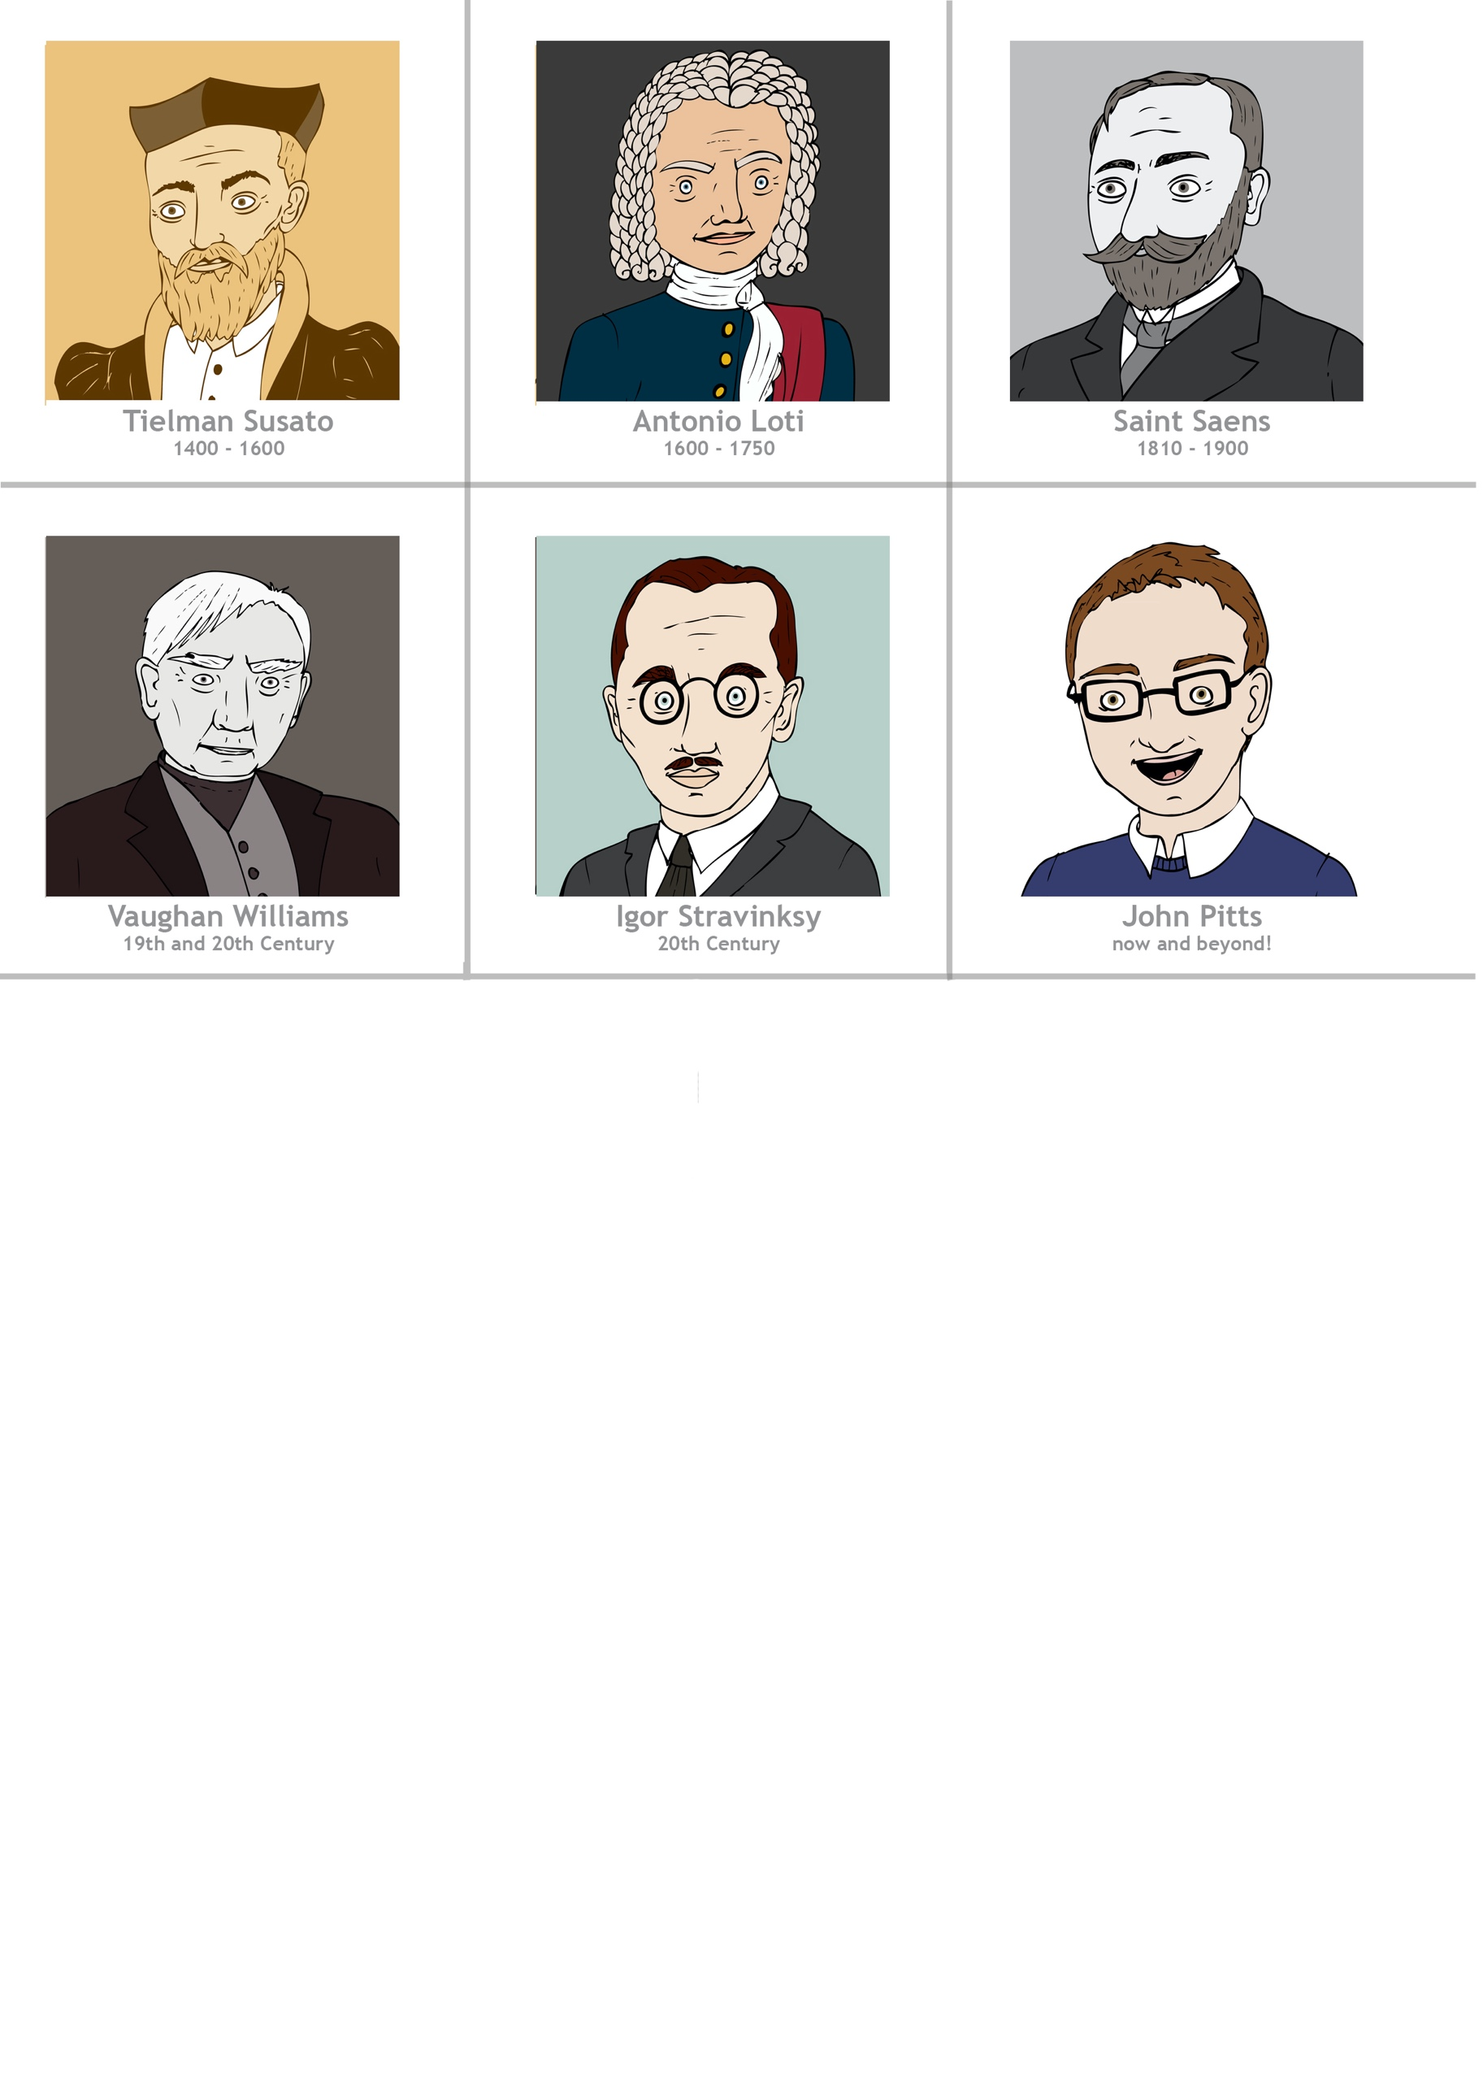
- Listen to the beginning of ‘The Lark Ascending’ without viewing the image . Encourage pupils to listen to the melody played by the solo instrument (violin) lyrics, indicating when it enters by putting up their hands. What is the piece about? The Lark . What country is it inspired by? England. Put the composer portrait on the time line and map.

The composer wrote the piece in 1914, but the outbreak of World War I meant he had to put its premiere on hold. It wasn’t until 1921 that The Lark Ascending received its first performance in the Public Hall in Shirehampton, featuring the violinist Marie Hall – the woman for whom Vaughan Williams had written it.
The soaring violin melody ascends so high into the instrument’s upper register that, at times, it is barely audible; shimmering strings, meanwhile, provide much of the beautifully sensitive accompaniment, evoking glorious images of the rolling British countryside. Midway through ‘The Lark Ascending’, Vaughan Williams treats us to an orchestral section that seems to borrow from his love of folk songs; it’s not long, though, before the lark returns, with the melody entwining itself around the orchestra and then breaking free, rising to ever loftier heights.

- Listen again, this time considering:
- What instrumental family can you hear in the introduction? (strings)
- Are the dynamics of the piece mostly loud (forte) or soft (piano?)
- Can you think of words to describe the mood/atmosphere of the piece? (pastoral, inspiring, flight shapes, soaring, swooping, happy, joyful, spirited, sense of space and freedom, bird song etc). Refer to the poem for more ideas through the link above.
- What colours come to mind when you listen to this music?

Main activity:


- Provide each table with photocopied images of landscape paintings (resources- Landscape Painting Images Powerpoint) By cutting and tearing elements from these images, all of which are from the same era as the music, pupils can create their own ‘pastoral’ imaginary landscape. You can also do this with a mixture of the paintings, and or torn up magazines. Encourage the children to consider their choices carefully and to overlap pieces. You may wish to ask pupils to create their collage onto green/brown paper so that the gaps do not matter! (See examples).

- Can the children select different textures and colours from the landscapes /magazines to make their own grass, sky, mountains etc as well as favourite trees, birds or figures? Listen to ‘The Lark Ascending’ as you create your works of art.

Plenary:
Listen to https://www.youtube.com/watch?v=P8Q9dz1kse8 ‘On The Banks of Green Willow’ by George Butterworth a contemporary of Vaughan Williams. Can the children identify any similarities between this and ‘The Lark Ascending’ (solo instrument, string accompaniment, English sound, use of folk song influence).

Opportunities for mastery (extended creative opportunity): An additional creative response could be to add descriptive words to your collages or to use paints to mix a wide variety of greens. Use your greens to create an abstract painting inspired by ‘The Lark Ascending.’

Keywords / vocabulary: The Lark Ascending, solo, violin, mood/atmosphere, strings, Folk song, texture, tone colour, timbre, melody, tempo, dynamics, landscape, legato (smooth), accompaniment.
Self-assessment opportunities:
- I can listen and respond creatively to a piece of music.
- I can suggest words to describe the mood of a piece of music, considering how the composer may have wanted the listener to feel.
- I can identify instruments and to consider how their timbre suggest tone colours.
Resources:
‘The Lark Ascending’ by Vaughan Williams.
‘On the Banks of Green Willow’ by Butterworth .
Landscape Painting Images Powerpoint.
Copies of landscape painting images for each table/ magazines.
Blank green/brown paper.
Glue and scissors.
Paint to mix a variety of greens (extended creative opportunity).

Opportunities for sharing work e.g. by recording, notation: Record your reflections on the mood/atmosphere of the piece more permanently by adding words to your pastoral landscapes. Can you add any other musical vocabulary to your works of art? (forte, legato…)

Music Assessment: Year 3/4 Music Chronology Lesson 4
You only need to note the names of children who are working towards or well above the criteria for the lesson. It will be assumed the majority of the class will achieve the objectives and you don’t need to record this. Use the space below for any specific notes on achievement or evaluation of class progress.

Names of any children who do not meet the learning objectives for this lesson | ‘I can’ assessment criteria | Names of any children who exceed the learning objectives for this lesson.
- I can listen and respond creatively to a piece of music.

- I can suggest words to describe the mood of a piece of music, considering how the composer may have wanted the listener to feel.

- I can identify instruments and to consider how their timbre suggest tone colours
Notes:

