Music Lesson Plan topic – Music Chronology

Lesson 3 of 6 Focus: Year 3/4
Key Learning Objectives:
- To follow a graphic score.
- To know that staccato means detached.
- To recognise repeated rhythmic patterns.
- To compose and perform melodic phrases.
Inter-related music dimensions covered: Pitch, duration (rhythm), timbre.

This lesson focuses on listening and creatively responding to ‘Fossils’, the 12th movement of the musical suite ‘Carnival of the Animals’ by the French Romantic composer Camille Saint-Saëns (1835-1921).
Listening focus:
1) Explain that the piece the children are about to hear is called ‘Fossils’. It is inspired by digging for fossils. (Take a moment to ensure that the children understand what a fossil is? Does this link to any topics you have explored at school? Dinosaurs, Rocks & Fossils?)

2) Listen to the piece. https://www.youtube.com/watch?v=0TSkIG9lFvY Can the children spot the instrument that sounds the most like fossils or bones? (the xylophone). Why might the xylophone have been chosen? (the timbre of the wooden bars resembles bones) What other instruments can you hear? (violin, piano, clarinet).

3) Divide the children into small groups or pairs. Give each group/pair a ‘Fossils Graphic Score Listening Map’. This map shows the order in which the instruments can be heard in the piece and the duration of each part (the number of beats rather than number of bars, so that it is easy for pupils to follow).

4) Ask the children to become conductors and to follow their listening map by pointing to each picture as they listen to the music. You could use lolly sticks/straws as batons! Can the children hear the change in instruments each time? The first picture (showing the string parts) only lasts for one beat so get ready to point to the next picture quickly!

5) Can the children guess why there are stars next to two of the pictures? You may need to give them a clue by explaining that it is because they may be able to spot a tune that they know very well! (Twinkle Twinkle little star).

This piece of music is from the Romantic era. Saint-Saëns was French. Put his portrait on the time line and map. Music composed at this time had more freedom of form and a more powerful and intense expression of emotion than music of the Classical period. Often the inspiration behind the composition was sparked off by a painting book or poem. Imagination, fantasy and quest for adventure are important ingredients in the Romantic style. ‘The Carnival of the Animals’ is one of Saint-Saëns most popular works, but Saint-Saëns premiered his ‘grand zoological fantasy’ privately. It was written as a bit of fun for friends. Each of the music's 14 movements represents a different animal, including a lion, donkey, and elephant, as well as fossils, an aquarium, an aviary and - Saint-Saëns' little joke - pianists, possibly the most dangerous animal of them all...

Main activity:
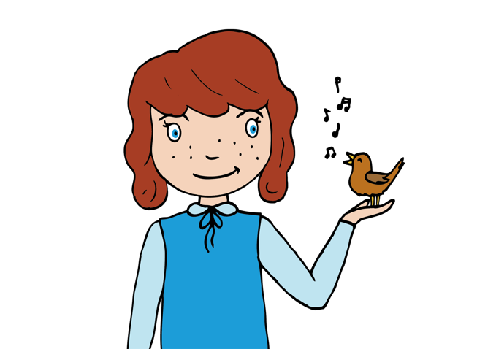
Highlight to the children that the main theme (first played by the xylophone at the beginning of the piece) fits to the rhythm of the words “digging in the ground, digging in the ground, digging in the ground just to find some bones.” Whisper this phrase together. Try listening again to the piece, this time the children should whisper along using these words each time they hear this rhythm.

6) Explain that the music here is short and detached. The musical word for this is staccato. Can the children think why the composer has used a staccato sound here? (to create the idea of a visual image of bones and also an aural idea of what bones might sound like).

7) Working in pairs, the children should use xylophones to compose their own staccato melodic phrases to the rhythm of the words “digging in the ground, digging in the ground, digging in the ground just to find some bones.” It would be helpful to provide pupils with only the notes D,E, F, G and A (either by removing bars or by adding stickers to the xylophone). The children must begin and end their phrase on D. Encourage the children to experiment by using notes close to one another or far apart. Can they create a melody that rises or falls in pitch?

Plenary:
Children perform their compositions. Invite the audience to shut their eyes and then each write one word on a ‘post it’ to describe the feel of the melody.
Opportunities for mastery (extended creative opportunity): An additional creative response could be to swap partners and combine melodic phrases to create a structured composition.
Child A plays their own “digging in the ground, digging in the ground, digging in the ground just to find some bones.” Repeat
Child B plays their phrase. Repeat
Child A repeat. Repeat
Child B repeat. Repeat
Children will have created a piece in Binary form – the same form as in the Susato in Lesson 1.
Keywords / vocabulary: Romantic, xylophone, graphic score, listening map, conductor, baton, rhythm pattern , staccato (short and detached), repeat/repeated, composition, melodic phrase, pitch (rising/falling), Binary form.
Self-assessment opportunities:
- I can follow a graphic score.
- I recognise staccato when I hear it and can play a staccato melody in a detached manner.
- I can recognise repeated rhythmic patterns.
- I can compose and perform melodic phrases.
Resources:
Fossils by Camille Saint-Saëns.
Fossils Graphic Score Listening maps.
Xylophones (one between two) with notes D, E, F, G and A.
‘Post its’.
Opportunities for sharing work e.g. by recording, notation: Use an ipad to record pupil’s staccato compositions to inspire another class.

Music Assessment: Year 3/4 Music Chronology Lesson 3
You only need to note the names of children who are working towards or well above the criteria for the lesson. It will be assumed the majority of the class will achieve the objectives and you don’t need to record this. Use the space below for any specific notes on achievement or evaluation of class progress.

Names of any children who do not meet the learning objectives for this lesson | ‘I can’ assessment criteria | Names of any children who exceed the learning objectives for this lesson.
- I can follow a graphic score

- I recognise staccato when I hear it and can play a staccato melody in a detached manner.

- I can recognise repeated rhythmic patterns.

- I can compose and perform melodic phrases.

Notes:

