Music Lesson Plan topic – Music Chronology

Lesson 1 of 6 Focus: Year 3/4
Key Learning Objectives:
- To learn about Renaissance instruments and to identify the differences and similarities to instruments today.
- To understand a piece of music is often written for a purpose and consider where it may have been performed.
- To listen carefully to a piece of music and use drama to respond creatively to it.
Inter-related music dimensions covered: Pulse, structure, duration, timbre, dynamics.

This lesson focuses on listening and creatively responding to La Mourisque by the Renaissance composer Tielman Susato (1500-1561). Put his picture on the timeline and map (he was born in the Netherlands).
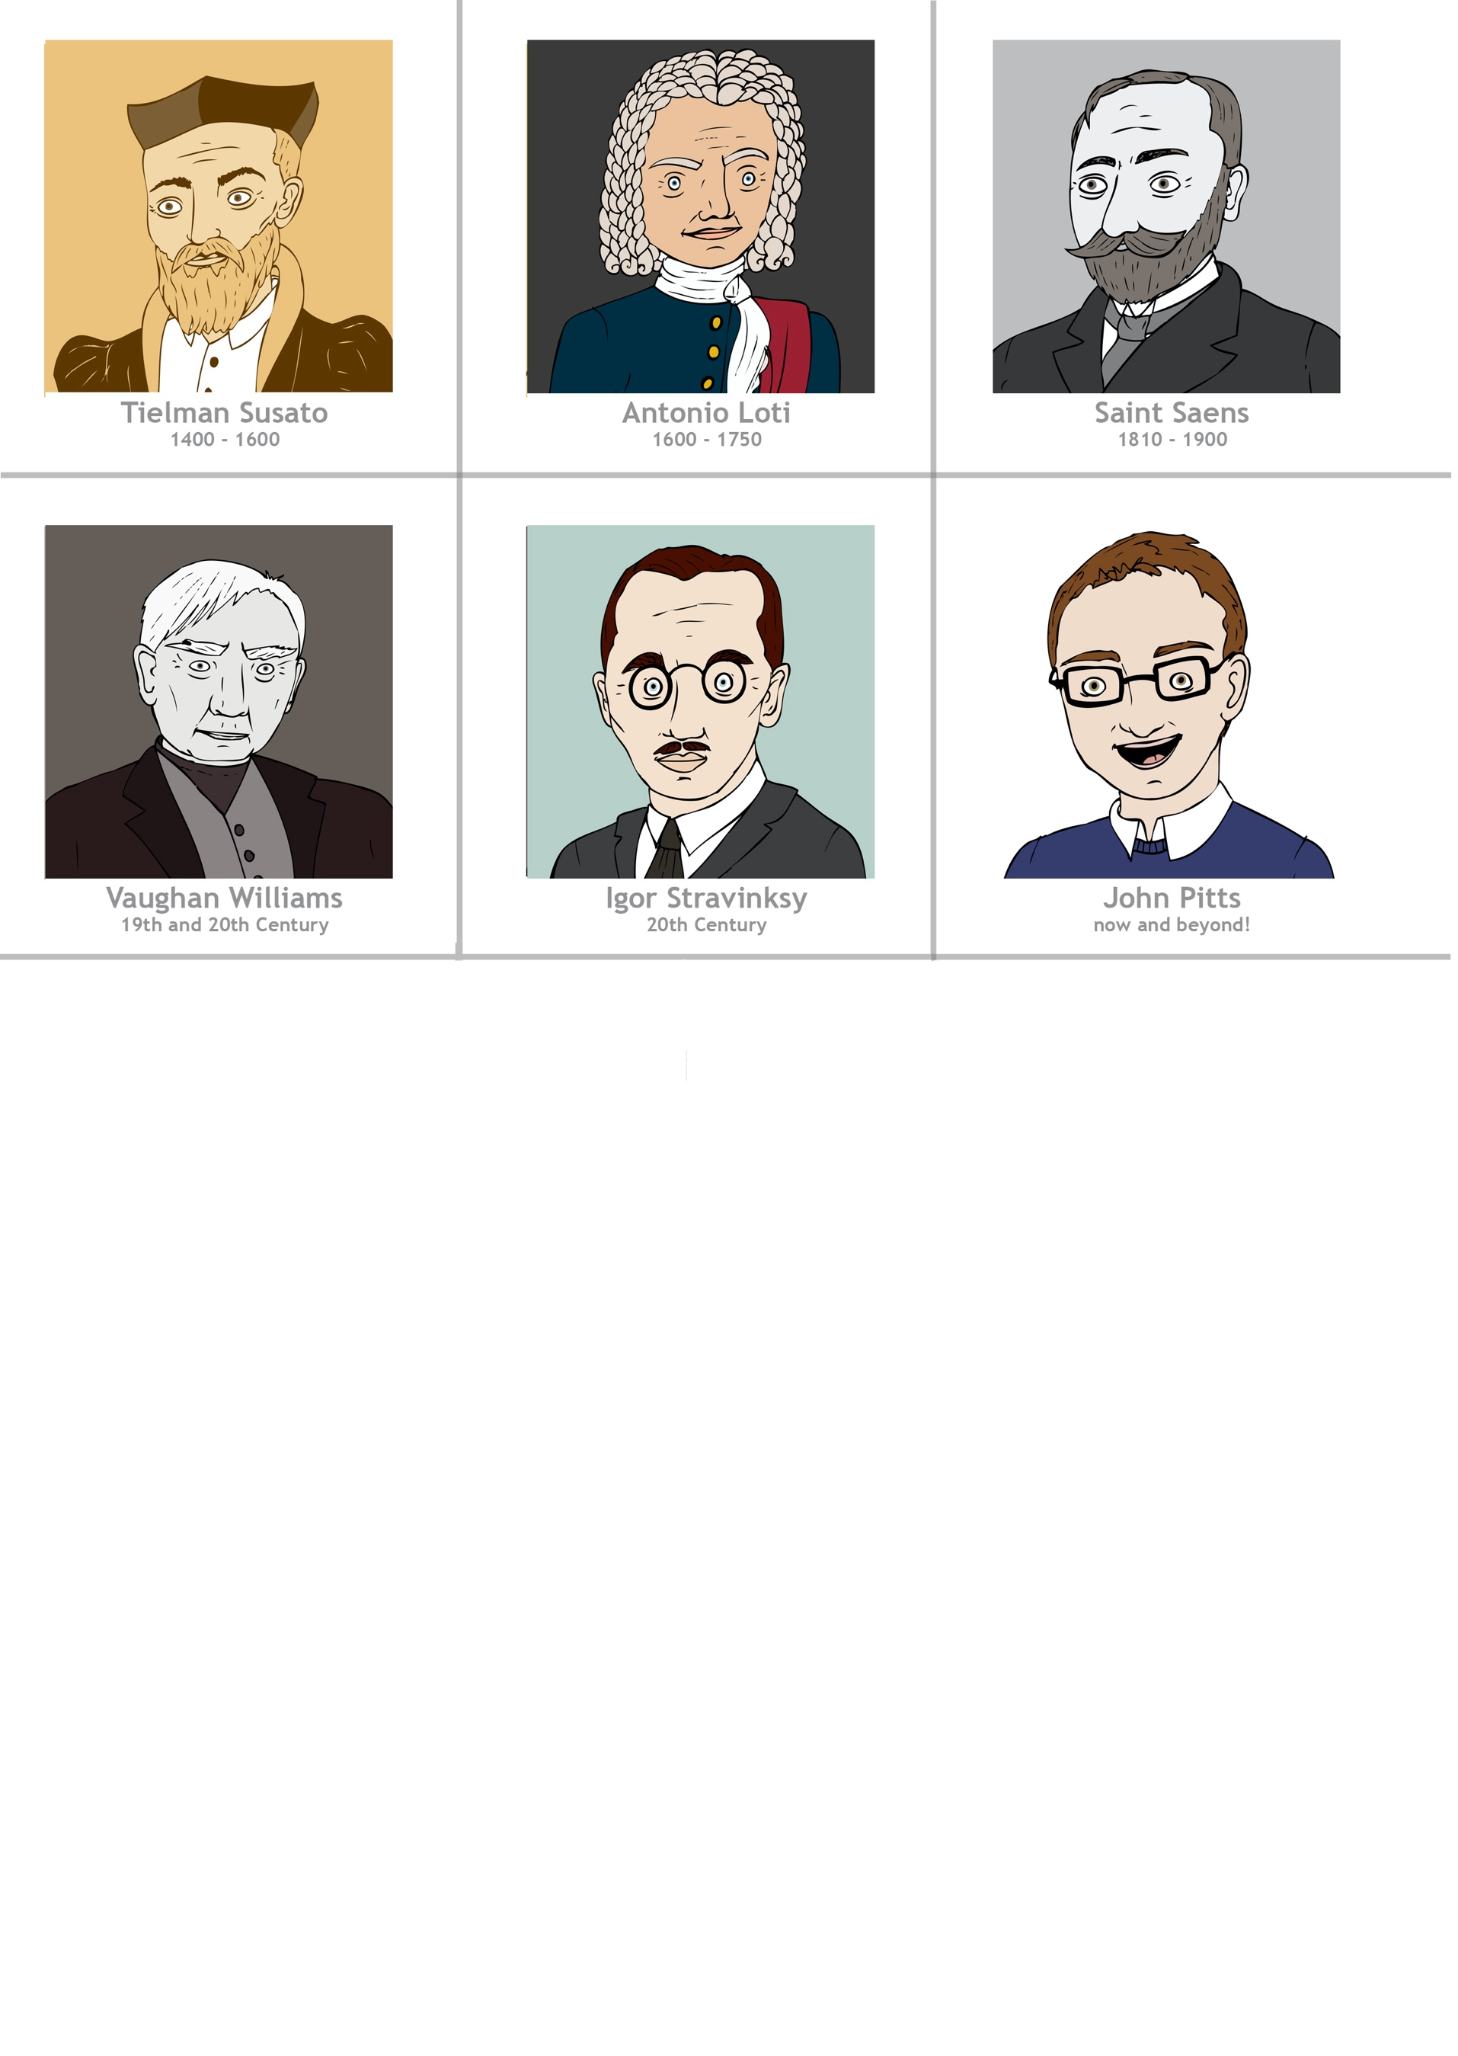
Listening focus: https://www.youtube.com/watch?v=htpM_id7KSQ

- Listen carefully to the piece. Can the children identify what instrument they can hear at the very beginning? (tambourine). What is the function of the tambourine at the beginning? (to provide a rhythmic introduction) Ask the children:
- How many different themes/melodies can they hear (two). This a Renaissance dance from between 1450-1600 and it is usual for these dances to be composed/structured in binary form (A repeated, B repeated).
- How many times is the first theme/melody repeated? (eight). You might get the answer 16 but in fact the second half of the first theme/melody is slightly different.
- To make the repeated sections more interesting, composers often changed them slightly. Can the children notice what these difference are (different dynamics e.g. forte loud / piano soft; decorated with more notes; instrumentation - different instruments used to play the same tune to change the timbre.
- Where might this music have been performed? (Explain that this piece was included in one of the very first books of dance music to be published and would have been played by court musicians for banquets, dances and parties).

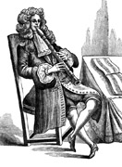
Main activity:
- Look at the ‘Renaissance Instrument Images Powerpoint’ to see some instruments from this period of history. The instruments would have been played by court musicians for the court and guests to enjoy and dance to. Can the children spot any instruments that are similar to those we use today? (viol – violin, lute – guitar/ukulele, tambourine – tambourine, recorder – recorder, serpent – bassoon, sackbut-trombone, trumpet-trumpet.)
- Listen to the piece again, this time looking at the ‘Renaissance Banquets’ Powerpoint. Can the children imagine talking, dancing, eating and playing music at a great banquet hall?

Plenary:
1) Divide the children into groups of 5/6. Ask them to imagine that they are in a Renaissance court at a grand banquet. Ask: what can you see? (courtiers dancing, laughing, eating, talking, drinking, musicians playing, servants delivering food etc).
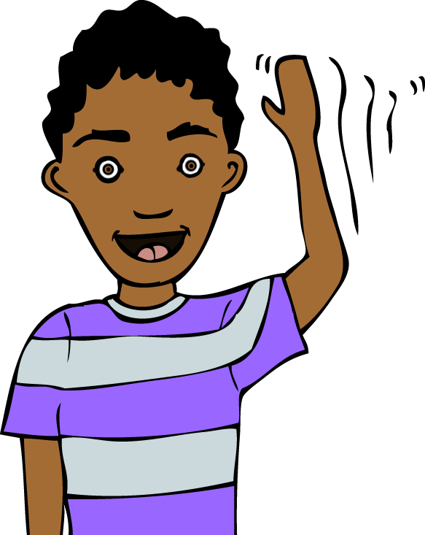
2) Play the music and ask each group to work together to create a /freeze-frame. Encourage the children to share their ideas with their group and to use the music and images to inspire them. What atmosphere does the music create? How does the music make you feel? How can you show these emotions using your face and your body? Can you think of words to describe the music? How can you link these ideas to your freeze-frame? Teacher to pause the music after a few minutes to signal that groups should silently freeze in their chosen positions.
3) Repeat and ask groups to create a second freeze-frame. Stop the music. Invite three children to step out of their freeze-frames and to move around the room looking at the scenes their classmates have created.
4) Repeat and ask groups to create a final freeze-frame. Stop the music. Whilst the children are frozen, the teacher should move around the room and tap a few children on the shoulder to make them “come to life” and say what their character is saying or thinking in the scene.

Opportunities for mastery (extended creative opportunity): An additional creative response could be to choreograph a Renaissance dance to the piece. Encourage the children to consider the short phrases and repetition of the main tune. Use the percussive rhythm of the tambourine to keep the pulse throughout the dance.

Keywords / vocabulary: La Mourisque, Tielman Susato, Renaissance, Renaissance instruments: viol, crumhorn, lute, psaltery, tambourine, recorder, tabor, serpent, sackbut, trumpet, introduction, structure - binary form, repetition, theme, melody.
Self-assessment opportunities:
- I can learn about Renaissance instruments and identify the differences and similarities to instruments today.
- I can recognise and identify repeated themes.
- I can identify the purpose of a piece of music and consider where it may have been performed.
- I can listen carefully to a piece of music and use drama to respond creatively and thoughtfully to it.

Resources:
‘La Mourisque’ by Tielman Susato.
Renaissance Instrument Images Powerpoint.
Renaissance Banquet Images Powerpoint.

Opportunities for sharing work e.g. by recording, notation: Photograph each group’s freeze-frames to share with another class or invite a small group of children to move around your live freeze-frames whilst listening to the music! If you choose to choreograph your own Renaissance dance (extended creative opportunity), perform this to parents in the school hall.

Music Assessment: Year 3/4 Music Chronology Lesson 1
You only need to note the names of children who are working towards or well above the criteria for the lesson. It will be assumed the majority of the class will achieve the objectives and you don’t need to record this. Use the space below for any specific notes on achievement or evaluation of class progress.

Names of any children who do not meet the learning objectives for this lesson | ‘I can’ assessment criteria | Names of any children who exceed the learning objectives for this lesson.
- I can learn about Renaissance instruments and identify the differences and similarities to instruments today.

- I can recognise and identify repeated themes.

- I can identify the purpose of a piece of music and consider where it may have been performed.

- I can listen carefully to a piece of music and use drama to respond creatively and thoughtfully to it.

Notes:

