Music Lesson Plan topic – Rhythm (Unit 2)

Lesson 6 of 6 Focus: Year 3/4
Key Learning Objectives:
- To further develop my understanding of notation.
- To explore texture and pulse by playing rhythms simultaneously in an ensemble.

Inter related music dimensions covered: Duration pulse /rhythm, notation, texture.

Starter activity:
Select an activity from Rhythm Card Starters.

Main focus:
- Hand out notation Lego set/rhythm fraction walls. One each would be ideal, however this lesson would also work with one set between two or three children.
- Ask each child (or group if you are using fewer lego sets) to create a four beat rhythm by building on top of the semibreve/whole note (as they did in the previous lesson).
- Allow time for the children to practise tapping their rhythm on their knees.

Ask children to bring their lego rhythm /fraction wall to sit in a circle. (On the floor with their lego pieces in front of them)
- Play the “Rhythm Machine” game from lesson two.
- Select a click track from the links below to “start the machine.”
- Invite the first child to tap their lego rhythm on their knees over and over again in time with the pulse on the click track.
- Invite the second child to join in. Repeat until everybody is tapping their lego rhythm in time with the click track.
- “Stop the machine” by stopping the click track.
- Ask the children to slide their rhythms one space to the left.
- Repeat the rhythm machine game with the children playing the different rhythm that is now in front of them. NB When you come to pack up the lesson each lego ‘set’ needs to be rebuilt as a wall.
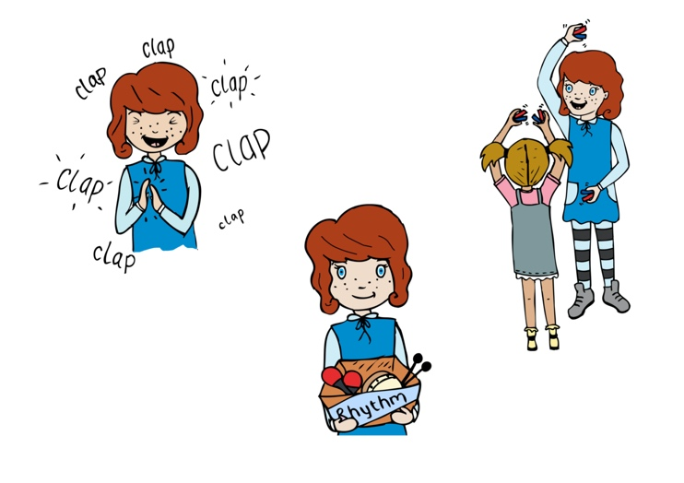
Click tracks:
www.youtube.com/watch?v=fCv3mBbvqXs - 70 beats per minute (slow - adagio)
www.youtube.com/watch?v=qP1os4seNeM - 90 beats per minute (at a moderate walking pace - andante)
www.youtube.com/watch?v=6ZpfGZaWzYc - 120 beats per minute (lively - allegro)
www.youtube.com/watch?v=eO6jTEKX7J4 - 180 beats per minute (very fast -presto)
Plenary:
Play the rhythms of ‘Frere Jacques’ and ‘This Old Man’ as one large ensemble.

- Clap the rhythm of ‘Frere Jacques’ together, saying the words in thinking voices only to remind the children of the rhythm.
- Stamp the first verse of ‘This Old Man’ together, saying the words in thinking voices only to remind the children of this rhythm.
- Split class into two groups and perform the two songs together- one group clapping the rhythm of Frere Jacques, the other group stamping the rhythm of ‘This Old Man’.
- Swap roles and perform again.
Keywords / vocabulary: Semibreve /whole note, minim / half note, crotchet / quarter note, quaver / eighth rhythm machine, duration - pulse / rhythm, texture.

Self-assessment opportunities:
- I can develop my understanding of notating rhythms by composing my own four beat rhythm using lego pieces.
- I can read and tap notated rhythms.
- I can maintain a rhythm in time with a regular pulse.
- I can maintain a rhythmic line within an ensemble.

Resources:
Lego notation sets / Rhythm fraction wall
Click tracks (links found on plan)
Notation chart
Opportunities for sharing work e.g. by recording, notation: You could record your final performance of Frere Jacques and This Old Man to share with another class.

Music Assessment: Year 3 and 4 Rhythm Lesson 6

You only need to note the names of children who are working towards or well above the criteria for the lesson. It will be assumed the majority of the class will achieve the objectives and you don’t need to record this. Use the space below for any specific notes on achievement or evaluation of class progress.

Names of any children who do not meet the learning objectives for this lesson | ‘I can’ assessment criteria | Names of any children who exceed the learning objectives for this lesson.
- I can develop my understanding of notating rhythms by composing my own four beat rhythm using lego pieces.

- I can read and tap notated rhythms.

- I can maintain a rhythm in time with a regular pulse.

- I can maintain a rhythmic line within an ensemble.

Notes:

