Music Lesson Plan topic – Rhythm (Unit 2)

Lesson 5 of 6 Focus: Year 3/4

Key Learning Objectives:
- To develop understanding of notating rhythms.
- To compose and notate rhythms.

Inter related music dimensions covered: Duration pulse/rhythm, notation.

Starter activity:
Select an activity from Rhythm Card Starter Bank.

Main focus:
- Hand out notation Lego sets/Rhythm fraction wall. One each would be ideal, however this lesson would also work well with one set between two or three children. If the children have the wall they need to cut up the wall into the relevant building blocks.
- Initially, give the children a few minutes to explore their Lego set/Rhythm Fraction wall and to make their own discoveries. During this time, children may take apart the set and build it again and/or talk to a partner about things that they notice.
- Ask “did anyone make an interesting discovery?” Share some ideas.
- If it has not been addressed during the idea sharing, consolidate that the lego pieces/wall could represent musical notes, just like the ones we see on our rhythm cards. (see Rhythm Wall resource)
- Ask some questions about the Lego pieces/Fraction wall : (refer to note value chart)
Can you identify the:
- semibreve / whole note
- minim / half note
- crotchet / quarter note
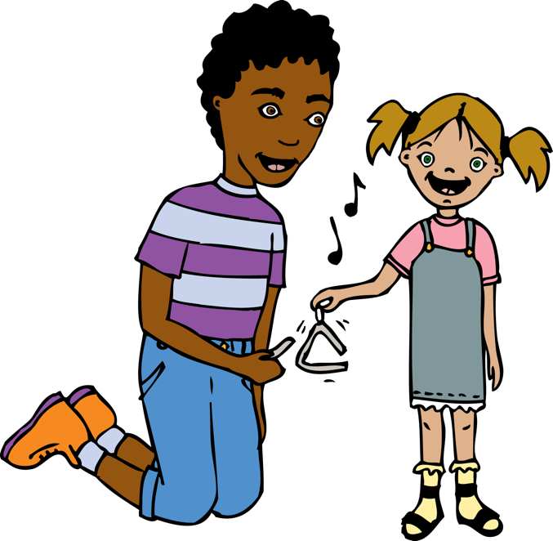
- 8th note / quaver
- How many crotchets / quarter notes equal one minim / half note? (2)
- How many quavers / 8th notes equal one crotchet / quarter note? (2)
- How many crotchets / quarter notes equal one semi-breve / whole note? (4)

- Using what you know, can you work out how many crotchets / quarter notes would be in two semibreves / whole notes? (8)
- Which note shown here has the smallest value? (quaver / 8th note) Which has the largest? (semi-breve / whole note) How do you know? (observe lego bricks / wall)
Show a rhythm card and ask the children to clap it. Ask them to make this card with their lego pieces / wall. Model creating some four beat phrases with the lego pieces by building on top of the whole note / semi-breve bottom piece. Ask the children to create their own four beat phrases. Share ideas with others on your table. Can everybody on the table create a different four beat rhythm? Swap rhythms with your partner. Can you clap one another’s rhythm? If children complete this quickly, you could extend their understanding by asking “How many different ways are there to make a four beat rhythm with the lego pieces? How could you prove to me that you had discovered all the combinations? How could you work systematically?”

Plenary:
- Sing the first verse of ‘This Old Man’ with the class to check that the children know the tune. Here is a clip if you are unsure: https://www.youtube.com/watch?v=URyr_F91un4
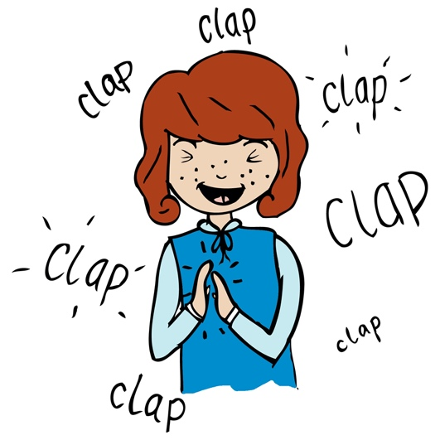
- Stand up and add stamping the rhythm at the same time as singing (every syllable will have a movement). Now try clapping at the same time as singing.
- Split children into two groups and perform the rhythm as a round, chanting the words with one group stamping and one group clapping.
- First group begin “This old man, he played one” (Stamp, stamp, stamp, - / stamp, stamp, stamp - )
- Second group join in after the word one with their clapping.
- Each group stops after “came rolling home.”
- Perform the round again, but this time internalising the words and using ‘thinking voice’.

Keywords / vocabulary: Duration, pulse - rhythm, notation, notes, semibreve, (whole note), minim (half note) crotchet (quarter note), quaver (eighth note).

Self-assessment opportunities:
- I can identify quavers, crotchets, minims and semibreve (8th notes, quarter notes, half notes and whole notes).
- I can demonstrate my developing understanding of notation by creating rhythms that I can clap.
- I can use the lego pieces/rhythm wall to make discoveries about note values such as “two crotchets equal a minim / two quarter notes equal a half note”.
- I can maintain a rhythmic line within a more complex ensemble performance.

Resources: Rhythm cards, Lego notation sets, Rhythm fraction wall – ideally printed out from resource enlarged to A3, laminated and cut out.
Opportunities for sharing work e.g. by recording, notation: N/A

Music Assessment: Year 3 and 4 Rhythm Lesson 5
You only need to note the names of children who are working towards or well above the criteria for the lesson. It will be assumed the majority of the class will achieve the objectives and you don’t need to record this. Use the space below for any specific notes on achievement or evaluation of class progress.

Names of any children who do not meet the learning objectives for this lesson | ‘I can’ assessment criteria | Names of any children who exceed the learning objectives for this lesson.
- I can identify quavers, crotchets, minims and semibreve (8th notes, quarter notes, half notes and whole notes).

- I can demonstrate my developing understanding of notation by creating rhythms that I can clap.

- I can use the lego pieces/rhythm wall to make discoveries about note values such as “two crotchets equal a minim / two quarter notes equal a half note”.

- I can maintain a rhythmic line within a more complex ensemble performance.
Notes:

