Music Lesson Plan topic – Rhythm (Unit 2)

Lesson 3 of 6 Focus: Year 3/4
Key Learning Objectives:
- To explore how rhythm is used in a non-western musical tradition.
- To learn about strong and weak beats in Indian talas.
- To perform Tintal tala with increasing aural memory.
- To compose and perform an Indian tala inspired rhythm in an ensemble with increasing accuracy.

Inter related music dimensions covered: Duration pulse/rhythm, structure.

Starter activity:
Select an activity from the Rhythm Card Starter Bank

Main focus:
- Listen to the first minute of the link below (without showing the children the picture on screen).
- www.youtube.com/watch?v=whLhMVLQSbA (from 23.43 Ravi Shankar)
- As the children listen, ask “what country do you think this music comes from? (India) Why”?
What instruments can you hear? Children might describe hearing drums / strings / guitar. The four instruments playing are Tabla – drums, Sitar – melody instrument, Tambura (drone instrument – tall one, long neck and gourd at the bottom) Sarod – (like a lute with a curved neck).

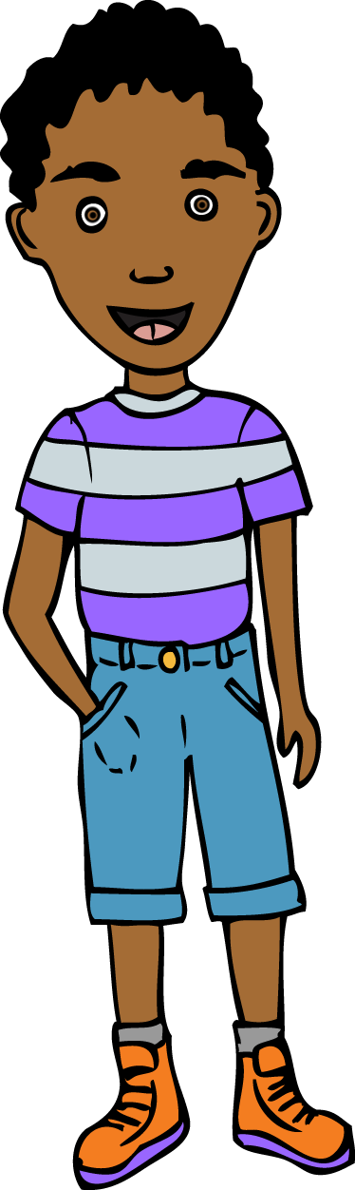
- Explain that this music is an example of music from India. Look at powerpoint with pictures of the instruments playing in the clip above.
The tala is a rhythm cycle.
- The tabla player improvised rhythms to this rhythm cycle.
- Listen again to the clip. Can you hear the drone played on the tambura and the tala played on the tabla drums?
- Explain that we are going to learn a common type of tala called Tintal. It has sixteen beats and the strong and weak beats are marked with actions.
- Show first page of the Tala grid powerpoint (4 box grid) and practise this section of the Tintal tala together. The first strong beat has been marked with a clap. Repeat it several times. (Clap, 2, 3, 4, Clap, 2, 3, 4, Clap, 2, 3, 4 etc) Initially, say the numbers aloud and then say the numbers in thinking voices only. (Clap -- -- -- Clap -- -- --)

1 | 2 | 3 | 4
Clap

- Show second page of the Tala grid powerpoint (8 box grid) and practise this section together. This time strong beats 1 and 5 are marked with claps. (Clap, 2, 3, 4, clap, 6, 7, 8) Again, try to count in thinking voices only.

1 | 2 | 3 | 4 | 5 | 6 | 7 | 8
Clap |  |  |  | Clap

- Show third page of the Tala grid powerpoint (16 box grid) and practise this together. A wave has now been added to the weak beat 9 (rather than a wave like waving goodbye, this wave is an outward sweeping motion with the hand held palm upwards). Try to perform the entire tala together, first saying the numbers aloud with the actions, then saying the numbers only in thinking voices. Once you reach 16, so straight back to 1.

1 | 2 | 3 | 4 | 5 | 6 | 7 | 8 | 9 | 10 | 11 | 12 | 13 | 14 | 15 | 16
Clap |  |  |  | Clap |  |  |  | Wave |  |  |  | Clap

- Once you have performed the complete Tintal tala a few times, explain that children are going to compose their own tala rhythm.
- As the first beat of an Indian tala is the most important children, should always put a clap on this beat.
- Split children into small groups.
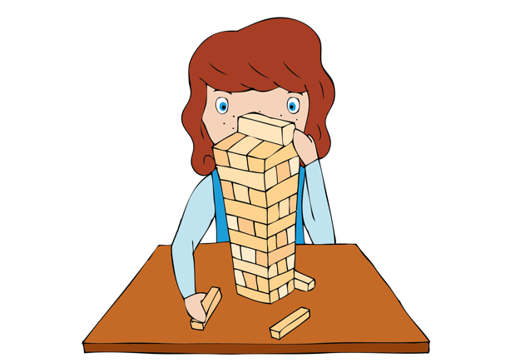
- Hand out blank Tala composition worksheet to each group for children to compose their own tala. (This worksheet file also includes two examples of a completed worksheet for your reference or to show the children). Children can insert claps or waves into the grid to mark whichever beats they choose. See example grid for suggestions.
- Once each group have completed the grid, rehearse their tala to ensure that they can perform it in unison, counting in their thinking voices.

Plenary:
Each group perform their tala to the class, using their grid to support. Discuss what makes a “good audience?” before groups perform. Can the audience identify which beats were marked with which actions? You could hand out a blank tala grid for children to try and notate the talas they hear and see performed.

If there is time, groups could swap grids and try performing one another’s tala.

Keywords / vocabulary: Tala, (rhythm cycle) tintal, tabla, drone, strong beat, weak beat, thinking voice, Sitar, Tambura, Sarod.

Self-assessment opportunities:
- I can listen carefully and respond to the music I hear.
- I can develop my understanding of weak and strong beats.
- I can count using my thinking voice and maintain a steady pulse.
- I can perform in an ensemble with increasing accuracy and aural memory.
- I can compose a tala.
Resources: Example of Indian Tala (link found on plan) ,Tala composition worksheet (blank version) one per group and or one each to record, Pictures of Indian Instruments [see resources]
Bristol Plays Music offers a selection of one off awe inspiring ‘Indian music’ workshops. 10-30 week courses can also be booked. For more information here: www.bristolplaysmusic.org
Opportunities for sharing work e.g. by recording, notation: The plenary performances of the group’s compositions could be recorded using an ipad.

Music Assessment: Year 3 and 4 Rhythm Lesson 3
You only need to note the names of children who are working towards or well above the criteria for the lesson. It will be assumed the majority of the class will achieve the objectives and you don’t need to record this. Use the space below for any specific notes on achievement or evaluation of class progress.

Names of any children who do not meet the learning objectives for this lesson | ‘I can’ assessment criteria | Names of any children who exceed the learning objectives for this lesson.
- I can listen carefully and respond to the music I hear

- I can develop my understanding of weak and strong beats.

- I can count using my thinking voice and maintain a steady pulse.

- I can perform in an ensemble with increasing accuracy and aural memory.

- I can compose a tala
Notes:

