Music Lesson Plan topic – Rhythm (Unit 2)

Lesson 2 of 6 Focus: Year 3/4
Key Learning Objectives:
- To use a “thinking voice” to internalise rhythms.
- To play rhythms faster or slower (changing tempo).
Inter-related music dimensions covered: Duration pulse/rhythm, tempo, texture.

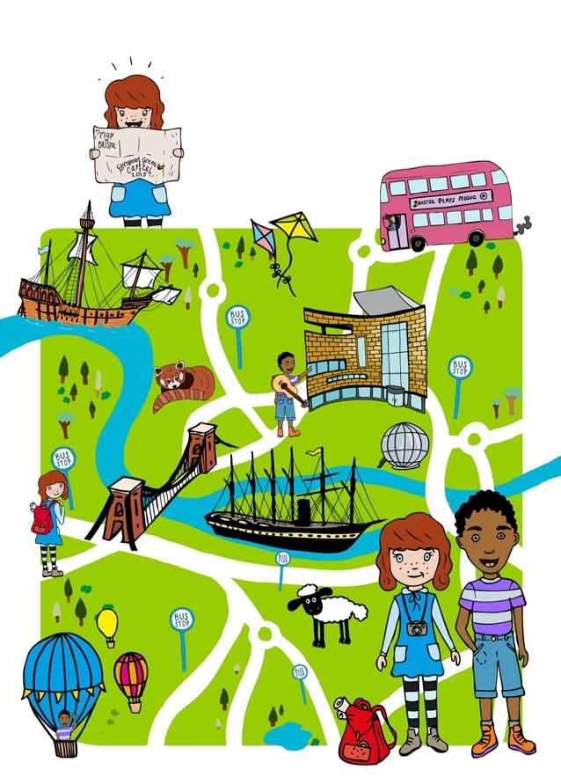
Starter activity:
Select an activity from the Rhythm Card Starter Bank

Main focus:
- Explain that we are going to join in one at a time to create a rhythm machine.
- Ask children to think of some Bristol landmarks (the Where am I in Bristol? game and Bristol Rhythms worksheet should support this) write down a list of suggestions on the board. Encourage children to clap their suggestions, rather than just say them. Whole class clap each suggestion together before it is written on the board by the teacher.
- Ask each child to select one Bristol landmark that they will add to the machine and remember it.
- Sit in a circle.
- Select one of the click tracks below and play to “start the machine.” A click track is a steady click that maintains the pulse, like a metronome. The medium speed 90 beats per minute (at a walking pace - andante) or 120 (fast/lively - allegro) beats per minute would be ideal to start with.
- Invite one child to clap their Bristol place rhythm over the top of the click track, clapping it over and over again whilst using their “thinking voice” to say M shed (rest rest), M shed (rest rest), M shed (rest rest). [See Rhythm Card Year 3 number 1]
- Point to the next child in the circle, who joins in clapping their rhythm over and over again (Clifton Suspension Bridge, Clifton Suspension Bridge…) [See Rhythm Card Foundation Level number 3]
- Point to each child in turn, until everyone is clapping their rhythm over and over again in time with the pulse on the click track.
- Stop the rhythm machine by holding both hands palm down and sweeping outwards.
- Select another click track to try the rhythm machine again at a different tempo. The children could clap the same Bristol landmark or select another from the list. Explain that the rhythm machine will now move at a different tempo (speed).

Click tracks:
www.youtube.com/watch?v=fCv3mBbvqXs - 70 beats per minute (slow - adagio)
www.youtube.com/watch?v=qP1os4seNeM - 90 beats per minute (at a moderate walking pace - andante)
www.youtube.com/watch?v=6ZpfGZaWzYc - 120 beats per minute (lively - allegro)
www.youtube.com/watch?v=eO6jTEKX7J4 - 180 beats per minute (very fast - presto)

- Learn the chant “First you make your fingers click”

The following video clip shows a teacher teaching the chant to a group of children. You could watch the whole clip to learn the chant then teach it to the children without the video, or use the clip in the classroom to support. Below is a suggestion for how to use the video clip in the classroom to learn the chant together.


vimeo.com/32571333 (Start at 1.20)
- Stop the video after the children have repeated each of the four lines (1.48) and try this with the class.
- Start the video again
- Stop after the children in the video have repeated the first two lines together and the second two lines together (2.30) and try this with the class.
- Start the video again.
- Stop after the children in the video have repeated the entire chant (3.40) and try the whole chant with the class a few times, spotting and fixing any mistakes that arise (as in the video, it is important to remind the children to do the action when they say the word- they must stamp when they say the word “stamp” and clap when they say “clap” etc.

Plenary:
Try internalising the rhythm of “First you make your fingers click.” Ask the children to say the words in their thinking voice and just do the actions. Model this first to the children, or use the video. (The teacher in the video models this at 3.40)
- Perform the chant by mouthing the words only.
- Perform the chant a few times, only saying the words in thinking voices.

Keywords / vocabulary: Rhythm machine, repeated rhythms, click track, tempo, pulse, thinking voice, texture.

Self-assessment opportunities:
- I can listen to the pulse carefully and repeat a rhythm that fits in time with it.
- I can internalise a rhythm and perform it with increasing accuracy and aural memory.
- I can clap the rhythm of a place name.
Resources:
Click tracks (links found on plan).
“First you make your fingers click” video (link found on plan).
Rhythm cards.

Opportunities for sharing work e.g. by recording, notation: N/A

Music Assessment: Year 3 and 4 Rhythm Lesson 2- Unit 2
You only need to note the names of children who are working towards or well above the criteria for the lesson. It will be assumed the majority of the class will achieve the objectives and you don’t need to record this. Use the space below for any specific notes on achievement or evaluation of class progress.

Names of any children who do not meet the learning objectives for this lesson | ‘I can’ assessment criteria | Names of any children who exceed the learning objectives for this lesson.
- I can listen to the pulse carefully and repeat a rhythm that fits in time with it.

- I can internalise a rhythm and perform it with increasing accuracy and aural memory.

- I can clap the rhythm of a place name

Notes:

