Music Lesson Plan topic – Rhythm (Unit 2)

Lesson 1 of 6 Focus: Year 3/4
Key Learning Objectives:
- To develop understanding of reading staff notation.
- To explore notating rhythms.

Inter-related music dimensions covered: Duration pulse/rhythm, notation.

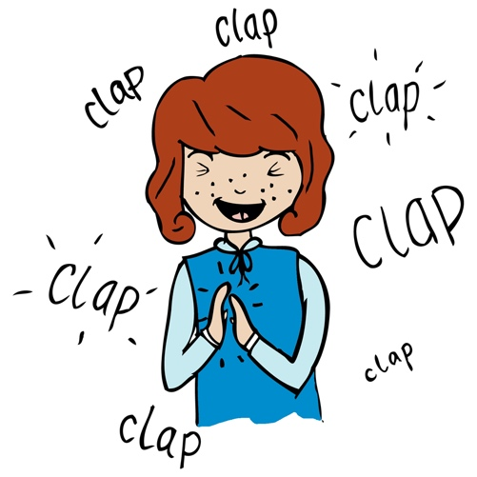
Starter activity:
Select an activity from the Rhythm Starter Bank.

Main focus:
Play ‘Don’t Clap our School Back’. Teacher to play a variety of Bristol place rhythms, which the children play back. However, when the teacher plays the name of your school (e.g. Hor-field Primary.) the children don’t play, but say back “Horfield Primary.” Play some rhythms softly (piano) and others loudly (forte) for the children to copy. (examples could include Ashley Down Withywood, Southmead Filton, Shirehampton Easton.) See video resource.

Place four rhythm cards on the board. One must be crotchet 1/4 note, crotchet 1/4 note, minim ½ note – from foundation level rhythm cards.

Play and say “Bris-tol Zoo” by clapping or using rhythm sticks. Ask the children to repeat.
Ask children which card out of the ones displayed on the board represents “Bris-tol Zoo?” (Which card matches the words?) (it is Year 4 card 8) To support the children in working out the answer, model counting the syllables in the phrase by counting the chin bumps (place hand on chin and say “Bristol Zoo.” There are 3 chin bumps, therefore Bristol Zoo has three syllables. This means we can look for a rhythm card with three notes). The answer is the crotchet 1/4 note, crotchet 1/4 note, minim card ½ note.
Once the children have selected the card that they think represents Bristol Zoo, check the answer by clapping the other rhythm cards together to see whether or not they match Bristol Zoo.

Children work in pairs to complete Bristol Rhythms worksheet. Children work together to clap each Bristol place name, select the correct notation from the options and write the place name in its matching box.

It is important to note that more than one place name fits into each box. Ensure that children are clapping each place name and counting chin bumps, where appropriate, to help them to work out the answers.

Note: A completed Bristol Rhythms worksheet can also be found in the resources for your reference or for the children to use to mark their work if you wish.
Plenary:
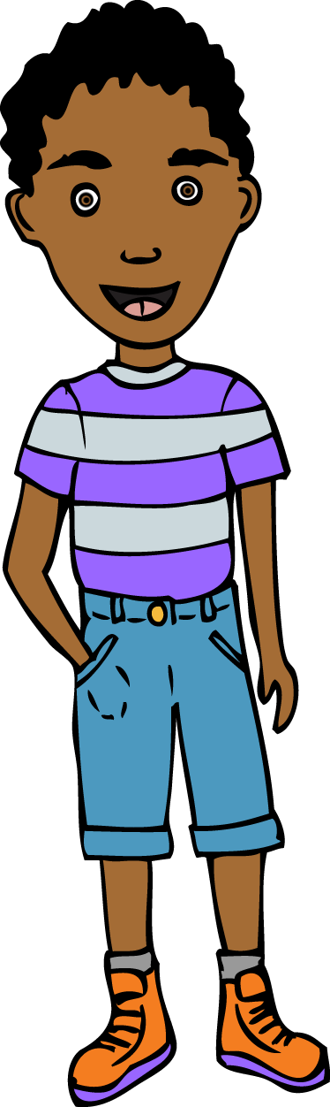
Sing Frère Jacques’ together as a class (the children will probably be familiar with the song, but it is always best to check!) If you would prefer to learn the song by listening to a recorded version. [www.youtube.com/watch?v=BC6rvbxdywg]

- Divide the class into two groups and sing Frère Jacques as a round.
- Invite a confident child to come up to the front to be the singing leader of the second group, whilst you lead the first.
- The first group begins “Frère Jacques, Frère Jacques”
- After the second “Frère Jacques,” the second group begins.
- Each group keeps singing until they reach the end of the song “Ding dang dong, ding, dang, dong.”

- Once the children are familiar with singing the song as a round, add clapping the rhythm at the same time. (Frè-re Jac-ques, Frè-re Jac-ques…= clap, clap, clap, clap….clap, clap, clap, clap)
- Try performing the round, with both groups clapping the rhythm and singing at the same time. To extend this the groups should clap and or stamp and not sing. Try to maintain a regular pulse.

Keywords / vocabulary: Syllables, notation, duration, pulse/beat, rhythm, round.

Self-assessment opportunities:
- I can use my understanding of notation to make links between notation and place names.
- I can work out the number of syllables in a place name by counting chin bumps or saying the phrase aloud.
Resources:
Rhythm cards Foundation level and Year 3 or 4.
Bristol rhythms worksheet (for paired learning).
Completed Bristol rhythms worksheet (for your reference or for marking).

Opportunities for sharing work e.g. by recording, notation: N/A

Music Assessment: Year 3 and 4 Rhythm Unit 2 Lesson 1
You only need to note the names of children who are working towards or well above the criteria for the lesson. It will be assumed the majority of the class will achieve the objectives and you don’t need to record this. Use the space below for any specific notes on achievement or evaluation of class progress.

Names of any children who do not meet the learning objectives for this lesson | ‘I can’ assessment criteria | Names of any children who exceed the learning objectives for this lesson.
- I can use my understanding of notation to make links between notation and place names

- I can work out the number of syllables in a place name by counting chin bumps or saying the phrase aloud
Notes:

