Music Lesson Plan topic - Water

Lesson 6 of 6 Focus: Year 3/4
Key Learning Objective:
- To maintain an independent line within a two part song.
Other Learning Objective:
- To sing in tune with expression and perform rhythmically simple parts that use a limited range of notes.
Inter related music dimensions covered: Pitch, texture.
Starter activity:
Listen to a number of capstan and hauling sea shanties. Ask the children to identify the main features of a sea shanty. Revisit who sang a shanty and why they did so. See resource for links to shanties and further information.

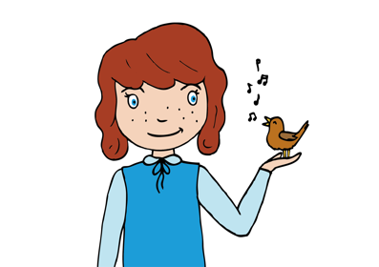
Main Activity:
Discuss how it is as important for singers to warm their voices up, as it is for athletes of footballers to warm up prior to performing. Use the warm up from Singup 1, 121, 12321. Use the notes and tracks from the Singup Website.
Collect from the class their ideas of what would make a good performance of their shanties.
Can the children sing in tune with a sense of the shape of the melody and with expression that creates the sense of a sea shanty?
Can they hold their part where there is two parts and appreciate the effect of the harmonies produced
Can they sustain a melodic ostinato to accompany the main melody?
Can they sign all the words with good articulation so that they can be heard and recognised by an audience?

Perform all the sea shanties rehearsed so far:
Three Pirates Lesson 1 schoolsonline.britishcouncil.org/classroom-resources/world-voice/three-pirates
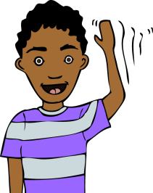
Their own class Bristol shanty
Drunken Sailor www.youtube.com/watch?v=Z4-ytFOS9TI
The Bold Pirate plus ostinato (From Folk Song Pack) www.efdss.org/efdss-education/resource-bank/resources-and-teaching-tools/bristol-folk-songs-pack

Plenary:
Record and evaluate the performance by watching a video of the performance or listening to an audio file.
Keywords / vocabulary: Pitch, ostinato, melody, shanty, capstan, hauling, articulation.
Extension opportunities: When performing the shanties use individuals who are confident and able as the shanty man.
Self-assessment opportunities: (I can..)
- I can maintain an independent line within a two part song.
- I can perform a song using my voice with accuracy, fluency, control and expression.
- I am aware of how different parts can fit together to form an overall effect.

Resources: BPM Bristol Folk Song Pack (http://www.efdss.org/efdss-education/resource-bank/resources-and-teaching-tools/bristol-folk-songs-pack)
Opportunities for sharing work: Record for sharing with other classes or prepare for performance in assembly.

Music Assessment: Year 3/4 Water Lesson 6
You only need to note the names of children who are working towards or well above the criteria for the lesson. It will be assumed that the majority of the class will achieve the objectives and you don’t need to record this. Use the space below for any specific notes on achievement or evaluation of class progress.

Names of any children who do not meet the learning objectives for this lesson | ‘I can’ assessment criteria | Names of any children who exceed the learning objectives for this lesson.
I can maintain an independent line within a two part song.

I can perform a song using my voice with accuracy, fluency, control and expression.

I am aware of how different parts can fit together to form an overall effect

Notes:

