Music Lesson Plan topic - Water

Lesson 5 of 6 Focus: Year 3/4

Learning Objective:
- To create symbols to represent the key features of a composition.
Inter related music dimensions covered: Structure, notation, pitch, texture, dynamics.
Starter activity:
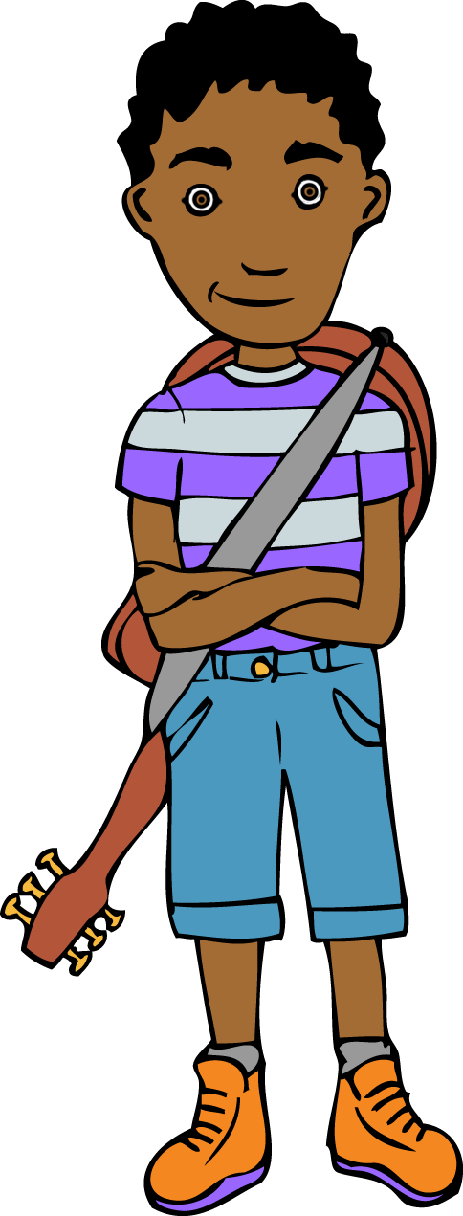
Listen to an excerpt from Rimsky-Korsakov’s – ‘Scheherazade’. The Sea, Shipwreck.
www.youtube.com/watch?v=0RX9Bhps-SQ from 6:20-9:00. Ask children to draw symbols to represent what they hear. They could use colour, shapes, lines etc. The children should share their work with their talking partner with each offering ideas of what their partner’s symbols might represent.

Main Activity:
Select one of the children’s ‘storm’ recordings made last lesson. Listen as a class and ask the children to use symbols to represent what they hear as in the starter activity. Each group (apart from the group whose recording has been chosen) now need to listen to the recordings of their storm pieces and create the symbols and score to represent their music. The group whose work was used as a class model should now work on creating some music using instruments to represent a ship wreck as in ‘Scheherazade’ and should notate it as a graphic score.

Plenary:
Display the scores using a visualiser or similar. Each group performs using their score whilst the rest of the class follow the score. Discuss how well the features of the compositions were represented by the symbols/scores. Sing the class version of the ‘Three Pirates’ song. This could be worked into a class performance of the song and group compositions in order to make a larger structure.
Keywords / vocabulary: Graphic score, pitch, timbre, texture, structure, dynamics (crescendo - gradually getting louder, diminuendo gradually getting quieter).

Extension opportunities: Swap scores and ask each group to interpret.

Self-assessment opportunities: (I can..)
- I can suggest appropriate sounds and instruments to achieve an effect for a purpose.
- I can identify timbres and suggest what they might represent.
- I can create symbols and a graphic score to represent the key features of a composition.
Resources: Three pirates song, visualiser, ‘Storm’ recordings.

Music Assessment: Year 3/4 Water Lesson 5
You only need to note the names of children who are working towards or well above the criteria for the lesson. It will be assumed that the majority of the class will achieve the objectives and you don’t need to record this. Use the space below for any specific notes on achievement or evaluation of class progress.

Names of any children who do not meet the learning objectives for this lesson | ‘I can’ assessment criteria | Names of any children who exceed the learning objectives for this lesson.
I can suggest appropriate sounds and instruments to achieve an effect for a purpose

I can identify timbres and suggest what they might represent

I can create symbols and a graphic score to represent the key features of a composition
Notes:

