Music Lesson Plan topic - Water

Lesson 4 of 6 Focus: Year 3/4
Key Learning Objective:
- To interpret symbols as musical sounds.
Other Learning Objective:
- To select instruments and explore the timbre of the instruments in order to represent aspects of a storm.
Inter related music dimensions covered: Structure, notation, pitch, texture, dynamics.
Starter activity:
Watch the BBC Ten Pieces film for Benjamin Britten’s ‘The Storm’ from the opera Peter Grimes. (www.bbc.co.uk/programmes/p02flv5p), which provides the context of the piece and has a snippet of an orchestra performing it. Explain that we will be using it as inspiration for the rest of the lesson. Further information on the piece and graphic scores can be found at downloads.bbc.co.uk/tv/tenpieces/lessonplans/creative_response_britten_storm.pdf and a video clip about the piece www.bbc.co.uk/programmes/p028dt7c

Main Activity:
Explain that musicians read music in many different ways: some examples are: conventional western notation, lead sheets/tab with chords, graphic scores, collections of pictures and other symbols.

Ask pupils to experiment by interpreting the lines from the ‘Singing Line sheet’ with their voices. Discuss with pupils how they can interpret the lines using musical sounds. For example, ask pupils how the shape of a particular line determines the dynamics, pitch, rhythm and the texture of the sound (a thin straight line could be a quiet single note; a thick line going up could be loud sounds with notes rising).

Divide the class into groups and explore which tuned and untuned instruments might be used to represent different timbres of; the shape of the waves, the pattern of lightning, the clouds. Now ask children to create the music using these instruments to represent the movement of the waves, the lightning strikes, the gathering clouds and the intensity of the rain. Each group needs to compose music to reflect all aspects of the storm. Record each group on easi -speak microphones or a device which will allow each group to listen to their work next week.
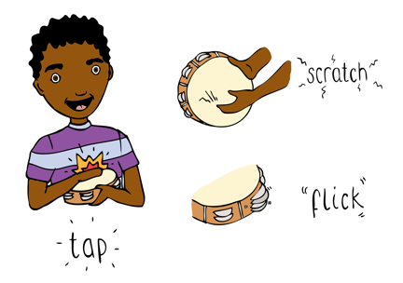
Plenary:
Listen to and review the recordings. Children should identify the key features e.g. in one group waves are represented by a glockenspiel. How have all the elements of the storm been represented in sound? How effectively was this done?
Keywords / vocabulary: Graphic score, pitch, timbre, texture, structure, dynamics (crescendo - gradually getting louder, diminuendo - gradually getting quieter).
Extension opportunities: Listen to Benjamin Britten’s other three ‘Sea Interludes’. Try and identify each of the four interludes having heard them at least once. Write the titles out of order on the board. The children should try to write down on whiteboards the order that they hear the excerpts played to them.
Dawn www.youtube.com/watch?v=-6esm67yWpA
Sunday Morning www.youtube.com/watch?v=692noeACXrs
Moonlight www.youtube.com/watch?v=hxYG-EU4iSI
The Storm www.youtube.com/watch?v=2X7JDvTarqQ
Self-assessment opportunities: (I can..)
- I can suggest appropriate sounds and instruments on order to achieve an effect or portray an idea or physical thing.
- I can identify timbres and suggest what they might represent.
Resources: ‘Singing Lines’ sheet.

Music Assessment: Year 3/4 Water Lesson 4
You only need to note the names of children who are working towards or well above the criteria for the lesson. It will be assumed that the majority of the class will achieve the objectives and you don’t need to record this. Use the space below for any specific notes on achievement or evaluation of class progress.

Names of any children who do not meet the learning objectives for this lesson | ‘I can’ assessment criteria | Names of any children who exceed the learning objectives for this lesson.
I can suggest appropriate sounds and instruments on order to achieve an effect or portray an idea or physical thing.

I can identify timbres and suggest what they might represent.

Notes:

