Music Lesson Plan topic - Water

Lesson 3 of 6 Focus: Year3/4

Key Learning Objective:
- To maintain an independent line within a two part song.

Inter related music dimensions covered: Pitch, texture.
Starter activity:
Singing warm up activity. Sing www.youtube.com/watch?v=Z4-ytFOS9TI ‘Drunken Sailor’. Clap the pulse during the instrumental section. Work on diction!
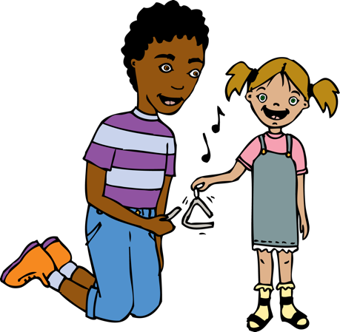
Main Activity: Learn the melody for the song ‘The Bold Pirate’ from BPM Bristol Folk Song Pack.

Split the class into two groups, one to sing the melody line, the other to sing the ‘ostinato’ (the bold pirate) underneath. Teacher to select more confident singers to stand at the front to lead each part. To help children to feel the ‘pulse’ of the piece, repeat the circle activity from Lesson 1.

Plenary:
Once the song has been sung a few times, the teacher should play the drum part. Invite the children to take part and keep a steady beat. “What is a steady beat called?” A pulse.

Keywords / vocabulary: Pulse, ostinato, pitch.

Extension opportunities: Learn the harmonies for ‘The Bold Pirate’.
Learn the ostinati for ‘Drunken Sailor’ (example written out in PDF music)

Self-assessment opportunities: (I can..)
- I can maintain an independent musical line within a two part song.
- I can sing a simple song in tune and with expression as part of a group or on my own.

Resources: BPM Bristol Folk Song Pack (www.efdss.org/efdss-education/resource-bank/resources-and-teaching-tools/bristol-folk-songs-pack).

Opportunities for sharing work: Record for sharing with other classes or prepare for a performance in assembly.

Music Assessment: Year 3/4 Water Lesson 3
You only need to note the names of children who are working towards or well above the criteria for the lesson. It will be assumed that the majority of the class will achieve the objectives and you don’t need to record this. Use the space below for any specific notes on achievement or evaluation of class progress.

Names of any children who do not meet the learning objectives for this lesson | ‘I can’ assessment criteria | Names of any children who exceed the learning objectives for this lesson.
I can maintain an independent musical line within a two part song.

I can sing a simple song in tune and with expression as part of a group or on my own
Notes:

