Music Lesson Plan topic - Water

Lesson 2 of 6 Focus: Year3/4

Key Learning Objective: To identify the key features of a sea shanty.
Other Learning Objectives:
- To perform as either the Shanty man or in chorus.
- To demonstrate a feeling for the pulse of the song.
Inter related music dimensions covered: Duration, structure (call and response).
Starter activity:
Create a class boat (children sit in pairs in two columns with a gap in the middle) and listen to ‘Haul away Rosie’ www.youtube.com/watch?v=fpLYKkfw_D8 Children to ‘haul a rope’ in time to the pulse of the music.

Main activity:
Re-watch the ‘Three Pirates’ schoolsonline.britishcouncil.org/classroom-resources/world-voice/three-pirates and sing.
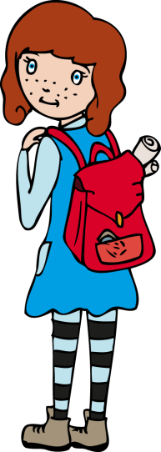
As a class, look at the lyrics for the song (from World Voice Songbook) and explain that they are going to rewrite the lyrics for this song so that the pirates are travelling to Bristol. Explain the role of the ‘Shanty man’ (A soloist who improvises lines to which the workers reply with a chorus that does not change – yo ho, yo ho….) and model changing a line i.e. “Three Pirates came to Bristol Town to see the famous Durdham Downs.”

Collect ideas of things the pirates might do/see in Bristol. As a class create a Bristol shanty with 3 different verses. Perform with expression as a class with an individual or small group as the shantyman.

Children split into groups of 3/4 to take turns at being the ‘Shanty man’ with their group responding with the chorus.

Plenary:
Listen to another sea shanty ‘Haul away Joe’. Ask the class to identify the key features of a shanty. (Call and response, shanty man leading, chorus response, no accompaniment (a capella) as sailors on boats, lyrics describe actions) www.youtube.com/watch?v=YvBHdw-EqLM&list=RDYvBHdw-EqLM. Feel the pulse of the song by clapping along or hauling on imaginary ropes.
Keywords / vocabulary: Shanty man, pulse, chorus, call and response, lyrics, a capella (no accompaniment).
Extension opportunities: Ask children as individuals or in small groups to create further verses maintaining the same structure as the class sea shanty.

Self-assessment opportunities:
- I can sing simple songs in tune with expression as part of a group or on my own.
- I can create call and response phrases.
- I can demonstrate a feeling for the pulse.
Resources: BPM Bristol Folk Song Pack (www.efdss.org/efdss-education/resource-bank/resources-and-teaching-tools/bristol-folk-songs-pack)

Opportunities for sharing work: Record performances for evidence.

Music Assessment: Year 3/4 Water Lesson 2

You only need to note the names of children who are working towards or well above the criteria for the lesson. It will be assumed that the majority of the class will achieve the objectives and you don’t need to record this. Use the space below for any specific notes on achievement or evaluation of class progress.

Names of any children who do not meet the learning objectives for this lesson | ‘I can’ assessment criteria | Names of any children who exceed the learning objectives for this lesson.
I can sing simple songs in tune with expression as part of a group or on my own

I can create call and response phrases

I can demonstrate a feeling for the pulse
Notes:

